Herbert & Sandy's WedSite Blog

- Back to Main Page
- Recent Entries
  - Cruise Photos from Glenda Beall
Thursday, October 19, 2006
  - The Readings At the Wedding
Tuesday, October 17, 2006
  - Wedding Ceremony
Tuesday, October 17, 2006
  - Jacqueline's Photos from the Wedding
Tuesday, October 17, 2006
  - Day 19 (10/11/06): Donnerwetter, Spa, and Home Again Home Again Jiggity Jog
Wednesday, October 11, 2006
  - Day 18 (10/10/06): Kingston
Tuesday, October 10, 2006
  - Day 17 (10/9/06): Last Day on the Boat; We Arrive in Kingston.
Monday, October 09, 2006
  - Day 16 (10/8/06): Upper Canada Village and Fort Wellington – A Fantastic Day.
Sunday, October 08, 2006
  - Day 15 (10/7/06): Rolling….rolling….rolling down the river….
Saturday, October 07, 2006
  - Day 14 (10/6/06): Montreal – without the Rain!
Friday, October 06, 2006
- Recent Comments
  - Surrey Blackburn on Day 16 (10/8/06): Upper Canada Village and Fort Wellington – A Fantastic Day.
10/22/2006
  - Glenda on Wedding Ceremony
10/17/2006
  - GayMoring on And here they are!
10/17/2006
  - Barry on More Photos with the Fantabulous Surrey Blackburn (surreyblackburnphoto.com)
10/15/2006
  - Glenda Beall on And here they are!
10/12/2006
  - Fred and Tim on A Full Day of "Chores"...! (Champagne, Rings, Angels and Things)
8/9/2006

Cruise Photos from Glenda Beall

We are still sorting and uploading our 100s of photos from the honeymoon — but Glenda sent me some so I thought I would post them here!
http://www.kodakgallery.com/ShareLandingSignin.jsp?Uc=19ozr0ly.52yqrddq&Uy=-jmhz7d&Upost_signin=Slideshow.jsp%3Fmode%3Dfromshare&Ux=0

MORE >>

Posted by Sandy Shepard at
10/19/2006 9:36 AM | View Comments (0) | Add Comment | Trackbacks (0)

The Readings At the Wedding

Folks that weren't able to make the wedding wondered what quotes wound up getting "pulled out of the hat" for the "Gospel/Torah" portion. (Instead of having set "Scripture," we had everyone give poems/quotes/etc., and then pulled a reader from the guests out of a hat, and then had that reader pull the reading out of the hat.)
The readers/readings were:
1. Rosemary Yates: Dr. Seuss quote (the longest of the bunch!) - listed below on the 8/3 blog entry
2. Dr. Paul Ogden: Two quotes from those submitted...
I think men who have a pierced ear are better prepared for marriage. They've experience pain, and bought jewelry. (Rita Rudner)
If Love is the Answer....Could you re-phrase the question? (Lily Tomlin)
3. Eve Abbott: Two quotes from those submitted...
Swing and sway, Enjoy the day, "Bona fortuna" from Turin, Where we stay! (from John & Peggy Mooney, who will be biking through Italy on the wedding day)

Love is an exploding cigar we willingly smoke. (by Lynda Barry. submitted by the Brown-Gracey family (Theresa, Chris, London & Bart))
It's interesting what comes out of the "pile," ain't it?

MORE >>

Posted by Sandy Shepard at
10/17/2006 5:32 AM | View Comments (0) | Add Comment | Trackbacks (0)

Wedding Ceremony

Many who weren't able to come to the wedding were curious what I had written for the ceremony. This is going to be a LONG post — but I will put the ceremony here. (I will post the Readings next.) If you aren't interested, you can skip it

Wedding Ceremony

[greetings e.g. who is Sue to us.]

Herbert and Sandra, you are two people from different walks of life entering into the marriage relationship of oneness; a relationship in which neither of you loses your personal identity but where you help each other to be their best. Together you will work to make the marriage a relationship of love. Love is a friendship that has caught fire. It is quiet understanding, mutual confidence, sharing and forgiving. It is loyalty through good times and bad times. It settles for less than perfection and makes allowances for human weaknesses. Love is content with the present, it hopes for the future, and it doesn't brood over the past.

Lei Ceremony

As you know, my home is in Hawaii. For the Hawaiian people the word “Aloha” has three meanings. I believe that each of these meanings has significance for your marriage today.

The first meaning of “Aloha” is “Hello.” This signifies that you are beginning a new life together; a life of love and commitment.

The second meaning of “Aloha” is “Good Bye.” This signifies that you are leaving the past behind as fond memories, and greeting the future with excitement and anticipation.

The third meaning of “Aloha” is probably the most important. And that meaning is “Love.” You have discovered together how special love is when it is shared. At this time will you turn to each other and express “ALOHA” from your heart … by exchanging leis.

[First H, then S place lei over the other’s head. Allison needs to help get train through.}

And now, Sandra and Herbert would love to hear their family and friends affirm their love, and we may do this by saying a heartfelt “Aloha” to them in unison— on the count of three. Please let them hear your voices, loud and clear! One – two – three:

Group: “Alo-ha!”

Readings:

We now come to the Gospel or Torah portion of out ceremony. Instead of a traditional reading, Sandra and Herbert had asked their friends and family to contribute short quotes, poems, or stories on the topic of love and marriage. Sandra will now draw the names of three of our honored guests from this basket and we ask them to come up, select one of the poems from this basket, and read it out loud. If you have forgotten your reading glasses or otherwise feeling shy, please say “Pass” and she will pick another name.

[audience members read three poems; give additional instructions to readers as needed, for example, obviously, the bigger “packages” are longer quotes, the shorter ones are shorter quotes.]

In addition to letting the Universe select what is read tonight, our couple considered it wise to hedge their bets and also chose a poem themselves. I will now read the poem “The Prophet on Marriage”, written by the Lebanese-American poet Khalil Gibran.

Then Almitra spoke again and said, "And what of Marriage, master?"

And the Prophet answered, saying:

Together you shall be forevermore.

You shall be together when white wings of death scatter your days.

Aye, you shall be together even in the silent memory of God.

But let there be spaces in your togetherness,

And let the winds of the heavens dance between you.

Love one another but make not a bond of love:

Let it rather be a moving sea between the shores of your souls.

Fill each other's cup but drink not from one cup.

Give one another of your bread but eat not from the same loaf.

Sing and dance together and be joyous, but let each one of you be alone,

Even as the strings of a lute are alone though they quiver with the same music.

Give your hearts, but not into each other's keeping.

For only the hand of Life can contain your hearts.

And stand together, yet not too near together:

For the pillars of the temple stand apart,

And the oak tree and the cypress grow not in each other's shadow.

[pause]

Vows

Herbert and Sandra, are you ready to take your vows of marriage? [yes, yes] Please face each other.

[Couple faces each other with hands joined]

Herbert, do you take Sandra to be your wife, your partner in life and your one true love? I DO.

Will you cherish your friendship and love today, tomorrow, and forever; will you trust her and honor her? I WILL.

Will you laugh with her and cry with her; love her faithfully through the best and the worst, through the difficult and the easy? I WILL.

As you give her your hand to hold, so you give her your life to keep, as witnessed by those gathered here to celebrate with you.

Sandra, do you take Herbert to be your husband, your partner in life and your one true love? I DO.

Will you cherish your friendship and love today, tomorrow, and forever; will you trust him and honor him? I WILL.

Will you laugh with him and cry with him; love him faithfully through the best and the worst, through the difficult and the easy? I WILL.

As you give him your hand to hold, so you give him your life to keep, as witnessed by those gathered here to celebrate with you.

[addressing the audience]

Do you, this couple’s friends and family, support this union? WE DO.

And now, I would like for everyone to form a more uniform circle around the couple, as we prepare for the Exchange of Rings. Let’s make this a connected circle, by holding hands, creating a circle of loving connection around Sandra and Herbert.

Exchange of Rings

Though small in size, rings are very large in significance. Made of precious metal, they remind us that love is neither cheap nor common; indeed, love is the most precious thing of all. Made in a circle, their design tells us that love must never come to an end; we must keep it continuous. These particular rings chose our couple, at an Antique Store in San Francisco, and are a true and unique blessing to this union. As you wear these rings, whether together or apart, may they be constant reminders of these promises you are making today.

[Yoram passes rings to H]

Please give one another the ring to seal your promise of love and faithfulness.

[H puts ring on S then S on H]

May these beautiful rings be a symbol to you for the continuing love you pledge to each other today.

And at this time, while friends and family continue to hold hands in a circle of support and love for Sandra and Herbert, I’d like for you all to take a silent moment to extend your loving thoughts and wishes to this couple, for a long, healthy, happy life together. Let them feel your love pour over them and through them.

Sue nods to DJ to start music…[“I’ll Be” by E. McCain]

Pronouncement

[music starts in background]

With this union of hearts and hands, and by the authority vested in me as a minister and by the laws of the State of California, I pronounce you wife and husband.

You may kiss the groom.

[fade up music, kiss, fade down music] Clap & cheer!

Blessing Of The Bread

A wedding challah is a traditional part of a Jewish wedding. Blending many traditions, Sandra has baked the challah herself of Hawaiian sweet bread with lots of chocolate braided inside. The couple’s friend Jacqueline will now give the Blessing of the Bread, and then the couple will break the bread.

[blessing, breaking, and eating]

The challah will be set out near the entrance. After the ceremony, the couple would like everybody to have a taste of the bread to affirm their kinship or friendship with the newlyweds.

Ketubah

A Ketubah is a traditional Jewish marriage contract that has been signed before witnesses for thousands of years. The couple will read the Ketubah, and then we will sign it to seal this union.

Sandra and Herbert would like to invite their friends and family to witness the day by placing their signature on the matte around the Ketubah. It will be out for the rest of the evening on the table to the right of the entrance. Oh, and please sign the Ketubah BEFORE eating the challah – I am sure they would not want chocolate fingerprints on the handmade document!

This concludes the ceremony. Please bear with us for a few minutes while we get the room and the couple ready for their dance.

[fade in music e.g. Stevie Wonder “Signed, Sealed Delivered”]

MORE >>

Posted by Sandy Shepard at
10/17/2006 4:40 AM | View Comments (1) | Add Comment | Trackbacks (0)

Jacqueline's Photos from the Wedding

A few more photos from the Rehearsal Dinner, and a couple from the Groom's Quarters "getting ready"!
http://www.kodakgallery.com/ShareLandingSignin.jsp?Uc=19ozr0ly.9j8ngifi&Uy=fin5ji&Upost_signin=Slideshow.jsp%3Fmode%3Dfromshare&Ux=0

MORE >>

Posted by Sandy Shepard at
10/17/2006 4:31 AM | View Comments (0) | Add Comment | Trackbacks (0)

Day 19 (10/11/06): Donnerwetter, Spa, and Home Again Home Again Jiggity Jog

We woke up to a serious crack of thunder and lightening at about 7:30 this morning – rain pouring and I mean P-O-U-R-I-N-G down! We went down for another wonderful Rosemount Inn breakfast – and then I was slated to have my Spa Day. (Herbert had planned to do more town walking – but the weather didn’t make that seem such a pleasant proposition!)

The Rosemount turns out to have a full spa – including waterfall sculpture, a place to have tea, etc. – in the “basement.” Who knew? (This place is huge!) My aesthetian, Jennifer, was wonderful and very knowledgeable. I had a three hour “detox” treatment (hey, I’m trying…) which was made up of first a Lemon/Salt “body scrub” followed by a hot shower, then a body wrap with a seaweed/herb skin wrap, reflexology foot massage, “anti-aging” facial, then a full hour massage, followed by warm jojoba oil with rosemary and peppermint oil massaged in the my hair and scalp, followed by a lemon and water rinse! Yes, I could not walk after it was all done (laugh!)

The seaweed wrap was pretty amazing – they put this “mud lotion” on you, and I figured after, I would have another shower. No – after you’ve been pampered with the foot massage, facial, etc., they “unwrap” you – and it’s all been sucked in. Woah!

The “Detox” part of it started working almost immediately – fat leaves your body “as water” (so to say), and in the 45 minutes that I had from the time the treatment ended, through packing and then waiting for H, I had about 8 visits to my ‘office’! I also was able to cinch in the travel pants a bit, which, even if momentary, gave me a good feeling!

H had been able to brave the weather to pick us up gourmet sandwiches and dessert (chocolate bread pudding!) at the boulangerie/patisserie mentioned before, which was good, since the Kingston airport can literally only handle one airplane at a time! (We had blithely assumed we could get a meal, coffee, etc. there – um, no.) We were in a high-wing puddle jumper on our way to Toronto, where we had to clear customs.

As we were waiting in the Customs line, I noticed that there was a big drop of red near my feet. I thought, “Sheesh, that’s a big drop of blood, someone’s cut their foot.” Then we moved forward a bit more, and I saw a couple more drops. Pretty big drops in fact. So I scanned the floor, trying to figure out where the bleeding was coming from. Couldn’t see anything more. We move forward…more drops. UH-OH………….it was coming out of H’s suitcase…which contained our 6 bottles of Nova Scotia wine! We made it through Customs and Clearance, frantically hoping we would not have to open the bag (nothing like looking like axe murderers), and once we cleared and went around the corner, we tried to find what bottle had cracked. We found that the bag holding the New York Muscat Icewine (of course, the most expensive one!) seemed to be soaked, so we wrapped it up in a Safeway plastic bag we had in there (for muddy shoes, etc.) and just hoped that that was “it.” Of course, I am not looking forward to unpacking that bag – which contains, you guessed it, all our WHITE laundry!

We had a pretty uneventful flight from Toronto to San Francisco – I caught this “missive” up, and Herbert read his book. We are now on the Airporter, and not looking forward to catching up with the Real World starting tomorrow!!!!!!!!!!!!!

(My anticipation is, as we unload the digital photos from the two cameras, to “tag” a link on each day with the photos for that day on the page. So, if anyone is actually reading this, “check back” in a week or so, and hopefully from Day 1 through today – if we took any photos today, not sure – we will have the photos showing what I have somewhat described. Shame, though, we were too “etiquette-conscious” to take photos in the restaurants!!)
Postscript: As I post this, the "denouement" of the Airporter ride was that we had sent for a taxi to meet us, which was "hijacked" by 4 toughs who offered the cabbie $15 a piece, and the cabbie laughed at us and said "Hey, too bad, it's money, bay-bee." THEN, we called his company, they sent ANOTHER cab, and the cabbie pulled up in front of a young gal who was about 5 months pregnant, and shoo'ed us out of the cab and said "Too bad, she's pregnant." NEXT cab took us home — Herbert gave the guy a very nice tip, I think just because we were so glad to be "outta there!" The whole time, there was a homeless guy jeering us too, about getting our cabs "swiped" etc. — it was totally distasteful. Lesson learned — we should have called Jan and Tom, or Mom to pick us up at Manzanita, or gotten off at the "big bright" Larkspur Airporter Terminal, instead of having it take us to the one closer to our home (which is at a bus stop which — obviously — is not the place to be at night).
Oh well — we're home now — and the one SUPER good thing that I learned (c/o the Internet) is that when you have a bag full of white clothes that have had a full bottle of red wine poured on them, then been "shaken and stirred" for about 7 hours in an airplane.....Dawn dishwashing detergent, plus hydrogen peroxide. Yeah, baby. The wine stains were blue and "set" by the time we got the stuff out (and cleaned up the glass, etc.) — these stains just LAUGHED at Wine Away, etc. (It turned out NOT to be the IceWine — which is, ahem, a white wine and also a small bottle...OH NO it had to be the serious, red cabernet, brute strength, "I speet on your white laund-ree" bottle of wine.) So H fired up the computer — and there were like 150,000 websites ~devoted~ to "getting red wine stains out" (yeah, really). It kept coming back to Dawn dishwashing detergent plus HP (unless the item was a "delicate" and then Woolite plus HP, but "Dawn's your best bet.") Sho'nuff — it really did work. I can't tell you how grateful I was — 2 items that were completely "ruined" of mine were not replaceable.
So, time to get some stuff I forgot into the blog above — including a photo Julia took on her phone of us scurrying out of her car to the Airporter! — and then this weekend we get our "professional" photos from Surrey.

MORE >>

Posted by Sandy Shepard at
10/11/2006 1:53 PM | View Comments (0) | Add Comment | Trackbacks (0)

Day 18 (10/10/06): Kingston

We caught a cab to our B&B, the Rosemount Inn (http://www.rosemountinn.com/). One other couple from the cruise actually were staying there as well. The Rosemount is a Tuscan-style villa, in the upper part of town. It has that “stately decay” look – with a big overgrown (but in a very planned way) garden, inviting porch with comfortable furniture, etc. We were greeted by Holly, the innkeeper, and her gorgeous and I mean GORGEOUS Golden Retriever, Katie. (Katie eats Solid Gold, bison and salmon oil formula. Holly gets it special from the States – and it apparently costs about like it’s named. But you should have seen this dog. She was 7 and she looked about 2.) Here are Holly and Katie: http://www.rosemountinn.com/inn.htm

Our room was the best room of our trip! It was called The Tower. As you walked in, you were in the bedroom – and then from there, you stepped up one step, and you were in a sort of anteroom, where a desk (upon which the computer sits – and where I sit now!) is tucked under the steep winding stairs). Behind you is your own private deck, the only one off any of the bedrooms. It was on the floor above the front porch. Then, going “up and over” the desk and the anteroom, a steep pair of stairs wound up and up and up – to another sitting room, complete with fireplace, 2 chairs and a table – in the tower of the Villa! I L-O-V-E-D it!!!
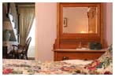
That night, Thanksgiving night in Canada, most of the restaurants were closed – but we happened upon a restaurant called Tango (http://www.greenwoods-inn.ca/tango.htm). From 4-7, they offer all their “tapas” (appetizers) for ½ price. They had the most extensive per-glass wine list we saw in all of Canada – and in fact I wrote down the 2 wines we had, because we both liked them so well. We had an amazing “tapas” of shrimp in a lime and sambal (what is sambal?) sauce, which (as there was no bread on the table) we wound up scooping up and into our mouths on our knives and the back of our forks, it was so delicious. We also had a small appetizer-sized Beef Wellington, which was OK – the crust was great, the beef inside was a bit overdone.

We went from there down to the Waterfront, to a restaurant called Sizzle. This is an adjunct to the Four Points Sheraton, and it touts that their chefs won an Iron Chef Competition (though it might have just been for Canada – or maybe just Kingston, that part was partially obscured!) We had a nice Greek salad, and then a very homey Portuguese mussels, pork and chorizo stew. The weather had turned cold, so we had lots of food to head back to the B&B – but not before racing at a “breakneck walk” to our final destination – the Austrian restaurant on Princess Street (the main street in town). They were just closing their doors and offered us dessert “to go,” but it turned out to just be cakes, not, as H had hoped for, streudel. So we went back to our B&B and “virtuously” had a few homemade cookies and tea left over from the 4:00 tea service. We tried to hear what the Kingston Ghost Tour was saying outside of the Inn when they came by – but I didn’t try all that hard.

The next day we awoke – and discovered that our B&B has the most amazing breakfast I think I have ever seen! We had a small square of 70% cocao French single-orchard chocolate (with a little article about how that much chocolate a day was good for your heart), then a plate with enough food for a whole day…savory fluffy scones with chives and herbs, a quiche of chiles, tomatoes, and some other herbs with a homemade salsa on top, a salad with some fancy dressing (we had had – ta da – “Thousand Island” – yes, that’s where the name comes from – dressing on our last day on the boat), and fresh fruit, plus French press coffee and cream.

I love coffee and tea services, and I have to say that theirs was one I think I will now covet. The handles on top of the lids for each piece were cranes, standing but with their necks S’d down and their beaks holding the top “button” of the lid (e.g., for the coffee pot, the top of the sugar bowl, etc.) Each of the handles was embossed with a face, and then about 2/3 of the way down (at the beginning of the 4 “feet” each piece had), was a man’s bearded face, and he had a Sou’wester hat on his head. Then the feet were crane’s feet holding a little ball (you’ve seen the lion’s feet ones – just like that). I couldn’t get over it. And she had a full service – including a samovar with that design.

After we tore ourselves away from Breakfast, we did a full tour of Kingston. We were going to rent bikes, but when we got out, it was quite cold and very blustery – so riding a bike would have been murder on the face/hands. (I, in fact, bought mittens and also a very silly raw silk, rainbow-threaded hat with the ear flaps that tie under your chin and a big tassel on top – my ears and cheeks were getting cold! No, Herbert didn’t disown me but I’m sure it was touch and go.) We went to the University, a few art museums (very interesting), bought some gifts, etc. We got some snacks at the bakery/patisserie for Chez Piggy – one of the many well-reviewed restaurants in the area. It’s called Pan Chancho (www.panchancho.com). They had some of the most gorgeous food – a deli, fresh-baked bread, fresh pastries, etc. We purchased an apple/raspberry galette, about 4 different Quebecois cheeses, and then 3 different rolls (a rye, a pumpkin seed, and an olive/rosemary). For our midnight snack in the tower, of course!

When we were out and about, we discovered that Kingston was a pretty special down. This place has like 5 bookstores, a bunch of jewelers all making fantastic, different jewelry for not TOO terrible prices, etc. Yeah, ok, so I bought myself a necklace, bracelet and earrings from the museum from a local artist that was so different, I just couldn’t stop thinking of them (we went back for them), and a new silver ring for H (this one has a Native American-type theme carved in it – arrows and such), then another necklace for a friend handwrought in silver with a poem that was stamped into it and then I got to pick the color of the gemstone “dongle” for it. Don’t ask me how Mastercard hasn’t just turned me down flat by this point. We also found a blacksmith who had made corkscrews – really more of an art piece than anything – on handwrought hooks. We figured that would be perfect for our friends watching the cats – as they have a wine cellar and this would look pretty on the wall. (We went to a “Purveyors” on Princess Street – looked like something from turn of the century England, and smelled like chocolate, tea, coffee, etc. – and I found a box of chocolates on the top of which was stamped “Thank You For Minding My Cat”…but it was very pricey for not that great of chocolates – funny though huh??)

When we were making our reservations, we had been waffling between the Rosemount, and the Frontenac Club (www.frontenacclub.com). We went by the Frontenac – which was a bank, then a gentleman’s club, then had been purchased by a guy who was a businessman/innkeeper, and his partner, a designer. We decided to take a look in – and Herbert was sad we hadn’t stayed there! It’s just so difficult to know from Internet photographs whether a place is “the real McCoy” or is a cheap imitation – well, the Frontenac is The Real McCoy. Holy Cow. It was luscious. Modern, gorgeous beds, manly but in a comfortable, amazing way – wow. Not sure we will go back to Kingston, but if you are ever there, and you don’t want the “Victorian thing” (mind you, I loved our Tower room!), you must stay at the Frontenac Club!!! Wow, wow, wow. Full library, a den in the old bank “vault,” etc. – pieces of the bank left, pieces of the men’s club here and there, but all integrated into, hey, is it PC to say that “perfect gay designer style” that is so perfect? I think about the guy who does the home makeovers on Oprah. It was like that, throughout, while remaining comfortable. Luscious. It had a busy road outside – but hey, it was a bank for goodness sakes – so you couldn’t hear a thing.

That evening, we were going to hit Le Chien Noir or Chez Piggy – but we wound up instead going to Tango again for the same glasses of wine and 2 different appetizers – then back to our Tower Room for cheese, bread, and pastries! I also booked a full spa treatment for the next morning – I was just going to get a massage, but H said “Go for it!” (http://www.rosemountinn.com/spa.htm)

MORE >>

Posted by Sandy Shepard at
10/10/2006 1:52 PM | View Comments (0) | Add Comment | Trackbacks (0)

Day 17 (10/9/06): Last Day on the Boat; We Arrive in Kingston.

This morning we passed through the area of Thousand Isles that’s considered “Millionaires Row” – wow! People here actually just own their own islands, and then build these amazing homes on them. One of the largest (though never inhabited) is Boldt Castle (http://www.boldtcastle.com/). It is now a State Park (U.S. Side – we couldn’t go because we would have had to have cleared customs just to visit, and then clear again to return!) George Boldt built this magnificent castle for his wife, but she died in 1904, just as it was being finished. So he never inhabited it – and ultimately it was given to the Thousand Islands Bridge Authority to run. It really is a castle – it covers a whole island, which Boldt had carved into a heart shape for his wife.

We were able to leave the boat (on the Canadian side!) to go to the 1000 Islands Skydeck. It’s in Rockport, Ontario, and it’s a big, high tower (with, of course, a gift shop at the bottom!) that affords you a 360 degree view of the whole area. You could see the river, all the trees (well, more just “colors” from up there), homes, etc. What a great vantage point!

Someone asked when we were having this overview of the Seaway how much was flooded. Seven entire communities (from which some of the homes, churches, etc. went to Upper Canada Village), 20,000 acres of land, and 1,100 farms were flooded, and about 6,500 people lost their homes and a big part of their history. Quite a human cost, all things considered.

As we finished lunch, we could see our destination – Kingston – on the horizon. Time to settle accounts (oh no! The bar tab!), pack (can you say L-A-U-N-D-R-Y?), and debark for new adventures!

MORE >>

Posted by Sandy Shepard at
10/9/2006 1:51 PM | View Comments (0) | Add Comment | Trackbacks (0)

Day 16 (10/8/06): Upper Canada Village and Fort Wellington – A Fantastic Day.

Well, last night I didn’t make it to Roger James – I was “pooped” out by 8:30 and my “little nap” lasted until 9:00 a.m.! It’s a bummer because apparently Roger James was a lot of fun – a “one man band” and with a lot of fun clean stories and jokes. Herbert went up, and was particularly impressed with his playing of the bodhran drum. I’m sad that I missed it – but I definitely needed the shut-eye.

I seem to be able to make a “detox” last until about 4:00 on the boat – when one or the other of my fellow passengers (and if all else fails, H!) gives the “Martini Time” holler! Oh dear…well, it is my honeymoon, right?

Today, after the end of the Shuffleboard Tournament (thunder from the rooftop), we had lunch and then were off to Upper Canada Village (http://www.parks.on.ca/village/home.htm). Two horse-drawn wagons picked us up at our dock, and took us for the drive over to the village, and then an overview of the site. We were then free to explore for about three hours.

It wasn’t nearly enough! Upper Canada Village is a village “recreated” in the period of the 1840s-1860s in the area. A number of the homes, businesses, and the like were saved when the St Lawrence River was expanded, flooding many villages and homes.

The day was a perfect, perfect autumn day. As this is the day before Canadian Thanksgiving (and is the last day that Upper Canada Village – which is “manned” by professional reenacters – is inhabited), the village was bustling with folks getting ready for thanksgiving. Okay, yes, at one point H and I rounded the corner of one of the wealthy farmhouses to find the women taking their pies out of Tupperware (we had just come from the Tinsmith, and H “innocently” asked where the “Tuppersmith” was located), but in general it was a busy “hive” of blacksmithing, cooking, candlemaking, and the like.
The village is quite large – and again, just gorgeous. Because it was the day before Thanksgiving, they didn’t have a lot of visitors – in fact, the “non-indigenous” population until about noon (when we had to leave) was so small that we pretty much had the village to ourselves. It made me wish for period dress to “blend in.”

We were particularly taken by the three working mills. Yes – real working watermills. It was great stuff. The first was a sawmill, which was milling logs – and then the logs were taken over to another guy, who was actually ‘powering’ a saw with 2 horses in a hot-walker type contraption. The second was a grist/flour mill – where I could have stayed for hours. It was almost totally silent. The leather belts were turned by the water turbine below, and ground the wheat. It was then “lifted” by a conveyor built of wooden cups, which took it under the floor and up and into a huge (40’ long or so, probably 10’ wide) rolling ‘sifter.’ The fabric in the sifter went from very very fine, where the finest of the flour fell through into a compartment, down to less and less fine cloth, and at the end, the bran came out into sacks. Each wheel could and did grind 350 pounds per hour.

Herbert would ask each station what they did “in their real life,” and the miller was quite adamant that what he did for his “real life” was he was a period historical miller. He said that this was his life’s blood – he kept the whole mill running, making his own tallow and beeswax “coating” for the leather to keep it running quiet and smooth, etc. He said that “during the winter months” he was a carpenter, but that his “real job” started in the Spring through the Fall – there. And in fact, looking at that machine and how lovingly it was cared for, etc. – I quite agree with him.

H couldn’t think of any actual working water mills that he had seen – I believe many of us has seen steam mills, or water mills that are museums, but this one was going strong. It was a delight to see.

The last mill was also just shake-your-head amazing. It was, again, all water-powered. In this one, the wool from the village’s sheep came in at the bottom, and there were period carding/etc. machines. Then, upstairs, a seriously intricate “contraption” – the first time on the whole trip I really longed for a video recorder – basically brought that wool through a variety of pins/rollers/levers/etc. – and out the far end came a fairly thick “rope” of wool. This was then fed onto another machine (which we never got to see work – it was going to be fully “loaded” at around noon, but that’s when we had to leave), which then spun, on over 200 wheels, the wool “rope” into yard – involving spinning the yarn first as the machine spun “out” and then the yard winding back on top of itself (think of yard, you’ll remember that it isn’t really just one “thread” but two, one spun backwards onto the other), as the machine was pulled back through pulleys that stretched tight on the first run. Just amazing.

We also stuck our heads into the dyeing area – where they were dyeing the wool blue for blue yarn. As the reenacter explained, this is where “dyed in the wool” comes from – that if the wool itself is dyed before it is spun, the color holds better than if it’s dyed when the wool is already spun into yarn.

We were really sad to leave Upper Canada Village. Herbert found a VHS movie of the village in German, which he’s going to send to his Dad. In the gift shop, they sell the fresh bread from the bakery, blacksmithed “smith puzzles,” bags of the flour (yes, really!), woven blankets from the yarn (we had missed the weaving shed), quilts, tinware, etc.

We walked back from Upper Canada Village, as it was a gorgeous day, about 65 degrees and a perfectly flat walk back to the boat. After we were all back, the boat took off for Prescott, for a tour of Historic Fort Wellington (http://www.pc.gc.ca/lhn-nhs/on/wellington/natcul/index_E.asp).

Our guide was a young guy, getting his Masters in History locally. He worked as a docent at the Fort – and he was just a wonder. He gave a fantastic presentation, and you could tell it wasn’t just something he had memorized from a manual – this guy lived the stuff. We learned a lot about the life of the soldiers in the Fort, and were able to go through the buildings as he painted a very vivid picture of their lives. The married soldiers brought their wives and family with them – because it helped prevent desertion. However, the man and wife lived on basically wooden boards, with straw-stuffed “ticking” (that also contained all sorts of creepy crawlies). Their kids slept on the floor under the bed – and were allowed small dogs or cats, because the rat population was so awful, that they needed “predators.” After a child reached 14, s/he was kicked out – if a girl, of course, her father might arrange for her to marry one of the soldiers upstairs (the single men lived on the 3rd floor, the married on the 2nd), because there really wasn’t much food/water/etc. out in the “hinterlands” and nowhere else for her to go. If a soldier was shot, the wife had 2 days before she was sent out of the fort packing – 1 day to mourn her husband, the next to “court” a man from upstairs (!!) And the guys upstairs wanted downstairs, as it was somewhat better living – but….holy cow!

The women were treated at a lower “level” than men or children – especially when it came to washing. There was one big bucket on the 2nd floor – and every morning, first the men washed their face, hands and feet in it. Then the children could wash in it. (Yes, same water.) Last, the women. Yes, they were washing their faces in what the men’s and kids’ feet had been in. Worst would be shaving day (every Wednesday), because then all the whiskers would be in the water. Some women’s diaries made the best of it and touted “rubbing the whisker water” on their faces to keep their cheeks cherry red. Yu-uck! Everyone basically didn’t bathe their bodies at all. Mmmmmmmmm……..

That night was the Celebration Dinner night. We had steak or salmon – and, miracle of miracles, if you ordered the steak rare, you got it rare! We actually gave the chef a standing ovation. Everyone came out in their nicest “duds” – it was really fun to see. Then after, we had a trio come on board, and they cleared the floor for dancing.

This was just the best. One of the couples, Joan and Raymond from Long Island, really cut a rug! I thought that at best they were in their late 60s – I did know that they had been married for 20 years and each had been widowed – I found out that night that Joan was eighty. I should be that lucky!!!! This is what my mom is going to be like at 80 – everyone’s going to think she’s 50 In fact, Raymond and Joan sort of looked like my mom and dad – he was tall, slim, sort of stoop-shouldered like dad with a "solar panel on top" (love that), and she had short cut hair, was shorter and “perky.” We really liked them.

At one point, they started to play the Tennessee Waltz, and by that time the whole boat knew that we were “newlyweds” and so when I convinced H to dance (he took off his Doc Marten-y shoes that he’d brought for the trip and wore socks – I wore bare feet), we stood up and everyone clapped which was really cute. The floor was very small, but amazingly, we were able to Viennese Waltz around it. People freaked out. (It was great.) We got a few turns out, and of course as the woman, I was looking up at the tin ceiling. Herbert said to me “are you getting horribly dizzy?” and just as I said “No” I stepped on my OWN foot, and burst out laughing. He was concerned, said “Oh no did I step on you?” and I couldn’t stop laughing and I said “no ~I~ stepped on me!” We were able to finish the waltz and then at the end people kept coming up to us, very emotional and saying how “wonderful” it was that “young people” were still dancing in “such a beautiful way.” Well then of course it got out that we had given foxtrot lessons at our wedding – our boat compatriots loved that idea!
I got a few more dances in – one with Milton, a Catholic schoolmaster from England who was…well, definitely in his 70s. He got out to Swing dance with Vanessa, his wife, and you could tell she was not happy. My guess is that Milton (who was hopping and bopping like mad) has a heart condition – he just danced around her and she looked cross. It made me sad because he was having such a good time. He’s a big fellow, with big bushy eyebrows and a wonderful smile behind big glasses. Vanessa actually sort of went off in a huff (she did come back) and when the next Swing came on, I asked Milton to dance. This was the first “cross-over” that there had been – everyone was only dancing with their own partners. He said to me “I’m not really allowed” and I said “well, you just swing me around, I will do all the hopping and bopping.” It was a serious gas. He really had the moves – and an iron lead! I did moves I had no idea I could do. While I was bopping with Milton, Joan asked Herbert to dance – but Herbert said she had obviously been doing “freeform social dancing” for the past 60 years, and he didn’t know how to do it with her. So they just wound up doing Charleston moves! (Thank goodness Mom had taught H some!)

We had been hanging out with 2 couples – Stuart and Gay from Atlanta and Gay’s sister Glenda and her husband Barry from North Carolina – and Gay went to bed and I danced some swing with Stuart, and then when they called Last Dance Glenda didn’t want to dance and Herbert didn’t either – so Barry and I danced. He was a very VERY smooth dancer. It was great. He is a tall, big guy, and it was really fun to dance with him. I know it was a slow dance, but I can’t remember what it was. We were basically dancing cheek to cheek and joking the whole time! (Barry and H and I had gotten in trouble at the bar a few nights previously, when poor Glenda had felt poorly and had to go to bed – we were passing notes, making comments, etc. – I think basically just trying to make each other laugh while everyone else was nodding off – oh I mean listening – to the music.) I really liked them and it would be a lot of fun to see them again – though that’s unlikely to happen, sad to say. They were great. (We actually gave Gay and Glenda our tour books from Quebec and from Nova Scotia, because they had been trying to decide whether they would travel there – and we had been raving about it and thought it would be fun to let them have our books to start some “planning.”) I think that Stuart said he was the only one of the 4 who wasn’t getting social security – but you would think that they were all in their late 50s. Barry even sang some Frank Sinatra — I want to say that Glenda said that he had done this 20 years before for her and that he said he would do it "every 20 years" — but that might be wrong. (He had a great voice, maybe it was only 2 years before )

Off to bed after a really fun “Celebration Evening” to await our last day on the boat!

MORE >>

Posted by Sandy Shepard at
10/8/2006 1:47 PM | View Comments (1) | Add Comment | Trackbacks (0)

Day 15 (10/7/06): Rolling….rolling….rolling down the river….

Today I woke up – and felt like a goose must feel who is being made into foie gras! Oh dear! I think yesterday was our excess “peak” and I have made promises to God to Be Good Now. So, grapefruit and hot lemon water and some prunes for breakfast…watching wistfully as the French toast, fresh beef hash, eggs, etc. got devoured around me…grilled chicken and salad (and no garlic toast or pineapple upside down cake) for lunch….Herbert said we have Way Too Much Wine in our cabin (and also the boat actually purchased Tanqueray and Campari on our behalf) and so I am “not allowed to be good all day.” OK then!

Today is a “cruising day” – we left early from Montreal, and are on the river all day. We are going through 4 locks, and covering quite a bit of distance. It’s warmed up a bit, but it’s still pretty nippy. There is a shuffleboard tournament going on over my head as I speak on the “upper deck” – sounds a bit like rolling thunder!

The leaves haven’t really changed like folks have imagined that they would have – it’s a combination of unseasonably warm weather and rains here in Quebec/Ottawa. I am glad we took some photos when we were in Nova Scotia! We kept not taking them, saying to one another “oh, we will get lots of chances from the boat.” Not so!

Once we settled into being the youngest (sometimes by 2 generations) on the boat, it’s actually been quite an enjoyable group to be with. No one asks anyone what they “do.” (Luckily, no one talks about their latest surgery either! ) Everyone talks about things they love to do – travels they’ve been on, hobbies, stories, etc. It’s very relaxing, and there just isn’t any of the “one-ups-manship” that seems to sometimes happen in a group more our own age. Or, perhaps, establishment of some sort of “pecking” order. There’s none of that here. Very relaxing.

Well, it’s a bit later, and we just received the “newsletter” so I can report that today we are going through four locks, Lower Beauharnois (42’ lift), Upper Beauharnois (42’ lift), Snell Lock (which is in the USA – I believe New York) (48’ lift), and Eisenhower Lock (also in the US) (43’ lift). We also said through three lakes, Lake St. Louis, Lake St. Francis, and Lake St. Lawrence.

A little while ago I went up to the top deck, bundled up in my jacket, blanket from the room, etc., and took in some of the scenery. I got some definite laughs from the folks doing their After Lunch Constitutionals around the decks! It was just too cold to not have the blanket (it’s probably about 55 out there), but it was nice to be outside and in the sun. Supposedly tonight we will be docking at Crysler Park Marina, where we can have another stroll before dinner. It’s a large migratory bird sanctuary. The entertainment is supposed to be a concert with Roger James, who apparently plays “guitar, banjo, piano, bodhran drum, harp, sings, and tells stories, but he can’t dance.” We’ll see

MORE >>

Posted by Sandy Shepard at
10/7/2006 6:20 AM | View Comments (0) | Add Comment | Trackbacks (0)

Day 14 (10/6/06): Montreal – without the Rain!

This morning us “late sleepers” were woken but the giant alarm clocks (e.g., the engines) at the 8:45 a.m. departure for Ste Anne de Bellevue. We passed through another lock, and then we were in the St. Lawrence River proper and on our way to Montreal.

Herbert and I were able to get out as soon as we docked in a small town called LeChine, and go for a fairly long walk. As with the other towns we have docked at, there isn’t much of a “there there,” but we did get down to see their cathedral. On our way back, we found an open-air market, and noted that it was to be open until 7:00 p.m. We thought we could replenish our stock of baguettes and cheese!

We returned to the boat just in time to board the coach tour of Montreal. We had a fantastic guide – Herbert mentioned that she could have been a radio announcer, she was so smooth, and full of interesting facts. She had been a nurse, and apparently took up the docenting as a hobby – but you need to go to school, etc. to be certified to do the tours. She has been doing it now for eight years. We drove through both the old and new towns of Montreal, and were able to get out of the coach at Notre Dame Basilica, which was gorgeous inside (http://www.basiliquenddm.org/). The basilica is all made of wood – painted, with soaring ceilings and light stained glass in them, etc. Since it was so sunny, the docent even commented this was one of the prettiest days she had seen the basilica on the inside, it was just flooded with light. She told us that now to get married in the Basilica, you have to have a minimum of 750 guests, a 2 year wait, and pay $11,000 for the privilege. Yikes!

We had the coach drop us off in the town of LaChine, and we did hit the open-air market. It reminded me of France – one waited in line at the vendor (think of a line at an ATM), keeping a “distance” from the customer who was ordering. The vendor then helps the customer, talking and asking what sort of thing the customer will be cooking, etc. Then you are given little tastes, and choose what you’d like. Very civilized! We wound up with a whole wheat baguette, a local Quebec blue cheese, a Quebec Tomme, and then a French brie because, though we wanted to try to buy totally local, the cheese “would not be ready to eat that evening” and so we were steered to the French brie. We also obtained a pot of duck pate, which was made by “two French brothers who have set up shop locally.”

Herbert was reading a bit about the St. Lawrence River – apparently 30% of all the fresh water in the world flows through it. I had thought we were on the St. Lawrence the whole cruise, but actually the first river we started out on was the Ottawa River, that flows down into the St. Lawrence. We traveled about 100 km down the Ottawa River, which is in total about 1000 km (about 600 miles) and the largest tributary of the St. Lawrence.

The entertainment for the evening (we had snuck out beforehand for the previous nights) wa a concert by a flutist and guitarist. They brought a listing of music (conveniently broken into the 5 CDs that they had for sale!), and then asked the audience to pick 12 songs for them to play. I got in 2 that I wanted (because I spoke up quickly, hey, youth and skill….), Take 5 and then an Argentine medley by Astor Piazzola. The others chose old standards like Summertime and then for example the opening prelude to La Traviata. Some sounded better than others – I have to say that my 2 choices were really quite good, but probably because the “original” hadn’t used an entire symphony orchestra like the opera selections!

I had been asked by one of the guys if I could massage his wife, who had had a bad spell of neuropathy in her neck, so I did that before the entertainment. She’s really a great gal, and I was glad to. I even brought our iPod and speakers down to their room so that she could really relax. Well, Barry (her husband) kept the martinis and negronis running for Herbert and me – oh dear – and we wound up with something like 3 or 4 of them by the end of the evening. Then, Herbert and I went back, and had our evening glass of wine, plus cheese, pate and bread. Yeah, I bet you can imagine what we felt like in the morning….!!!!

MORE >>

Posted by Sandy Shepard at
10/6/2006 6:19 AM | View Comments (0) | Add Comment | Trackbacks (0)

Day 13 (10/5/06): On the Riverboat

It was definitely nippy last night – 36 degrees – and is supposed to be a “balmy” 50 today. The boat has 44 passengers, from the provinces of ON, BC, QC and AB, the states of OH, NM, NC, NY, NJ, IL, OR, UT, GA, VA, MA and us from CA, and then England. The Canadian Empress is the only ship cruising the St Lawrence Seaway.

We were glad to have not only gotten the “honeymoon suite” at the front of the boat, but also to be on board for this particular week. Herbert actually had tried to get us out the week before (which would have meant that we would have left right after the wedding on our honeymoon), but he couldn’t get the “honeymoon suite” (which has a double bed, instead of 2 side-by-side singles or two bunks) until this week. If we had been on the boat last week, we would never have gotten outside…it rained the entire week! Though we had some rain when the boat was leaving Ottawa, the forecast is for “brisk and clear” weather.

The first day we left Ottawa, and wound up docking at a small dock a bit of a way downstream. Herbert and I got out to have a walk, and watch the ferries take the cars across the water. Not much around there! The next day after breakfast the boat took off, and after cruising along for a bit, we docked and visited the Cumberland Heritage Museum. (http://www.ottawaplus.ca/portal/profile.do?&profileID=428283) The “museum” is set on a 100 acre site that shows life as it was in Canada around the 1930s. Houses, the oldest gas station in Canada, barns, etc. have all been carted and then meticulously put back together into a village. The docents dress in period clothing, and each “interpret” one of the buildings – but as we were only to be in the village for a few hours, they split our group into 3 and then carted each one around to “representative” buildings on the site.

We did go with our group to the first building – a train station that had been deemed “redundant” in its village, so it was carted to the Museum. The guy who had been responsible for carting the Church there told us that the hardest part isn’t getting it from the first site to the Museum – it’s actually putting it up on its foundation. Each house is split into 3, and is carted down on lorries 1/3 at a time. But then the trucks have to ‘back up and onto’ the foundation on boards, and there can’t be an inch of disparity – as the building needs to go back together on the foundation!

After listening to the docent in the train station (who does a Morse Code demonstration), Herbert and I decided it was a lovely (if cold) day, and that we would instead go for a walk around and just peek into all the buildings but not actually be “docented to and carted around.” We visited the pigs in the barnyard (two big sows named Lunch and Dinner), the turkeys, saw the sawmill where they were doing a shingle-making demonstration, etc.

When we reached the far back area, Herbert spied a road that still seemed to be on the site, so we headed that direction. We wound up in a clearing, with a model railway running through it! The Ottawa Valley Live Steamers and Model Engineers had set up a 1600 foot long ground track with 5 and 7.25” gauges, and two of the members were there oiling the switches and tracks. Well, we got to talking to one of them – and he took us for a ride! It was great – through the Fall colors, around the meadow, etc. He didn’t have a steam engine – he had more of a standard issue “locomotive” that actually used a snowblower engine to run it. Herbert gave him some $, which he refused until he said it was “for the Club,” and we headed back to our group.

After the Museum, we went back to the boat and had lunch, then we sailed a bit more to Fassett, Quebec, where we visited Omega Park (http://www.parc-omega.com/56k/Omega-GB.html).This is a drive-through 1500 acre wilderness park with herds of elk, ibex, red deer, bison, lots of wild pigs, and then bears, wolves, and coyote in their own sections. We were in a school bus – and were handed out carrots by our guide. We drove through the park, and then were able to feed the carrots out of the window to the various vegetarian animals.

Some of the elk and ibex were huge – it was the beginning of the “Love Season” (as our Quebecois guide called it) and the male elk had their full racks of antlers. Some had upwards of 12 points. The ibex, also, had enormous horns – they don’t lose their horns, so they just get bigger and bigger. One male’s horns were so tall and huge, I don’t know how he held them up with his neck muscles! Each time he would turn all I could think was that his back feet would be coming off the ground with all that weight in front of him!

At the end of the day, we went through our first lock – the Carillon Lock – which had a 65 foot drop. It was very odd to be in there as the water went down, down, down, and you were faced with the “guillotine gate”! It did seem like something out of James Bond. Once we were through the Lock, we docked at a nice park (very deserted, just like the first night), and so Herbert and I got out and had a little walk, then had what is becoming a very bad habit of our 2 martinis-plus-wine dinner, then off to bed!

MORE >>

Posted by Sandy Shepard at
10/5/2006 6:18 AM | View Comments (0) | Add Comment | Trackbacks (0)

Day 12 (10/4/06): Leaving Quebec City for Montreal, train from Montreal to Ottawa, boarding our riverboat cruise

Today we left QC (via a quick trip to Lush to restock our hair conditioner supplies!), and are heading for Montreal to catch our train for Ottawa and to meet our cruise. We are driving now – but this time, I made sure we were on a main highway upon which we will be for about 200 miles – so that I can type without having to worry about getting us lost!

We went for a long and nippy (“refreshing”) walk this morning after breakfast, up to the Chateau and back – and were glad to have the “town back” as the QM2 had slipped out in the night! We enjoyed the various musicians that are on the corners of the old town – one guy playing wine glasses with his fingers to make an ethereal sound, a gal singing opera “karaoke,” etc. Our guess is that the musicians are somehow licensed by the government, because they are all very very good, ambient (with CDs to sell if you ask, too) – but not at all with that down-and-out, “hustler” feel that you sometimes get in San Francisco.

We had wanted to pick up some wine for the boat trip – and our hotel pointed us back uptown to a wine store next to the Chateau. Little did we know that this was Ze Wine Store – with no bottle less than about $50! (Well, ONE bottle less than $50.) We met our first “I speak French only” snob there – who looked at us in our traveling clothes and our “do you have a nice South African red?” and busied himself imperiously Elsewhere. Of course, that irked Herbert, who wound up buying a bottle after making the guy give us recommendations. And what kind of wine did we wind up with? Ahem – Pinot (the one wine I don’t care for). The wine merchant was So Disdainful that I Vud Not Drink Ze Nec-TAR of Ze Gods, Ze Burgundy From Ze Burgundy, Frrrrrrrrrah-nce, that we just bought it. (Oy.) I suppose that at the end, he somehow liked us, as he gave us his card (Alain Doré, Conseiller en Vin, saqsignaturequebec@saq.qc.ca www.saq.com – “Vins rares et prestigieux; Liqueurs fines et grands cognacs; Imortant assortiment de millésimes) so that “Ven I Loved Heez Choices And Vanted Some REAL Vines Not Zat Pfffft Carifornia New Vorld Stuff,” I should call him. As we had already tried to ship 5 of the wines we had purchased home (so we didn’t have to carry them) and the duty on these wines – worth about $80 – would have been $150, I think that Ordering From Monsieur Alain will not be in my future!

So, onward out of QC and down the highway – and to our next adventure! As we near Montreal, the one thing I can say is – Montreal in Fall is RAINY RAINY RAINY and GREY (OK maybe that’s not true all the time – but it’s sure been true this trip!)

Met with champagne and chocolates “for the honeymooners” in our stateroom – and the “Little Birdie” portion of the ship’s Newsletter mentioned not only our honeymoon, but one of the other couple’s 50th. Love it!

MORE >>

Posted by Sandy Shepard at
10/4/2006 6:17 AM | View Comments (0) | Add Comment | Trackbacks (0)

Day 11 (10/3/06): A Day in Quebec City with the Queen Mary 2

So, yesterday I wound up getting us hopelessly lost another time, I believe because I was splitting my attention between writing and navigating. So, the Bond Girl part of me says – when you’re being counted on to do something (in this case, navigation), do what you’re supposed to do…don’t try to do something else you’d like to “get done” as well (in this case, catching up on the blog). I really did get us lost in a big way, and we wound up losing a good 2 hours’ worth of time because of it.

Granted, H said that I could catch the blog up and write – but in reality, driving is tricky around here (the signs aren’t great) and it’s my job to know better. Lesson learned.

So we wound up in Quebec City around 5:30 or so (instead of about 3:30 like planned), and got to our hotel, Hotel Le Priori (www.hotellepriori.com) down in the “basse-ville” (lower old town) near the wharf/water district. It was the perfect spot. It was an interesting hotel – an old old brick and stone building, retrofit a la W Hotel in San Francisco (just smaller). This was our first “modern” (or “non-Victorian” really) hotel/inn/B&B, and it was fun to have the difference.

We went out to check out the town after unpacking – and just fell in love with it. As H said, Quebec City looks like ‘Europe, only better.’ The town is clean, and as it’s a UNESCO site, it has been internationally recognized as being a cultural heritage destination. A good portion of the streets are cobblestone, no litter, French-style (copper Mansard roofed) buildings, etc. We pretty much had the lower town to ourselves. We ate at a bistro recommended by our hotel that was so-so, and then took the Funicular up to the Chateau Frontenac. (It even has its own Wikipedia entry! http://en.wikipedia.org/wiki/Ch%C3%A2teau_Frontenac)

The Chateau Frontenac is one of the most recognizable buildings in the world (and bills itself as the “most photographed” hotel in the world). It looks like a French imperial palace. It was built by the railway lines as a railway hotel in Quebec City originally – which accounts for the fact that it doesn’t really have a “grand entranceway” though the hotel itself is very grand. The lobby area is quite small in fact – H noted that this is likely because it was really just used as a waystation from “here to there,” not as a destination hotel itself.

We had dinner at a restaurant suggested by the hotel, right at the foot of the funicular (bistro sous le fort), which was adequate…then went up the funicular to have a drink in the Frontenac overlooking the old city, then took the funicular back down to our hotel. It’s hard to explain how lovely the town is – again, the best way to describe it is “Europe, but better.”

The next morning we woke up for a full day in Quebec City – starting with a walking tour, then High Tea at the Frontenac, and ending with a gourmet dinner (hey, you knew that right) in one of the 3 haute cuisine establishments in town. We had a lovely breakfast at our hotel – we expected a Continental breakfast, but in fact were greeted by hot eggs, sausage, bacon and ham, fresh croissants, yogurt and fruit, etc. It was a nice surprise! Thus fortified, we headed outside to take the funicular up to the area that the walking tour was to start.

Mon Dieu!!!! “Our lovely little village” was absolutely CRAWLING with people. I mean, PACKED. As we looked down one of the little cobblestone alleys that led down to the waterfront, we suddenly realized the “problem” – the Queen Mary 2 had pulled in overnight!

She was early – she was supposed to arrive on Thursday – but there had been storms at sea apparently, and so she had pulled into QC two day early. She holds about 6,000 passengers, and had “surprised the town” with her arrival. (We discovered this as we hit the funicular/Frontenac/tourist information/etc. – everywhere we went, the staff looked a bit shellshocked, and when we asked, it was the fact that they were “unprepared” for the onslaught of the QM2 2 days early. Yah, I can imagine!)

We could have tagged onto one of the 100s of QM2 tours (different languages, different flags, all tromping up and down “our” cobblestone streets), but we went to our set tour, and I’m glad that we did. Our guide was fun, and took us up into some areas that are a bit off the beaten track. (Very beaten, that day!) The tour took a little over 2 hours and covered both the upper and lower towns, and was a great orientation. The day before, we had tried to do a walking tour out of the Michelin Guide of the Grand Allee/Battlefield of Abraham area, but it’s certainly easier to have someone lead you around!

Our time in Quebec has been mainly grey skies, with intermittent blustery squalls. This day was no different – we were glad to have snagged one of the umbrellas from our hotel, as about every 15-20 minutes, the rain would pelt down! We enjoyed the tour, and, now that we had learned the back stairs that connected the upper town to the lower, were able to eschew the funicular ($3 each way) and travel back and forth more like “locals.” (Fewer QM2 ants – I mean patrons – on those back ways…as opposed to the funicular, which was packed.)

We came back to our hotel, changed for High Tea, and headed back up to the Frontenac. We had a lovely, British-style High Tea, with a window view down onto the UNESCO square and the ants (Of course, we know that we will be “ants” in a few days, when we are on our tours from the riverboat – but hopefully not quite so bad.) At the Frontenac, they roll 12 different kinds of leaf teas to your table, and then you choose your style. I had sort of a “floral Earl Grey” number – it was bergamot with some other flowers in it. We mentioned to Jean-François, our server, that I was allergic to fish – and he switched out the salmon finger sandwiches for a couple extra prosciutto/ asparagus and shrimp and cream cheese ones.
We were lucky to have booked the Tea when we did, though, because I don’t think we would have gotten the same service had we been an hour later! You guessed it – the ants showed up, just as we were ending our meal. We knew something was going on when the tea “trolleys” disappeared for trolleys filled with teapots already full of tea!

We snuck away, and wandered around the back alleys, visiting a few galleries, antique shops, and the like. We had had our hotel obtain a dinner reservation at Panache (www.saint-antoine.com), a restaurant that is a member of the same “fraternity” as French Laundry with a few others in QC (www.restaurantinitiale.com, www.laurieraphael.com, and www.restaurant-utopie.com). We happened past Panache – and the chef’s menu basically looked like the “same old same old” foie gras, duck, etc. (I am smiling as I type that!) We decided that instead, we wanted to find a haute cuisine restaurant that might be a little “different.”

So we ducked into the bar between two Kimpton-style hotels (71 and….Auberge St. Pierre, located at 71 and 79 rue St. Pierre (www.auberge.qc.ca and www.hotel71.ca), and plotted our evening. The bar was great – it had caught our eye because it had a huge mural above the bartender’s head, which was a Quebec artist’s combination of a Klimt-Deco-type scene. The bar is not large – in fact, when H ordered a negroni and I ordered a martini, the bartender had to clean 2 of the martini glasses off the table from the other couple in the bar (who had cosmos on their table and 2 empty glasses)…so he could wash them and make our drinks! It is located between the two hotels, so they share it as their lounge.

The drinks were definitely “powerful” – the glasses were large, though the bartender didn’t fill them to the top….then again, ¾ of a glass was probably at least a glass and a half in a “regular” martini glass! Though he had to be instructed how to make the negroni, the drinks were great, and we obtained some information on his thoughts on a potential dinner venue.

We returned to our hotel, and then spoke with the front desk guy with respect to his views on the matter. He said that Panache had great food – but terrible service, and the “clientele” were mainly more in their 60s who “didn’t care that the service was glacial.” (Ouch!) When we asked for his suggestion and mentioned the suggestion of the bartender (Café du Monde, at 48 Rue Dalhousie), he said that the service was good there, but the food was mainly “your usual bistro style.” Instead, he suggested that we try LaurieRaphael, which is run by one of the most celebrated Canadian chefs. (E.g., he has his own show, cookbooks, line of dishes – you get the picture.) LaurieRaphael has the usual “Chef’s Menu,” but each night it also has their “Chef Chef Menu,” which are dishes the chef is trying out, to see how they are received. The problem with the “Chef Chef” is that you have to eat what you’re given – and as I have food allergies, we weren’t sure that would work. However, it sounded like fun, so we decided to change and then head over there.

The restaurant was definitely that slick, “high style” type – with very friendly wait staff. We mentioned to our waitress that H wanted the Chef Chef, but that I had food allergies, and so knew that I couldn’t do it. The Chef Tasting Menu had 2 fish dishes and 1 lamb – so I couldn’t order that either (well, I could have, but could have eaten basically only the sorbets between courses ). So I asked her to make the selections for me – and wine to match.

The maitre d’ came over to us, making sure that I had really asked the waitress to put together the menu for me – I’m not sure why that was so surprising, but they actually really liked the idea.

Our amuse-bouche was a shotglass of a cold tomato soup, with a beaten froth on top. (It looked like egg white, but wasn’t – maybe super frothed cream?) In the bottom of the shotglass was a peeled, lightly grilled cherry tomato. The waitress chose a sauvignon blanc for me for the first course, and another white for Herbert. When we first tasted the wines alone, his tasted more floral/buttery/”easy,” and mine more mineral-y.

H’s first course on the Chef-Chef was a trio salmon dish – strips of smoked salmon with a crème fraiche and caviar in between each long strip, a salad of long strips/chiffoniere of beets, daikon, zucchini and carrots on a bitter baby lettuce, and then a salmon tartare with chives and a mild onion-like (possibly shallots) chopped fine. The whole dish was low acid, to let the salmon’s richness come through. H had thought that the salad originally needed more vinegar or lemon, but it would have shifted the overall balance of the dish. The wine pairing was perfect for the dish, as with food, the taste actually shifted to bring out a more flint-y taste and so it became less “flat” or “uninteresting” (per H’s description).

My first course was from their main menu – and I can heartily recommend it! It was “scallops 4 ways” – served on a board with 4 big scallop shells, each with a different preparation. The first “way” was a lightly pan-fried scallop, with a brine juice and a few small strawberry pieces on top. The acid of the strawberry worked perfectly with the sweetness of the scallop (and the sweetness of the scallops brought out the floral/citrus flavor of the sauvignon blanc). The next shell contained the scallop, this time cut into thin “rounds,” with more strawberries, and a raspberry vinaigrette. (I’m such a good wife – on each of my servings, I would eat 2/3 and then give H the last “slurp” out of the shell.) The 3rd shell was piled high with scallop ceviche – scallop, lime, strawberry again, and some herbs (but not cilantro, which I don’t care for. Phew!) The last shell was so beautiful, that I wanted to take a photograph of it (though I was stopped by the “We Do Not Do That” look from Mr H ). It was scallop sushi – sushi rice with the scallop thinly sliced and wrapped around it, with thin slices of strawberry on top and tiny matchsticks of chives in between the slivers of strawberry. Gorgeous. This shell also contained a dulce (seaweed) salad as well. Yum!

Our waitress seemed relieved that we were enjoying “her” choices – I believe she was also relieved we were an “easy” table. The table next to us contained some “difficult” and just not very nice American patrons. They were older – 50s or 60s – and the guy obviously had a ton of dough, and from the conversation, it sounded like the gal with him might have been his mistress of a long time. The conversation (when it raised to the pitch where we couldn’t ignore it) had to do basically with where the gal with him (who was also his age) was going to “be” (geographically) and how he “kept her there” and how they would avoid “Her” (sounded like a wife)…I don’t know, I was probably making it all up, but the guy was so imperious, and the gal was basically trying to talk back, but it was quite obvious that whoever she was to him, she was completely dependent on his “largesse” (and he made sure that she understood that). It was kinda icky. And the guy was very imperious about the waitress too. I remember when we read the book about the French Laundry, that one of the things that would freak Keller (the chef) out was when food would come back on the plate – this guy was really sort of picking on the gal enough that she wasn’t eating ½ her food, and then when she tried to eat, he would have the waitress pick the plate up. And then order more food. Weird.

Anyway – so on to our 2nd courses. H’s “Chef Chef” was a Spanish Mackerel, which he said was surprising because it wasn’t at all oily or “fishy.” It was crispy on one side, as if pan-seared, and very tender on the other. It sat on a veal-like reduction, with a side of woodland mushrooms, and vegetables. The mushrooms were in a sweet (likely maple) sauce, which neither of us cared that much for – so he saved the mushrooms and put them on my plate when I gave him his “portion” of my meal.

I had a fantastic venison, also on a cabernet/veal-type reduction, with gorgeous salsify and baby potatoes in truffle oil (yuuum), and vegetables. The baby vegetables contained those little fresh baby corn, like we had had at the Ripplecove. Very delicious and tasty! H was served an aged Beaujolais with his course – an interesting wine, a little less “fresh” than your usual Beaujolais. I had a lovely Shiraz from Australia.

As our “sorbet” between this and the next course, we had an “pre-dessert” (so said the waitress) that was similar to the amuse-bouche. It was a raspberry or blueberry whip – hard to explain. It was like a frothy jam, but not sweet, and very cold. It had a bit of crème fraiche on top.

Next, we had H’s Chef-Chef dessert, which was a dense dark chocolate/cabernet…mousse?....with caramel “leaves” standing on top of it. I say ?mousse? because it was not in a dish, and it was actually hard enough to stand up on its own – but it wasn’t as dense as a cake. And it wasn’t that sweet, just very rich. This was served with what looked like a pink “egg” – which turned out to be fresh raspberry ice cream perfectly molded into an egg shape, with some cardamom “sprinkles” around it.

I opted for a cheese course – and the waitress came out with about a dozen fresh local cheeses on a board, from very light through a blue. I said to her “why stop now…you choose.” I watched as she actually took the board back to the bar area and consulted with the bartender and the maitre d’ – as I had said, of course, that I would want a local dessert wine to go with the pairing!

She had chosen a “grenat” to go with H’s dessert – we loved this wine – it’s a local Grenache-based dessert wine, but it isn’t particularly sweet. It was a perfect match to the chocolate. For me, she chose an Isle d’Orleans apple ice wine – which was VERY “apple-y”! The 3 cheeses that she chose to go with it were perfect as well – from the “midrange” of the cheese board. They stood up very well to the wine, but weren’t too “rough” (a la a blue cheese) to overpower it. (I have the names, but am currently back typing in the car, and the scrap of paper is in my luggage.) Overall, we were very, very pleased with the meal. We wound up (gee, surprise surprise!) closing down the place!

As we were leaving, something at the bar caught my eye, and I asked to see it – they had “toasting cups” made specially for them from Moet et Chandon, and I’d be curious to find out whether they are available for same from MeC. They look like a candelabra – with a silver metal bottom, curling up to “hold” two flutes, into which the champagne is poured. But the best part is that the flutes actually come out of the metal – they come to a point of glass, around which the silver metal is curled, but you can pull the glass out of the “holder” to take a sip and then put it back. It’s super looking – H and I had never seen anything like it before. They called them “loving cups” though what it really looked like was a candelabra. Very cool.

We walked back through the crisp evening along the wharf (with the QM2 looming above us on our left), down our little cobblestone alley, and back to our hotel!
LATER NOTE: 10/19/06 Found a "note" that I had written (what is it with me, pens, napkins and 5 glasses of wine?) during the dinner about the cheese and wine. This is what I wrote: "Sheep cheese Deg. Petoncle; 2nd cheese Rose Blanche; 3rd cheese Riopelle. Wines: Sauv blanc; Cour-cheverny; Shiraz bundaleer; Fleiurie; Neige eternelle (apple)" So, THERE. )

MORE >>

Posted by Sandy Shepard at
10/3/2006 6:15 AM | View Comments (0) | Add Comment | Trackbacks (0)

Day 10 (10/2/06): Sadly leaving Ripplecove; to the Abenaki Museum; Quebec City.

Today is Day 10 as I write – I am catching the writing up and not doing all that good of a job of it. As I mentioned on yesterday’s posting, I have managed to get us about an hour “lost” – well, actually, I was “not navigating” and somehow we got on the wrong road and then H just kept going. Oh dear. Not good. We seem to be on our way now – we’re going into the “country” to get to an Abenaki Museum (www.museedesabenakis.ca (info@museedesabenakis.ca). On my father’s side, I’m 1/64th Abenaki Indian, and my dad likes to cite that often. So I figured we would hit the museum, to see if there is anything that might be fun to bring him back. It’s on the way to Quebec City (where we’re headed), just a bit off the beaten path. (Of course, WAY off the beaten path, if you wind up driving in a big country circle….ooooops.)

For breakfast at the Ripplecove (since it’s ALL about eating), they lined up the “boat” that is on one side of the dining room (an old teak motorboat that they use as a bar) with fresh cold foods – homemade granola, fresh yogurt, pastries (shoot me – fresh chocolate croissants, almost croissants, blueberry and plum muffins, etc.), juices and fruit. We were also served a hot dish at the table.

The fruit includes this cute little thing that H and I want to look up when we get home. Here, it’s called a “cerise de terre” – or “ground cherry.” It looks a bit like a tomatillo (with the husk?), has no pit, is about the size of a grape, and tastes like a plum. They peel back the husk and make a little “flower” of it, showing the “cherry” underneath. They also did a wonderful little thing I would like to try – they took tangerine slices, and cut them along the front or “inwardly curved” side – and then opened it up, making little “tangerine butterflies.” Simple and really cute! The strawberries tasted fresh, but were very small – like wild strawberries.

Our hot meal was a fresh buttermilk biscuit with eggs and bacon, a fresh sharp cheddar “sauce,” plus a side of sausage. (No, we didn’t have any wine. We do have some resistance!) Again, we had the really wonderful, professional service. I can only liken it to having a butler who shows up “at your service.” Herbert noted that both of our spoons above our bowls were facing in the direction that a left-hander would take them from – we figured that had to have been a “setting error,” not that they had noticed the night before that we are both left handed! (Of course, who knows!)

We hung around the Inn for a few hours while Herbert reserved our hotel in Kingston. Unfortunately, the Inn has a fantastic Spa, but it had been completely booked days in advance, so no massage for me while he was slaving over a hot computer! We took a few photos of the lounge, our room, the bar area, and headed off for our “detoured jaunt” up to Quebec City – where we are now!

Time to close up the computer and “guide us in” to Nicolet, the town with the Abenaki Museum. And – lunch!

MORE >>

Posted by Sandy Shepard at
10/2/2006 4:08 PM | View Comments (0) | Add Comment | Trackbacks (0)

Day 9 (10/1/06): Montreal; To Ripplecove Inn; walking the lake; the lovely lovely view.

After an interesting time in the train shower (balancing, turning on the water when it shut off, making sure not to soak everything in the process), we had breakfast on the train, and then exited in Montreal. Although the weather had been lovely while we were on the train, it was once again grey and rainy. Herbert parked me with all the luggage, and walked the six blocks to the rental car office to pick up our car. Their mid-size car was a PT Cruiser (a lot sexier than a Taurus).

We had planned to head straight out to the Eastern Townships, but decided to hang out in Montreal for a while and find their Old Town. Montreal looks a lot like Bordeaux, France – very French. We wound up having a “second breakfast” (did I mention I don’t have to fit in the wedding dress? Oy!) of crepes and bowls of café au lait in Old Town, and then walked down their Galleries street. We found some wonderful galleries in and among the overpriced “Sausalito-type” galleries. We even took down the information on one of the galleries, as we liked so many of their artists.

I managed to get us lost (“Didn’t you keep track of where we parked the car?”), and we wound up at a little womenswear boutique called Ambre. Though we might have walked in to ask for directions, H wound up sitting patiently in their “husband chairs” while I (sigh) tried on all the sale clothing. As they had free tailoring (shoot me) and I’m starting a “job that needs suits” when I return home, I bought a fun white blouse, a sage green jacket with a short matching skirt, and a matching Audrey Hepburn-type dress. (This is being taken in, then they will ship the whole lot to me via my Mom’s.) We did finally find the car – and headed out to the Eastern Townships.

On the road, we wound up having lunch in Magog, a small town in the Memphremagog river. Our lunch was another round of culinary excellence – served on the rectangular plate again, it consisted of a duck and spices in puff pastry (made fresh for each customer), a celery root puree, cabbage salad, wild rice with asparagus and green beans, plus an applesauce with cardamom. Each was just enough to get a wonderful taste of the serving. The restaurant was called The Boulangerie Owl’s Bread.
From Magog, we headed toward The Ripplecove Inn in Ayer’s Cliff (www.ripplecove.com).

The Ripplecove Inn is a four-star AAA inn, Select Registry landmark, etc. etc. It looked a bit like a lodge on the lake (if you could call something akin to the Ahwahnee to be a “lodge”). Our room had a fireplace, a deck looking out over the dock and the lake, Aderondack chairs, and a big four-poster feather bed. We had signed up for the “MAP” (Modified American Plan), which means that dinner and breakfast were included.

After all that time in the car, we unpacked and then took a walk around the grounds and the lake. It was unfortunately drizzly – and we managed to leave the 2nd umbrella in my car during our Mad Dash out on the first day – so we snuggled under it and walked around to see the sights.

That evening, we had a lovely dinner in the Inn’s dining room. It had very professional, older, subdued waiters – a real cut above. They also had a professional sommelier, as their wine cellar holds 6,000 bottles of wine!

We were going to get the Chef’s Tasting Menu, but unfortunately it had not only fish, but also lamb, both of which I can’t eat. So instead, we ordered off the menu – but had the sommelier help us choose wines from the Chef’s Tasting Menu to go with each course, since they had very limited wines by the glass.

Some of the reviews that we had read about the Ripplecove Inn despaired their “tiny portions” – but our guess is that these were Midwestern “big steaks and bigger potatoes” eaters. The portions were along the lines of a hearty French Laundry portion.

The “amuse-bouche” was a crab spring roll, standing on end in a nest of rice vermicelli and roasted sesame seeds. We had 2 appetizers – “Duck 3 Ways’ and “Lobster with Celery and Apples.” We “tricked” the sommelier a bit (meaning, we hadn’t been clear with our orders) and so he had paired these both with a 2000 Paul Goerg brut Champagne – but he’d thought we’d ordered the foie gras and lobster. The duck worked well with the champagne, but the foie gras would probably have worked better.

The Duck 3 Ways was warm smoked duck breast over a sieved raspberry sauce, duck gizzard with green bean salad, and small duck sausage/egg rolls with a mango/spicy chutney/salsa with cardamom. The Lobster was a full claw and tail, artfully placed on a salad of shaved celery root and Granny Smith apple remoulade. The plate was thinly spread with a yellow saffron Hollandaise sauce, with the lobster and salad “piled” on one corner of the square white plate.

Our next two courses were a seared Foie Gras and scallops on a next of barley and spinach, with a duck reduction sauce and fresh vegetables (white asparagus, baby corn that was actually grown that way and was fresh, not canned, parsnip, etc.) This was served with a 1er Cru Chablis “Extreme” from Jean-Mark Brocard (2002). The companion course were medallions of venison, sautéed with local wild mushrooms and fresh herbs, also served with the grilled vegetables. This was accompanied by a 2000 Pommerol from Chateau Chantalouette.

We followed the main courses with a cheese course of Roqueforte and a local cheese, which I had the waiter write down and have somewhere in my bag (We’re actually driving now, and I have already gotten us hopelessly lost because of typing instead of watching signs – I have to quit in a second, but we seem safe enough at the moment.) This was accompanied by a Sauternes from Chateau du Haut-Pick. For dessert, we had a Pear Tarte Tatin, served with port and blue cheese ice cream (yes, really!) The vin de dessert was a 20 year old tawny port. (NOTE: The only bit of the note I can read — what is it with all this wine and writing, I ask you? — is "cheese at the Ripplecove: d’ibenville (or d’ibeville) and au gré des champs." So there.)

As we were the last diners in the restaurant (our fate (laugh)), the waiter actually brewed a fresh pot of “deca” coffee for us – so we sipped our decaf and enjoyed the lovely dining room, then waddled back upstairs to our room!

MORE >>

Posted by Sandy Shepard at
10/1/2006 4:06 PM | View Comments (0) | Add Comment | Trackbacks (0)

Day 8 (9/30/06): Stern’s Mansion (heaven! Heaven!) in Halifax/Dartmouth; onto the Train to Quebec.

So we snuck out of the other B&B, and H found us a place at Stern’s Mansion, in a part of Halifax called Dartmouth (www.sternsmansion.com — one of only 5 star B&Bs in the Nova Scotia tourist board “phone book” of places to stay — The Halliburton (4 stars) looks good too www.thehalliburton.com). It looks as if Halifax and Dartmouth were originally sister cities on either side of the river, but now with bridges connecting them, etc., Halifax has really just “sucked in” Dartmouth.

Heaven! Heaven! In Stern’s Mansion, we were given the "Empress" suite, a room with a fireplace, huge gorgeous feather bed (with high thread count sheets – we suddenly realized “what the fuss was about”), a full hot tub/Jacuzzi in the cedar-lined bathroom….oh boy! And it was only about $20 more than we would have paid to stay down at the “IKEA B&B” in Peggy’s Cove. We were SO HAPPY to have moved!

When we entered the B&B, we asked the proprietress if she could point out a laundry to us – and she responded, “Sure, except it charges $8 a load, and I’ll do all your laundry for $5.” Heaven! (She not only did the laundry, but she separated out the clothes that we didn’t want to have run through the dryer, and hung them to dry, plus she folded everything. A goddess.)

We took a hot tub, lounged around, drank some wine, and about every 10 minutes would turn to each other and say “OH, I am SO GLAD we are here!” That evening, we went to dinner at a Celtic pub within walking distance, which was fun. As this was to be our last night in Nova Scotia, we thought we should get some “English” food before heading off to Quebec!

Staying in Halifax was a fabulous idea, too, because we had the luxury of switching our clothes around into just one suitcase for the train (so that we could check the other bag). We were able to spend time out, go for a walk, work on our itinerary, etc., without having to worry that in the morning we would have a long drive to Halifax to check in the car and reach the train. We were sad to only have one night at the Stern's Mansion!

I am typing this a little out of order – but want to get it all onto the blog and so I’m jumping around a bit (Today is actually Day 10.) After our lovely breakfast at the Stern Mansion, we drove down to the waterfront in Halifax, because I had read an article on the Farmers’ Market that takes place in an old Brewery there on Sundays. The market was great – it was rooms and rooms and rooms of purveyors of every kind of organic foodstuff from Nova Scotia! Flowers, meats, fish, a whole room with all the wineries (um, that’s like six, if you were wondering), veg, bread, you name it. Though there were a lot of people, it was very accessible because each “room” only had about 10-20 vendors in it. It went from the cellar of the brewery up through its three levels. If we had been staying longer in Dartmouth/Halifax, we would definitely have picked up some fresh sausage, baguettes and cheese (no need for more wine thank you!), but as the train trip included our meals, we kept our hands and our money in our pockets! One of the funnier things that happened was in the wine room – I had wanted to see the bottle of Jost port (which we had had at Fleur de Sel), and the winery owner asked whether I’d like him to open a bottle for some “quality control testing.” As it was about 9:00 a.m., I decided to pass!

We turned in the car at the train station – if you are renting in Halifax and taking the train, your best bet is definitely Alamo, as they are next to one another! – and boarded the train for our trip to Montreal.

We were traveling “Easterly Class” on the train – which is Canadian Railway’s version of first class. We had our own lounge to wait for the train, separate from “the masses,” our own porter, etc. On the train, we had an attendant/historian, who told us about what we were seeing from the train, about the history of the Acadians (of which she was one), how to catch a lobster (), etc. There was a fantastic Streamline-style observation car for us First Classers, where she brought us champagne, told us about the history, etc.

Our room had its own bathroom and shower, and though it was comfortable we spent most of our time in the Observation Car. The meals were – well, I guess one would say “Airplane Food.” (And not First Class Airplane Food.) Not exactly grand cuisine – but not bad. We spent a leisurely day watching Nova Scotia, New Brunswick, and Quebec go by – then turned in to be rocked to sleep on the train.

MORE >>

Posted by Sandy Shepard at
9/30/2006 4:05 PM | View Comments (0) | Add Comment | Trackbacks (0)

Day 7 (9/29/06): Peggy’s Blustery Cove; We Sneak out of the B&B; up and back to Halifax.

We returned to the Peggy’s Cove area yesterday (http://www.peggys-cove.com) and found a few B&Bs there that we would definitely recommend – Ocean Spray in West Dover (no vacancy, but looks like ‘The Spot.’ (fridamorash@ns.sympatico.ca)) and Havenside B&B (www.havenside.com). We were unable to find a space in either of these – and so instead stayed at Code’s Oceanside Inn (www3.ns.sympatico.ca/Oceanside.inn). We were slated to stay there for two nights – but, though the proprietors were lovely, the B&B was just…odd. The room, though it had a nice view onto the bay and gardens, was pretty much sterile inside – bright white walls with a couple of small botanical prints. Herbert realized that most of the glasses, etc. were from IKEA – including the wastebaskets. We had tried to fashion the same wastebaskets into lampshades for our wedding (we were going to make a “colonnade” of lamps down our red carpet, but just ran out of time)…so Herbert came out with the one from the room on his head, like our invitation! We were really bad. We started “diss’ing” the room – even though it was late – and I was half expecting the couple in the next room to start banging on the shared wall!

Our day included a trip back to Peggy’s Cove (very blustery, but fresh…and we had our jackets!), then returning to the B&B and trying to get our laundry done (most B&Bs will do it for a price) – “Oh no….” said our proprietress. Apparently the closest laundry was many miles away – and H just decided “that’s it, we’re leaving.” The B&B only took cash – so no worrying they would “charge our card for an extra day.”

Our dinner at Peggy’s Cove last night was at a diner called Candleriggs…the funniest part of that was that here, we had “our own fresh lobster” for dinner. The proprietor asked us whether we had eaten whole lobster before, and we admitted to being “lobster virgins,” so he brought us a coffee cup showing “how to eat a lobster” on it. It was pretty funny – but (though we didn’t buy the mug) definitely thorough. We did OK .

MORE >>

Posted by Sandy Shepard at
9/29/2006 5:16 AM | View Comments (0) | Add Comment | Trackbacks (0)

Day 6 (9/28/06): The Look Off, Hiking, Grand Pre Winery, and Driving back to the Coast

We are enjoying Nova Scotia so much, that we have taken 2 days off of the “Quebec side” and are staying longer here. In fact, as I type, we are driving back to the Coast (near Peggy’s Cove – close to Mahone Bay/Indian Point where we stayed a few days ago). The people are fantastic, and the geography/changing leaves/bays/coves/etc. are just stunning. We really didn’t have any idea what to expect – we are in love with Nova Scotia!

Today we went out to The Look Off, where we could see down into the valleys overlooking Wolfville – farms, forests turning color, and the water rushing back out of the bay in the tidal basin! Some of the farms had a very, very strange color green – we actually wound up “sneaking” a drive up one of the driveways to figure out what they were growing – it turned out to be broccoli! (The color from above is the strangest…almost a British Racing Green.) We took a little hike (about 6k or so) trying to fine the coast through a forest (fat chance), and then wound back down the road past the beach at Blomington Park to the Grand Pre winery, where we had a nice “snack” and of course, did some wine tasting! (http://www.grandprewines.ns.ca/.). This time, we bought a couple bottles of the New York Muscat – it had been served at Fleur de Sel, and Herbert really likes it. It’s an intensely aromatic white wine, with spicy notes of cloves and a sort of fruity/strawberry/lychee character (but NOT in a bad, cloying way). We also wound up with a bottle of the New York Muscat Ice Wine – different than the Ice Wine we had purchased at the previous winery. Theirs is apparently the more “standard” Nova Scotian ice wine, made from Vidal grapes. It has a very sweet first taste, with an apricot middle note, and a finish that is all grapefruit. It has this balanced crisp acidity that apparently is a trademark of the acid in the soils here. The New York Muscat Ice Wine, on the other hand, doesn’t have that finish – it has rich notes of more tropical fruits (e.g., kiwi or mango), and then doesn’t have that “citrus” note at the end.

Stotz, the winemaker and owner of Grand Pre, also makes apple cider. We had a taste of that, and somehow I wound up with a 6-pack in my luggage! It was so different than any hard apple cider I have tasted. (Loved their logo – it’s an apple in a Harley-Davidson-type leather jacket…Staff T-shirts not for sale. Boo hoo.) This cider has a golden color, and almost a caramel nose. It’s made from 6 different new and old varieties of locally-grown laceName Annapolis Valley apples. It has a wonderful, but not that sweet, long finish. I guess I would call it almost an “apple wine.” Compare a “grape juice” to a wine – that’s the difference between what I would call “traditional” hard apple cider or scrumpy, to this apple cider. Wonderful!
We have really enjoyed the fresh apples that we are finding in stands all around the area – it’s prime apple season. In fact, we have a bag behind the seats here in the car, and we have been munching away. The varieties are generally nothing we have ever heard of – their “least tasty” apple, per the farmers we have spoken to, is a Gravenstein (which we consider quite a tasty one in California!) I would tend to agree – we have a favorite (no, I don’t remember the name of it…) that is crisp, very apple-y in a tart/sweet way, that we have been munching down as we head back towards Peggy’s Cove.

Perhaps you’re wondering how I can write instead of looking at the amazing scenery – well, it’s raining. We have had some glorious days – but today it was supposed to rain, and it is. The best part, though, is we got our hike, outdoor lunch at Grand Pre, and the like in before it started. Now that I’ve caught up on our sightseeing thusfar, though, I will get back to my navigational wifely duties – and hopefully we will find a wireless or Internet connection sometime soon so I can post these to the blog!

My Blackberry doesn’t work at all here – Herbert’s cell works off and on, but we have only really been able to check the Internet to make reservations – and for me to surreptitiously check email now and again – when we get to B&Bs. We have only been charged once, and then, only $5 Canadian. Since we have made most of our reservations online, we have needed to “reserve” an hour or so each evening to be sure we have everything set. Unfortunately it’s mostly landlines, so very slow!

It’s now pouring – I better sign off and help H directionally!

MORE >>

Posted by Sandy Shepard at
9/28/2006 5:13 AM | View Comments (0) | Add Comment | Trackbacks (0)

Day 5 (9/27/06): Tidal Day; Wine Tasting; Amazing Lunch; Mr. Haliburton; a Lovely Dinner.

We decided to head out to see the “largest tides in the world” today. It’s quite something – in a 6 hour period, the water complete recedes out of the enormous bay, and then fills it back up. We have photos of the boats grounded in the mud (and I have nasty anchovy-smelling mud on my nice new white sneakers…don’t ask…what I’d do for a photo…), and then the same boats floating merrily on the water 6 hours later. It’s a 40+ foot difference – when the tides are out, the “cliffs” that tower over you are actually the beach 6 hours later!

After watching the tide slowly seep out of the bay, we visited the Sainte Famille winery for a tasting (http://www.st-famille.com/main.htm). We have been learning a lot about Nova Scotia wines. I like the white made with the L’Acadie Blanc grape – it’s similar to a chardonnay. The Seyval Blanc grape is like a sauvignon blanc, and then there is a lot of “dry” Muscat as well – very flowery and perfume-y, but without that cloying taste. Lovely. Herbert likes the Marechal Foch grape – it is a rich, fruity, complex wine that tastes a bit peppery like Zin, a bit fruity like Merlot, but has a characteristic “tobacco” finish. (It’s really wild. Imagine what an aftertaste a bit like pipe tobacco or a cigarette would be like in the middle of your tongue – this is it.) He also likes the Luci Kuhlmann, which is more of a big dry red. We bought a few bottles of wine at Sainte Famille, knowing full well we’re only allowed to take 5 back to the States…we plan to do some bottle-emptying on our week-long cruise down the St. Lawrence!

After buying the wine, we went out to the car, and then H sent me back to ask the Very Nice Salesperson where she would have gone to lunch. She gave us a few restaurants “from the guidebook,” but I asked, “Where would you like to go, if you were heading off to lunch?” She told us that a new restaurant had opened in Windsor, an industrial town nearby, about 2 weeks previously. She said that “Everyone was talking about it,” but she hadn’t had a chance to check it out. That sounded great to us! We got directions, and headed off.

The Cocoa Pesto Bistro is at the far end of Windsor, in an ENORMOUS bright yellow building, which is being restored as The Woodshire Inn (www.thewoodshire.com). They only have 2 inn rooms open, but will ultimately have about a dozen.

The Bistro is very urban – the waiters all in black, black leather chairs, polished wood tables, Frank Sinatra music, high Victorian ceilings, big bright paintings, etc. It looked good to us The chef is Scott Geddis, and the Inn is being restored by Scott and his wife Marilyn.
We wound up having a couple of appetizers – then shared their “signature” dish, pork ribs. We are fairly sure we have never had better ribs. They were dry and house-roasted; meaty and juicy in the middle near the bone. The sauce was served on the side, a sort of chipotle/smoky “secret recipe” sauce. The ribs were served on a bed of true “French” French fries – the very thin, matchstick-type fries that are crunchy on the outside and potato-y on the inside; perfectly seasoned with a little sea salt and parsley. (They are often served in a white paper cone in France, and we had them served that way at the French Laundry.) I had had a piece of gravel (!) in my salad, and so they comp’d us to our desserts (a plum frangipani and a walnut/cranberry torte). The presentation of the food was excellent – the frangipani had a swirl of fresh strawberry under it that had obviously just been sieved to make a sauce; the torte had an “S” of caramel, and then small dots along the edge of a rosewater/sugar mixture. With enormous glasses of wine, tax and tip,the bill was only about $15 Canadian each (something like $12).

We actually considered coming back for dinner – for more ribs! We were brave, however, and soldiered back around the coast (via an Antique store “going out of business” sale, where we picked up a lovely Art Deco type painted candy dish), to watch the tide float the boats up, then we came back around to Wolfville. via the Haliburton House and Museum. Haliburton was once a well-known writer, who came up with the character “Sam Slick,” a Yankee salesman who came up to “trick” the Canadians. There was a docent who showed us around and told us a bit about Haliburton. One thing he was known for was coining phrases – I was able to take some notes (on the Blackberry, of course!), and the phrases that Haliburton originated included: The early bird catches the worm; Give and take; Raining cats and dogs; Barking up the wrong tree; Facts are stranger than fiction; Quick as a wink; Jack of all trades and master of none; Honesty is the best policy; I wasn’t born yesterday; Live and let live; You can’t get blood from a stone; Every dog has his day; Drink like a fish; and A stitch in time saves nine. (Amazing, huh?)

We had wanted to just go and drink wine and eat cold cuts in our room , but we were talking with some locals who said we “must try” The Tempest. The chef, Michael Howell, is considered one of the great chefs of Canada and in fact is going to be at the James Beard thing in New York this next time. He has been on the Food Channel, etc. apparently many times. (www.tempest.ca)

We decided to “only” have a couple of appetizers at The Tempest – we had their signature Nova Scotia lobster corn chowder (fantastic), a puree/bisque of apples and various root vegetables (I thought it was OK, a little apple-y, H loved it), and then Yucatan scallops rubbed with Mexican spices on crisp chipotle tostadas with an avocado/onion salsa. Very nice. The ambience was great – again, little rooms, fun art, nice tables. The service was slow, but we amused ourselves piling the river rocks that each table had into little totems. The food was very, very nice – the lobster chowder was really fantastic. H had had that at the Blomindon Inn, and found it just creamy and fairly bland – this was done with a background tomato note but big chunks of avocado, corn, and lobster, that really made the tastes stand out.

We left, for another Jacuzzi soak in our room, and a final “cold cuts” supper – red wine, bologna, pate, fresh rye bread, and cheese, yes, in the tub. Well, this is our decadent honeymoon, after all!

MORE >>

Posted by Sandy Shepard at
9/27/2006 5:12 AM | View Comments (0) | Add Comment | Trackbacks (0)

Day 4 (9/26/06): Kayaking, Victorians, and the Blomington Inn.

We took off after our wonderful breakfast at the Inn and headed for Kejimkujik (KEH-jim-KOO-jick) Park (http://www.greatcanadianparks.com/nova_scotia/kejimku/index.htm). We had a picnic there, and rented a 2-person kayak from Loon Lake Outfitters…ok, so one more thing I’m enthusiastic about, but not so good at! I seemed to keep steering us into the reeds! It was beautiful, with all the trees along the banks changing color. Unfortunately, Herbert lost his ring that we had gotten in Hawaii over New Year’s – not sure if it was during the kayaking, or what. Kejimkujik is renowned for a fairly stupid endangered turtle – which lays its eggs on the tarmac. There are “look out for turtles” signs everywhere. We actually saw some turtle or another on our kayak trip…but my steering managed to scare it badly enough that it plopped into the water before we could take a photo!

At the Park, We made a picnic out of wine (surprise surprise), a baguette we had picked up on the way, and various pate/cheese/kippers (for Herbert)/apples. The apples are fresh and flavorful – and like the wine/grapes, they mainly come with names we have never heard of! We checked out a lookout, learned what “Drumlins” are (go look it up, ya), and then were on our way.

From the Park, we headed to Annapolis Royal on the bay. We visited their fantastic historic gardens (the brochure says www.historicgardens.com). Although it was pretty grey, we enjoyed walking the grounds, which included an Acadian dyke, a whole boardwalk with an old stand of Norfolk Reed (aka “Elephant Grass”) – and even a thatched Maison Acadienne showing a 17th century Acadian home with bake oven, potager and orchard. The gardens themselves included knot gardens, a rose garden that ran from antique Chinese/hipped shrub roses through present day beauties, pond gardens, rock gardens, heather collections, ornamental grass gardens…you get the picture. We took a lot of pictures of one garden which was castor plants (huge leaves, with bright red spiky masses of balled “fruit”) surrounded by flowing red amaranth. We also really enjoyed seeing the heirloom vegetable and fruit gardens – and were good not to pick any of the big, bursting Heirloom tomatoes off the vines!

After the Gardens, we drove down to Annapolis Royal proper and then walked around the 1800s military park, but it was definitely chilly, so we got back into the car and drove on to our next B&B – Victorian’s Historic Inn in Wolfville. (www.srinns.com/victoriainn or www.victoriashistoricinn.com) This is considered the finest Victorian home in Nova Scotia, and is a part of the Select Registry (www.SelectRegistry.com). Our room, the ‘Alcove’ up on the top floor, had a little fire place and sitting area, plus a Jacuzzi tub.

Wolfville is a wonderful picturesque town with a University in the middle – so it definitely has a young and vibrant influence. (We also stumbled into the ‘Library Pub’ for a drink, and in talking with one of the regulars, he showed us how Sylvie and Mario from the Fleur de Sel have brass plaques at the bar, with “barstools for life” status in “honor of their culinary expertise.” Small world!)

We went on a little tour of the area, winding up at the Blomindon Inn for dinner (http://www.blomidon.ns.ca/). Blomindon is a local town – short for “Blow Me Down” – which is what the winds do out there! The Inn is amazingly restored – we ate in the den/library, and marveled at the décor, and in particular the paint and small details all along and throughout. The food was OK – not great, but OK. We had a country pâté appetizer, then a lobster chowder and a Waldorf salad as the first course. The salad was nice, not one of those “mixed cream with apples and walnuts” awful things – it was the apples, walnuts, raisins, etc. all laid out on greens with sort of a buttermilk dressing. The lobster chowder was a bit too creamy – not particularly distinguishable. We then shared a caribou ragout, which was OK, and followed it up with a gingerbread dessert and a peach upside down cake – both so-so. We did love the ambience though! (Hey, I said we were food snobs, didn’t I?)

MORE >>

Posted by Sandy Shepard at
9/26/2006 5:11 AM | View Comments (0) | Add Comment | Trackbacks (0)

Day 3 (9/25/06): Luneberg – we spend our first Gift Money.

We awoke after a drizzly two days to a bright (crisp!) Nova Scotia morning. We had our breakfast with the other guests (a few from Cape Cod, and a number of Germans), then headed out for Luneburg. OK – after checking about 200 emails and sending a lot of “yes, I really am out of town with no access” answers back.

Luneberg is actually a UNESCO heritage site, because the town is so well preserved. There are only two in North America – Lunenberg, and Quebec City. Lunenberg likely looks like what it looked like in the early 19th century – a prosperous whaling and fishing village. We roamed around town a bit – and in fact I got in some trouble, as I found a local store (Chibby’s) that sells a famous (so says she) Canadian designer’s clothing. They were closing out the season and selling most of the clothes for 75% off – and their math wasn’t all that good, because some of the pieces were even more reduced than that. I tried on a couple of wonderful suits – one a sort of Chanel-y number, and another (unfortunately too large) with a long “swing” skirt and shorter jacket. After a bit of a tussle with my new husband over buying the Chanel, I wound up with a great, warm jacket – an Italian woven wool on the outside (black loose weave, with a pink shot through it), quilted on the inside – with detachable black plush velvet cuffs and collar! In U.S. dollars, the coat came to something a little South of $50.

Don’t tell – I might need to give them a ring on that Chanel number…

Anyway, in our roaming around Lunenberg, we wound up at a restaurant called Fleur de Sel (http://www.fleurdesel.net/). It was only a year or so old, but had wonderful reviews posted outside – in fact, it had recently been named one of the Top 10 New Restaurants in Canada. We pondered spending some of our “wedding money” on the chef’s menu (a la French Laundry) with accompanying wines, but decided we needed to do a little more gallivanting before we committed to it.

After our gallivanting, of course, we decided…what the heck? We felt a little odd, as we had neither a reservation nor the clothes to grace this establishment (hey, I did exchange my REI jacket for my new Marcona one!). We figure that, since we were showing up at about 5:30, we should be able to “get out of there” before the real patrons showed up. It was also a Monday night, so we hoped that it wouldn’t be too touch to get a table.

OK – so cut to the chase – we staggered out of the restaurant about 5 hours later, after one of the best meals of our very pampered, ‘we-have-been-to-the-French-Laundry’ lives…

I have a little piece of napkin here, which we wrote our courses down on, and let’s see if I can decipher it for you. We decided, about course 3, that it’s High Time that we start a podcast that’s basically Herbert and Sandy do Outrageous Food and Wine Venues. We love them, and we’re such freakin’ snobs now, we think it would be fun. And, ya know, a biz deduction, right?

Sylvie and Martin Ruiz Salvador are the owners of Fleur de Sel. Martin is the chef. He studied at the Cordon Bleu, then cooked his way around Michelin Star restaurants in France and Canada. Martin was off that night, and we had sous-chef Carolyn Ramsay – who had lived for a time in Petaluma! Her father had been with Bechtel.

The Chef’s Tasting Menu plus wine cost about $300 for the 2 of us (including tax and tip). $80 or so for the Tasting, $46 or so for the wine. This was easily the best value for the money we have spent on a meal in our pampered little lives.

The meal started with Gazpacho with an Andalusian flare – the traditional cold soup, but with chunks of crab and guacamole. The wine that accompanied this course was a dry reisling/sauvignon blanc combo. Of course, don’t ask the vintner or vintage, because we were just pre-natal food writers at that time (it took a couple more courses for the idea to be “born” )!

We actually only drank about ½ the glass of wine with the course, because it was a very hearty pour (a full pour into large glasses) and we figured (as had happened at the French Laundry) it was to “go with” at least 2 courses. Um, no. The waitress came back, a bit puzzled that we hadn’t finished our wine (okay, just wait a sec….THERE, done!), and brought us a local arugula micro-greens salad, with roasted cherry tomatoes and a balsamic/wine reduction. The waiter came and poured us a sauvignon blanc for this course. The restaurant is similar to the French Laundry – small rooms, with a few tables in each. Interestingly, I could see into the other room (Herbert’s back was to the door), and whereas the waiter served in there, our waitress poured – and vice versa in our room. It was a clever way to make it seem as if there was a Sommelier on staff for each section (the guy for us – the gal for them).

The bread on the table was from a local Boulanger – they had a dense light rye, a baguette, and an olive bread, all served with fresh unsalted butter. Don’t ask how much bread we ate. I don’t want to hear it. I fit in the wedding dress for the wedding gosh darn it….those days are over. LOL!

The tomatoes were particularly fabulous – the grilling brought out almost a candied sweetness, and the sweetness of the aged balsamic made them taste like tiny flavorful balls of tomato candy. While enjoying this course, we started “plotting” how we could spring some of their fairly simple but delicious food ideas on friends. (Anyone for a few-course dinner, chez Wolfram?)

The next course was an Assiette de Charcuterie. It consisted of a Ketch Harbour House cured pork lomo (think “cooked pork carpaccio”), beef bresaola (ditto, but beef), duck breast and Moroccan lamb prosciutto, pickled onions, gherkins, whole grain mustard, and a pickle spear. The way it was served was particularly nice – the 4 pieces of different meats were overlapped on a long white plate, and served with the pickles on the edges. We commented to one another that that made you pay attention to and savor each piece. One surprising thing that brought raves from us was the pea sprouts that underlay (underlied?) the meat and the pickles. They had the fresh flavor of snow peas, but without the hassle of peeling the peas, the overpowering “crunch,” etc. This was when we started taking notes! They served this course with a local New York (dry) Muscat, which was interesting as its floral notes played against the meat flavors.

The Charcuterie was followed by The Most Amazing Course Ever. We love foie gras (yeah, okay, fine, Goose Lovers Anonymous, come get us), and we absolutely had the best foie gras we have ever had at Fleur de Sel. Served with a sweet Muscat (we would have preferred a Natural champagne, and told them so), the local Quebec foie gras was served seared to perfection on a freshly toasted crostini, with a white carrot puree on a bed of truffled veal reduction jus. A poached black mission fig made the dish complete. Heaven, Heaven, Heaven. (This dish alone in the menu was $30, with the paired Chateau Les Pins Muscat de Riversaltes an extra $12) Did I mention Heaven?

After we picked our taste buds off the floor, the next course was a Nova Scotia lobster, butter poached, and served with a beetroot reduction and shaved fennel salad. These additions let the lobster shine, and didn’t overpower the bright sweetness of the meat. The dish was served on two “squares” of porcelain making one rectangular plate – the left side held the tail on the beetroot reduction, the right the claw (completely and perfectly out of the shell – how did they do it?) on the fennel salad. Yu-um. This was paired with a red wine – I asked twice what it was, but as we were now into oh, our 5th serious Big Glass O’Wine, I didn’t really retain what it was, and my scrawlings are embarrassing. It was a Grenache-and-something. OK, fine.

Our next course (yeah, I know, can you just stand it) was a full duck breast (cut into 4 pieces) and duck leg and thigh, served with a pinot that I actually liked. (No, I didn’t write it down. I know. I know.) The duck was local – the breast was seared rare (a bit too rare in fact, as it was a little bit “rare/chewy”), and then the duck leg was served as a confit (lovely), with a celery root puree, fingerling potatoes, cipollini onions, and a leek/veal jus.

We were getting stuffed. Now, when you go to The French Laundry, or Pacific Echo, or (wherever), if you have the tasting menu, it’s fantastic, you are rolling your eyes at every bite, but you never look at one another and say “Holy Cow, I am not sure I’m going to be able to make it.” We were fast approaching this level. As a value for the money, this was incredible. Who knew, in a remote fishing village in Nova Scotia?
The next course, the Cheese Course, was an assortment of local Nova Scotian cheeses – a camembert with an ash inner layer, a Prince Edward Island cheddar, and then a blue cheese. They were served with three egg cups, one filled with spicy pecans, one with a prune compote, and the last with “drunken grapes.” They served this with a local Jost port, which tasted a bit like a tawny/maple syrup combo. (Herbert adds from over my shoulder: “But not in a bad way.” )

Our last course (as we unbuckled our belts) was a three-dessert extravaganza. These were also served on the little square plates (making up a rectangle). The left-most was a chocolate and cabernet “volcano” cake, the middle was a crème brulee (unfortunately, the caramel was a bit overtorched), and the right-most was an apple galette (a bit too much dough). Yeah okay fine, we were so overstuffed we started pushing food around at this point! The desserts were served with a Kir Royale – which was a lot of fun. All our champagne “studies” have told us never to serve a champagne with dessert – as the sweetness of the dessert counteracts the taste of the champagne. But the Kir was sweet enough to hold up to the champagne. We have discovered a few local Ice Wines that we really like, that would have also held up to the test.

So, we staggered out of there, grinning ear to ear, and grabbed 3 brochures so that we can let our “friends who bought us dinner” (unallocated wedding money) know what a fantastic place they had sent us to! We walked up and down the bracing sea-air streets of the town for a while, ultimately braving the roads back to our B&B – a nice Jacuzzi, and then a nice hard snooze!

MORE >>

Posted by Sandy Shepard at
9/25/2006 5:10 AM | View Comments (0) | Add Comment | Trackbacks (0)

Day 2 (September 24, 2006): Halifax, the Coast, and Bayview Pines in Indian Point plus Eating In The Art Gallery

We explored Halifax on Day 2, including the 1749 Halifax Citadel (with circa 1869 Scottish 3rd Brigade Royal Artillery, 78th Highlander reenacters), etc. OK so mostly we wandered around and tried to find an internet connection…since cell phone (and Blackberry) coverage is slim to none. After finally intercepting some unsecured wireless somewhere, we headed out the coast on the “Lighthouse Trail.” Beautiful! Wonderful landscape – we’ll show you pictures. The leaves are just starting to change, and the whole of the coast is little fishing villages and hamlets, bays, and green hills. Fantastic.

We headed for Mahone Bay, with the thought of staying at one of the B&Bs in the town. However, just before entering the town, we crossed a bridge, and a sign saying ‘Bayview Pines, 5 miles’ caught our eye. We did drive into town – but wondered whether we might not find a more bucolic spot elsewhere. Mahone Bay is not a big town, mind you – but the B&Bs are mainly along the main road. The town was about the size of downtown Tiburon – but again, all the B&Bs are right along what would be Tiburon Main Street and Ark Row, as it were).

So we headed back over the bridge, and out into the countryside, to Bayview Pines (http://www.bayviewpines.ns.ca/ or www.bayviewpines.com) There, we were greeted by Chris and Joanna from the Midlands of England (though for nine years, they have owned and run the Bayview Pines). They had a room for us – a suite in the converted red barn. Nice!

Upon their recommendation, we headed back into Mahone Bay for dinner. We started at one of the cafes that they had recommended – but the ambiance wasn’t that great and (horrors!) the wine list was pretty limited. As I sat there looking at the slurpie bar from our table, I said to Herbert “I want to try the other Café.”

Now, surprising as it may sound, I have NEVER sent back a meal, or a bottle of wine – or left an eating establishment on my own volition, once seated. He was surprised, but immediately said “Let’s go!” And off we went. (I spent the next 10 minutes saying, dazedly, “I just made us leave a restaurant…”)

We went to another café in town, which was situated in an art gallery called “The Cheesecake Gallery.” It billed itself as a “Wine Bar” – but their wine list wasn’t any better than the previous place. The ambiance, though, was great. We were surrounded by very colorful, fun, local artworks. We had a fine enough meal, badgered the waitress (who was in good humor) into letting us taste some wines until we found one we liked (“Bin 888” from, I believe, Australia), and mostly were just relieved not to be at the Halifax Comfort Inn and a King of Donairs dinner! (We did have a lovely Key Lime Pie, that actually tasted like it was made with key limes, however that might have happened.) After dinner, we returned to the Inn and sat out on the wrap-around porch as the weather cleared, looking at the farms across the inlet and the little bay islands, and feeling quite pleased with ourselves. So pleased, in fact, that Herbert decided we should spend a few more days in Nova Scotia, so I went back and took a bath in our deep-soak Jacuzzi tub (hey, it was a barn, but a very nice barn) while he rolled our itinerary around the Internet. Yes, the Inn even had wireless!

MORE >>

Posted by Sandy Shepard at
9/24/2006 5:09 AM | View Comments (0) | Add Comment | Trackbacks (0)

Day 1 (Sept 23, 2006): Julia Saves The Day; The King of Donairs; Our Special Rate

Our honeymoon started with a bang. We’d blithely assumed that the plane left at a little after 1:00 – and it actually left at 11:00. I used all my Bond Girl tactics and was able to pack in 10 minutes – but how to get someone to fetch us to the Airporter? Cousin Robin (living with us then and watching the house now) doesn’t drive; Jan and Tom (our neighbors) had left for Hawaii early that morning, Mom and Dad weren’t answering the phone…Julia!

Julia and Chris live up the road from Herbert – and I am embarrassed to say I saw more of Julia (whom I adore) when I lived in Petaluma (about 45 minutes north) than now, when she’s within easy “hailing” distance. Bad me. Upon calling Julia, the telephone conversation went something like this:

“Julia, what are you up to?”

“Sleeping.”

“Think you could jump in the car and race madly to the Airporter, fling us on, and ‘round back before your sheets get cold?”

Well, it wasn’t QUITE like that, but you get the picture…suffice it to say that Julia showed up in 10 minutes, looking marvelous as usual, and spirited us and our luggage away towards the highway. We had missed the Airporter at our local stop, so raced the bus and ultimately overtook it about a stop or so before the Goden Gate Bridge. Julia did indeed “fling us on” – taking this photo of us in all our “glory” heading off to our honeymoon adventure!
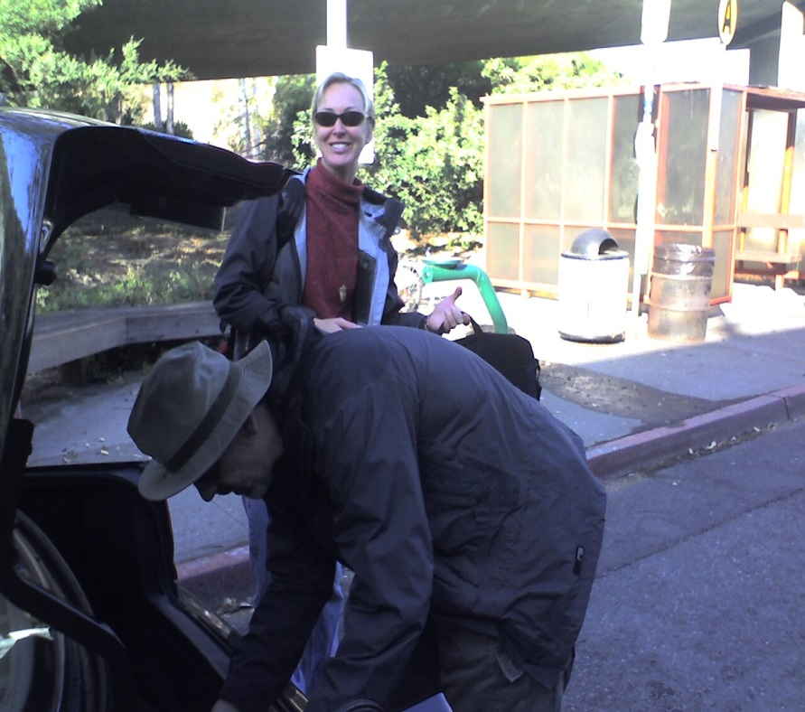
Our trip to Halifax was uneventful – not even any lost luggage. So we picked up our car (it was about 11:00 pm local time – 4 hours ahead of California) and headed out to our motel.

As I’ve mentioned before, the Rolling Stones were in town, playing to 50,000 adoring fans on the Halifax Commons that evening. It was raining, but apparently the Stones were in great form, and even stayed out and took their bows/encores without making a big deal of the weather. (I believe that Kanye West opened for them, but I could be wrong.) The rain and feet turned the Commons into a mire, but apparently a good time was had by all.

Because the Stones fans had filled Halifax local hotels, we were out at a motel in the boondocks – and in fact thought that perhaps the Reception Clerk was at the Stones concert, as it took her about 15 minutes to answer our tired rings. (Not good.) Some other patrons finally showed up and at least let us through the locked door into the lounge area – when the Clerk finally showed up, she looked Quiet Surprised to find folks waiting there for her.

We asked (as their banner promised) for the Special Weekend Fall Rate, and she pretty much laughed in our face, telling us the hundreds of dollars we were paying for that night WAS their Special Rate. Yeah, the special Fleece The Stones Fans Rate….

We proceeded up a couple floors of stairs to our room, with a beautiful view of the U-Haul on one side and the King of Donairs restaurant on the other…

…Which was to be our dinner that night.

What’s a Donair, you ask? It’s, well, sort of a gyro, but with a sweet sweet SWEET white sauce on the meat (and tomato and onions and lettuce). We opted for the take-away Donair Pizza (sauce on the side) and took that back to our room…..mmmmmm-mmmmm! Hey at midnight beggars can’t be (dot dot dot)

MORE >>

Posted by Sandy Shepard at
9/23/2006 5:08 AM | View Comments (0) | Add Comment | Trackbacks (0)

Photos from Seb, Randy, Suzanne and Surrey

And the photos come rollin' in! Hope you enjoy!!
Seb's photos:
http://www.kodakgallery.com/ShareLandingSignin.jsp?Uc=19ozr0ly.bfob069a&Uy=bpy2y6&Upost_signin=Slideshow.jsp%3Fmode%3Dfromshare&Ux=0
one from Suzanne, two from Surrey:
http://www.kodakgallery.com/ShareLandingSignin.jsp?Uc=19ozr0ly.c8m8roku&Uy=ldpqpg&Upost_signin=Slideshow.jsp%3Fmode%3Dfromshare&Ux=0
photos from Randy:
http://www.kodakgallery.com/ShareLandingSignin.jsp?Uc=19ozr0ly.9g6zz12m&Uy=qogh6b&Upost_signin=Slideshow.jsp%3Fmode%3Dfromshare&Ux=0

MORE >>

Posted by Sandy Shepard at
9/22/2006 5:42 PM | View Comments (0) | Add Comment | Trackbacks (0)

Photos from Sue Bird

Great photos from our Rehearsal Dinner, and The Wedding, taken by our officiant, Sue Bird.
http://www.kodakgallery.com/ShareLandingSignin.jsp?Uc=19ozr0ly.9jn4o0ji&Uy=ys0du6&Upost_signin=Slideshow.jsp%3Fmode%3Dfromshare&Ux=0

MORE >>

Posted by Sandy Shepard at
9/20/2006 9:35 PM | View Comments (0) | Add Comment | Trackbacks (0)

More Photos...

Herbert gave his daughter, Analiz, the camera at the wedding — here are the photos. (Plus one from our friends Seb and Randy, of our dance)
http://www.kodakgallery.com/ShareLandingSignin.jsp?Uc=19ozr0ly.3b0ghspq&Uy=p310s8&Upost_signin=Slideshow.jsp%3Fmode%3Dfromshare&Ux=0
Long URL — hopefully you can click on it!
"Wifezilla"

MORE >>

Posted by Sandy Shepard at
9/20/2006 12:08 PM | View Comments (0) | Add Comment | Trackbacks (0)

First Photos from the Wedding

From our friend Emily, who designed and built the WedSite for us. Enjoy!
http://www.kodakgallery.com/I.jsp?c=n0xb61j.8j8ctz1v&x=0&y=-2ix5my

MORE >>

Posted by Sandy Shepard at
9/19/2006 10:49 AM | View Comments (0) | Add Comment | Trackbacks (0)

And here they are!

We only have one photo so far...but here it is!
Wifezilla

MORE >>

Posted by Sandy Shepard at
9/19/2006 7:50 AM | View Comments (2) | Add Comment | Trackbacks (0)

Quote from Gerrie Hatten

There is nothing nobler or more admirable than when two people who see eye to eye keep house as man and wife, confounding their enemies and delighting their friends. (Homer)
May you always confound and delight.

MORE >>

Posted by Sandy Shepard at
9/15/2006 12:51 PM | View Comments (0) | Add Comment | Trackbacks (0)

Another quote!

Last one before the wedding! From Kirsten and Stefan Smith:
Often the difference between a successful marriage and a mediocre one consists of leaving about three or four things a day unsaid.
-Harlan Miller

MORE >>

Posted by Sandy Shepard at
9/15/2006 12:33 PM | View Comments (0) | Add Comment | Trackbacks (0)

The Champagnes.....

We just finished writing our "champagne hand-out" for the wedding. I thought I would paste
it here — in case ANYONE is reading this that is coming to the wedding (smile) who might
want to make their choices ahead of time!!!

++++++++++++++++++++++++++++++

THE CHAMPAGNES

Over the last six months or so we have visited at least a dozen champagne wineries in
Northern California and tasted many different sparkling wines. Tonight we want to
share some of our favorites with you. Below is some information about each
selection. Please feel free to ask for a taste of any (or all) before committing to one,
or go right for a glass if you already know what you like.

Inglenook St. Regis Reserve Brut (alcohol-free) We think this is one of the best-
tasting alcohol-free sparkling wines available. We compared this wine side-by-side with the
Sutter Home Fré Brut and the Ariel Brut Cuvée, and the Inglenook won hands-down! This
wine begins as a premium sparkling wine, crafted with the traditional winemaking techniques
Inglenook has used for over 120 years. The alcohol is gently removed to maintain a smooth,
crisp taste surprisingly similar to a sweeter Champagne.

Chandon Extra Dry Riche Not counting the Inglenook, this is the sweetest champagne
in our line-up. Blended from Pinot Noir, Pinot Meunier, and Chardonnay, with a touch of
Muscat and Pinot Blanc, it has an inviting floral bouquet, a bright, alluring flavor, a velvety-
soft texture, and a long finish. Having preferred brut champagnes in the past, we were
surprised how much we liked this wine. A new favorite!

Gloria Ferrer 2003 Carneros Brut Rosé Our rosé selection for tonight not only has
beautiful color, but a taste and finish that we found more pleasing and well-rounded than the
other rosé champagnes we tasted. Wine Spectator rated the 2002 vintage at 89 points.
“Creamy Pinot Noir and black cherry aromas carry over nicely to the palate in this rich, full-
bodied yet elegantly styled wine. It gains complexity and holds a tight focus right through the
finish.”

Schramsberg 2001 Blanc de Blancs This wine has been our favorite sparkling wine
for a number of years. In 1965, Schramsberg’s Blanc de Blancs was America's first
commercially produced Chardonnay-based sparkling wine. Rated at 90 points in the
Connoisseur’s Guide, “…very keenly on point for Blanc de Blancs.” In 1972, this wine was
served for the Toast to Peace in Beijing, between President Nixon and Premier Chou En-Lai,
and has been receiving medals ever since!

Korbel Natural Premium Champagne Korbel Natural is a very dry, balanced,
delicate sparkling wine that exemplifies the Korbel style. 60% Sonoma County Pinot Noir
and 40% Chardonnay, primarily from the cool Russian River Valley, this wine is crisp,
toasty, lemony. Natural was originally developed by Adolph Heck in the early 1960s as a dry,
sophisticated alternative to the sweet, bulk-processed sparkling wines commonly consumed
at that time.

After the wedding ceremony, we will add the following selections for you to
taste and enjoy:

Korbel Chardonnay Champagne During our wedding champagne hunt, we
uncovered that a well known rival ‘chateaux’ had held a blind tasting with their Tasting
Room staff, and the Korbel Chardonnay Champagne was the overall favorite, outperforming
several wines substantially more expensive and renowned (including their own!) Compare
this wine to our other Chardonnay-based selection, the Schramsberg Blanc de Blancs, and see
for yourself.

Gloria Ferrer Blanc de Noirs Our Blanc de Noirs selection is predominantly made
from hand-harvested Pinot Noir grapes and exhibits a vibrant red fruit character. We like the
creamy palate and rosy hues, which are the result of a small amount of Vin Gris blended into
the base cuvée. We believe this slightly sweeter wine provides a nice contrast to the other
selections in the second half.

Roederer Anderson Valley MV Brut Magnum Roederer Estate builds upon the
centuries-old tradition of fine winemaking of its French parent, Champagne Louis Roederer.
Based on a 70/30 ratio of Chardonnay to Pinot Noir, up to 15% oak-aged reserve wines from
the Estate's cellar are blended to form this “MV” (multi-vintage) cuvée. When we tasted this
wine at Roederer, we were surprised at the difference between the normal .75L bottle and the
1.5L magnum. Even though grapes, process, age, etc. are the same, the character of the
magnum is very different. We found it softer and creamier than the smaller bottle, with a
cleaner finish. The winemaker explained that premium wines almost always taste better in
larger bottles. Rated by Wine Spectator at 90 points, they find this wine "Smooth, rich and
creamy, with spicy pear, fig, melon and honeysuckle flavors that are fresh and lively, ending
with a tasty burst of ripe fruit.”

Gloria Ferrer 1989 Carneros ETS A special Wine Library release from Gloria Ferrer
in Sonoma, this very old vintage is only available at the winery’s Tasting Room. We found
this wine to be quite different than any other sparkling wine we had tasted, and must say that
it is not exactly our favorite. We decided to include it in tonight’s lineup as it may hint at
what champagne aged for many years might taste like, and it provides something new for the
champagne lover who has Tried Everything! Ask for a taste and see what you think.

CHAMPAGNE 101 Champagne celebrates life. From christening ships to toasting Love,
no other beverage is more versatile, fun or intriguing. Champagne owes all of its superlative
attributes to its unique characteristic—bubbles! Bubbles are key to the quality of champagne.
Although there are several different methods for making sparkling wines, the best are made
following the méthode champenoise.

This traditional way of making sparkling wine was developed in France's Champagne region
during the 17th and 18th centuries. The "champagne method" consists of taking still wines and
blending them to make a cuvée that represents the style of the winery or champagne house. A
complex cuvée can consist of as many as thirty to forty different wines. Once the various
wines are blended in large blending vats, a bottling dosage (also known as dosage d'tirage or
liqueur d'tirage), a syrupy mixture of sugar and wine, is added, along with special yeasts.

The cuvée is then immediately bottled and capped. The yeast and sugar in the bottling dosage
cause a secondary fermentation to take place in the bottle. This creates additional alcohol and
carbon dioxide, which gives the wine its effervescence or "sparkle." During the secondary
fermentation, the pressure in the bottle reaches as much as 110 psi. Less dosage results in less
pressure, producing a lightly sparkling wine style called crémant.

Champagnes are aged on the yeast for up to four years, depending on the cuvée style. After
aging is complete, the bottles go through the riddling (remuage) process. The bottles are
slowly tipped from horizontal to vertical over a period of four to five weeks, and slightly
turned once each day to work the sediment (mostly dead yeast) down into the neck.

The bottles are then disgorged, a process which begins by dipping them, neck down, into a
brine solution at zero degrees to freeze the sediment into a plug. The cap is then removed,
which causes the pressure in the bottle to push out the yeast plug. Finally, the shipping
dosage is added and the bottles are corked and caged.

The shipping dosage (or liqueur d'expédition) consists of sugar and some of the same cuvée.
The amount of sugar determines the degree of sweetness in the final wine. From dry to sweet,
sparkling wines are classified as brut, extra dry (or extra-sec), sec, demi-sec, and doux.

MORE >>

Posted by Sandy Shepard at
9/12/2006 6:47 PM | View Comments (0) | Add Comment | Trackbacks (0)

It's Only Rock and Roll . . . But I....Like It??. . .

You know, some things just make you laugh.
When we were getting the room "block" reservations for the wedding date, we had a hard time — because Elton John is in town, and a lot of people fly in to see him and then hang out. I believe it's at the Coliseum (big venue, so lots of folks). It's also the day that the So You Think You Can Dance dancers are doing their exhibition in Oakland . . . I even tried to get tickets for that (so sue me, get married, get to the Paramount) but the teeny-boppers and Benji-philes had all scooped up the tickets in the first 11 minutes.
SO NOW, we are finally getting around to trying to book our hotel reservations for the honeymoon. We got the "bones" (the travel/train/boat/plane) stuff done ages ago, but — hey, we're going to Halifax, what kinda trouble are we going to have, right?
Um....
Yeah, wait for it.
Call hotel one. Booked. Call hotel two. LAUGHTER, and booked. Call hotel....11, 12.....
The STONES.
the STONES are playing in HALIFAX, the weekend that we are flying in.
Could I make this up???
Is this like "old rock and rollers thwarting the Shepard/Wolfram Adventure" or what?
Next thing I hear, it's going to be like Blue Oyster Cult in Quebec City or Peter Frampton in Montreal....
xx S

MORE >>

Posted by Sandy Shepard at
9/7/2006 5:49 PM | View Comments (0) | Add Comment | Trackbacks (0)

More Photos with the Fantabulous Surrey Blackburn (surreyblackburnphoto.com)

This will be interesting...tell me if this very VERY long link works:
http://www.kodakgallery.com/ShareLandingSignin.jsp?Uc=19ozr0ly.37qbnhue&Uy=-5d8n2t&Upost_signin=Slideshow.jsp%3Fmode%3Dfromshare&Ux=0&UV=818568257810_743908661206
(you might need to cut and paste it into your browser).
Photos of H and me down in Pacifica — we went down to take "beach photos" with Surrey but the weather didn't quite cooperate — so instead we had these fantastic photos in her very photogenic garden!
Isn't she the BEST?
P.S.: OK don't bust my chops about how short the pink dress was when I sat in Herbert's lap. I know. I know.

MORE >>

Posted by Sandy Shepard at
9/4/2006 5:45 PM | View Comments (1) | Add Comment | Trackbacks (0)

Poem from JoAnn Baldwin

A Reading from The Irrational Season by Madeleine L'Engle

Ultimately there comes a time when a decision must be made. Ultimately two people who love each other must ask
themselves how much they hope for as their love grows and deepens, and how much risk they are willing to take.
It is indeed a fearful gamble. Because it is the nature of love to create, a marriage itself is something which has to be created.

To marry is the biggest risk in human relations that a person can take. If we commit ourselves to one person for life this is not, as many people think, a rejection of freedom: rather it demands the courage to move into all the risks of freedom, and the risk of love which is permanent: into that love which is not possession but participation. It takes a lifetime to learn another person.
When love is not a possession, but participation, then it is part of that co-creation which is our human calling.

MORE >>

Posted by Sandy Shepard at
9/4/2006 1:20 PM | View Comments (0) | Add Comment | Trackbacks (0)

Poem From Jacqueline and Yoram Arbel

May these vows and this marriage be blessed.
May it be sweet milk,
this marriage, like wine and halvah.
May this marriage offer fruit and shade like the date palm.
May this marriage be full of laughter; every day a day in paradise.
May this marriage be a sign of compassion and a seal of happiness here and hereafter.
May this marriage have a fair face and a good name; an omen as welcome as the moon in a clear evening sky.
May spirit enter and mingle in this marriage. I fall silent, for words cannot describe the spirit.
by Jalal Al-Din Rumi, 13th century Persian poet and founder of Sufism.

MORE >>

Posted by Sandy Shepard at
9/3/2006 11:45 AM | View Comments (0) | Add Comment | Trackbacks (0)

New Poem...

from Nancy Morgan and Mary Beth Davis

poem by Evan Covell Roberts

Begin.
Make a Circle
with your life.
Live within it.
Blossom and bear fruit
in sunlit happiness.

Later
test the edges.
Now and again
press against the high walls
of your circumscribed world.

Then
one day
break through,
leap free
of your fullness
into the emptiness
of the next, great

Beginning.

MORE >>

Posted by Sandy Shepard at
9/1/2006 4:40 PM | View Comments (0) | Add Comment | Trackbacks (0)

Our First Dance....

So, lots of folks are wondering our "first dance" is going to be. Well, it's going to either be me falling flat on my face (ta-DA!!!), or ... it's gunna be fun.
If you want to hear the music to our first dance (really a medley of 3 dances), it's here:
http://www.musync.com/sandy_one_track.mp3
It takes a bit to download — but it's worth it
Ginger and Fred

MORE >>

Posted by Sandy Shepard at
8/31/2006 4:42 PM | View Comments (0) | Add Comment | Trackbacks (0)

Who Is This Young, Cute Couple???

Who Are These Babies?
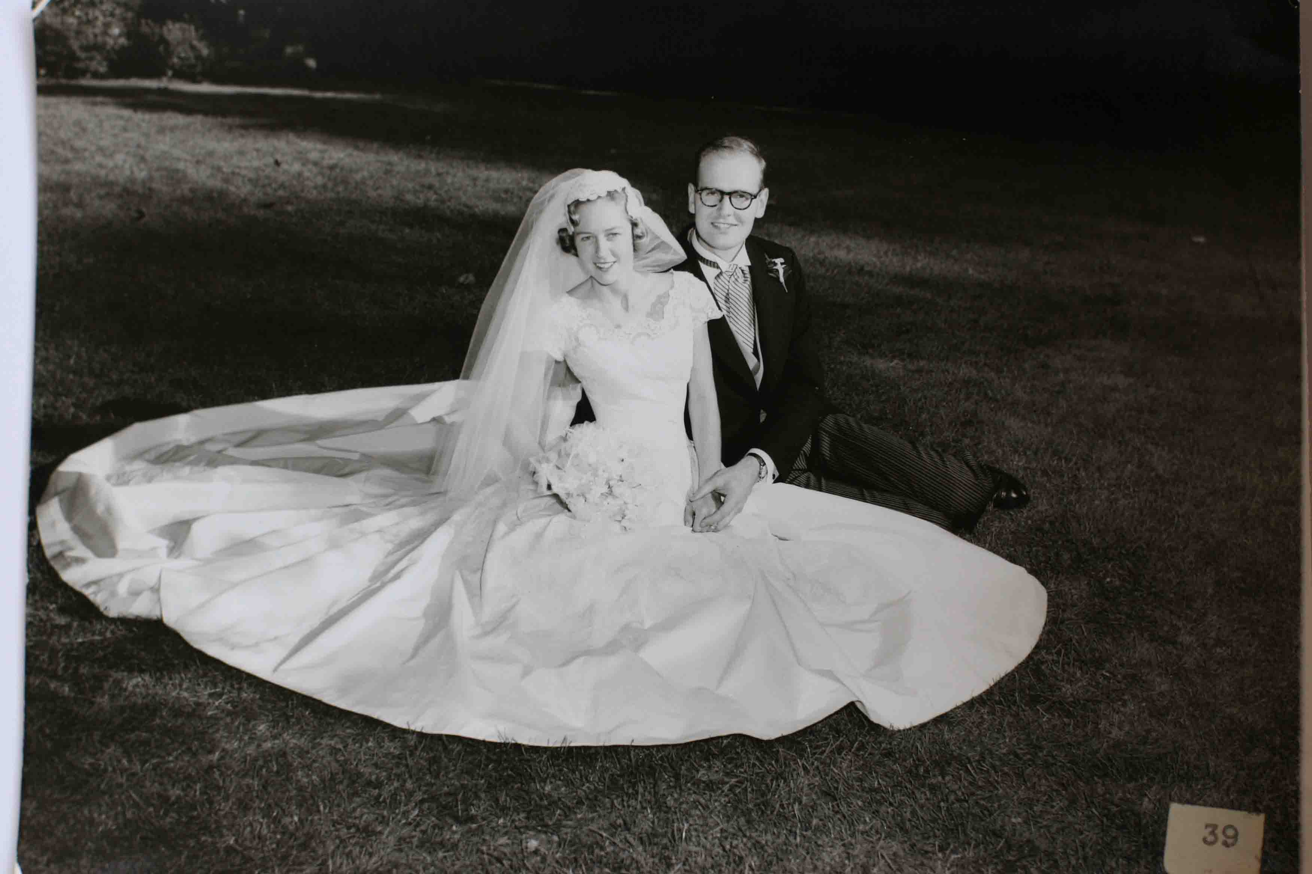 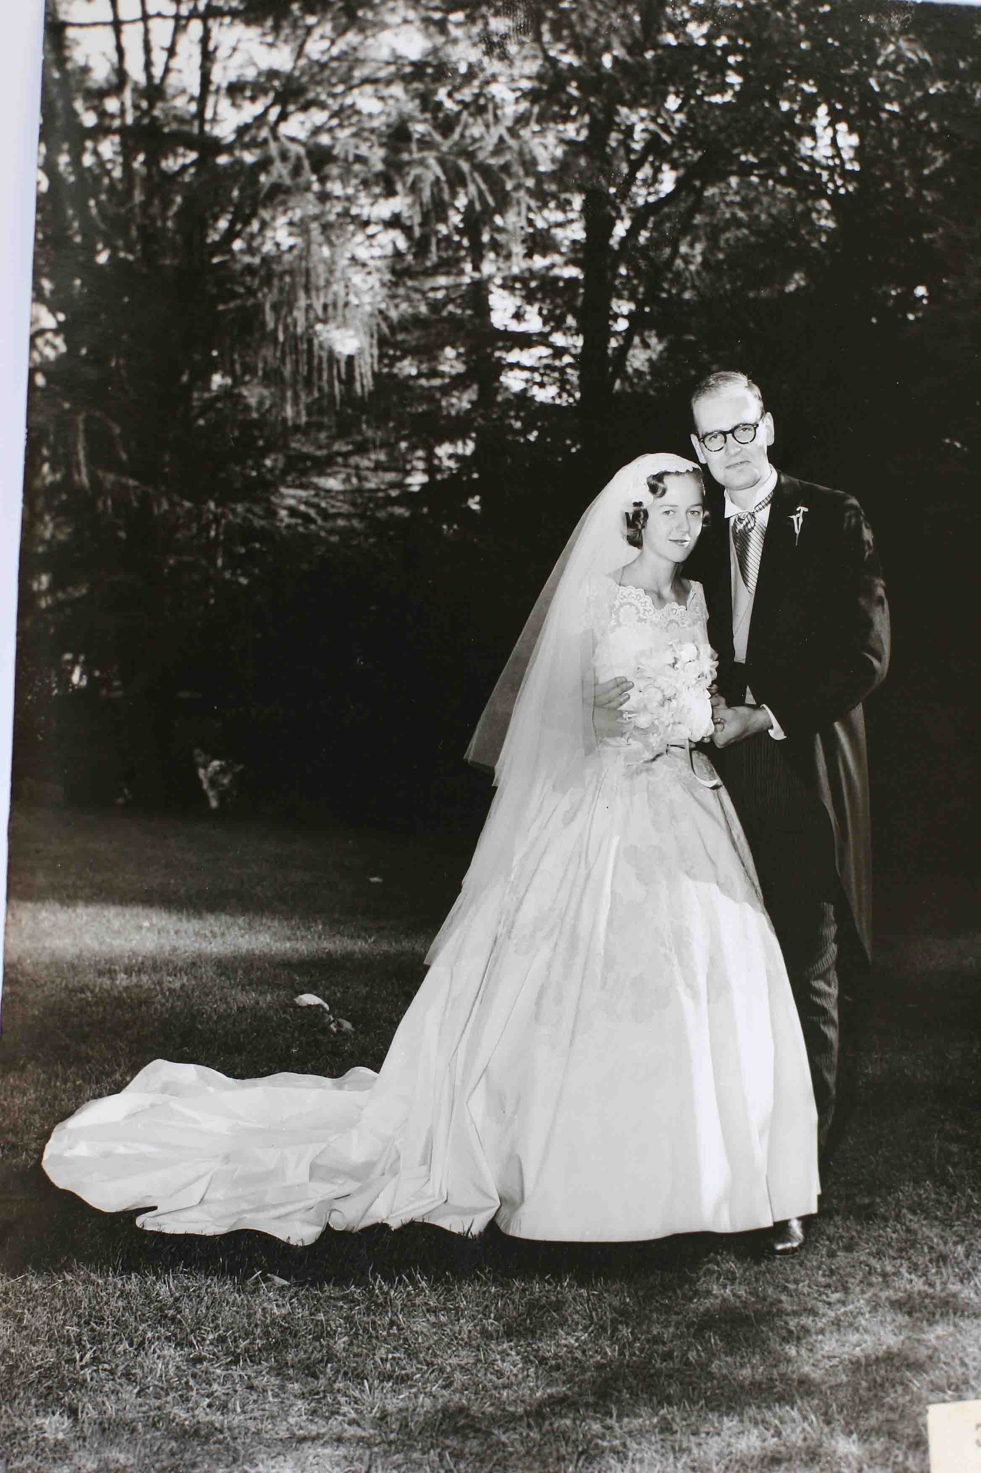
My goodness! It must be . . . Mom and Dad! (Such a shame that, because we will be ballroom dancing in the dress, we had to totally remove the train. Pretty, isn't it? Anyone need a blanket made out of white satin?)
[Courtesy of Surrey Blackburn Photo: www.surreyblackburnphoto.com]

MORE >>

Posted by Sandy Shepard at
8/28/2006 5:08 PM | View Comments (0) | Add Comment | Trackbacks (0)

New Quotes

I thought that we should start a new entry for the latest quotes, instead of putting them all in the previous one:
"Earth is crammed with Heaven" (Elizabeth Barrett Browning, from a card by Shend Diamond, LikeMindsPress.com) this is my favorite quote right now. Love Shendl's cards too — beautifully cut. Think I mentioned she is doing our ketubah.
"Marriage, they thought, was 'unnatural.' Marriage was only tolerable for people of strong character and independent minds if it were regarded as a lifetime association between intimate friends. It was a bond that should last only as long as both wanted it to. But as a happy marriage is the 'greatest of human benefits,' husband and wife must strive hard for its success. Each must be supple enough, subtle enough, to mould their characters and behaviour to fit the other's, facet to facet, convex to concave. The husband must develop the feminine side of his nature, the wife her masculine side. He must cultivate the qualities of sympathy and intuition; she those of detachment, reason, and decision. He must respond to tears; she must not miss trains." ("Portrait of A Marriage: Vita Sackville-West & Harold Nicolson," by Nigel Nicolson, provided by Janice Legow)

MORE >>

Posted by Sandy Shepard at
8/27/2006 3:09 PM | View Comments (0) | Add Comment | Trackbacks (0)

Surrey Blackburn -- SurreyBlackburnPhoto.com

My AWESOME photographer (you must use her — she has taken photos of my pets, me for headshots, etc. — and she's the Best of the Best) — Surrey Blackburn has taken pity on me — and forwarded me a few "wee snapshots" she took when she visited the wedding site with me a few weeks ago. So, just ignore the blurry shots below — here are the REAL shots, from my fabulous photographer!
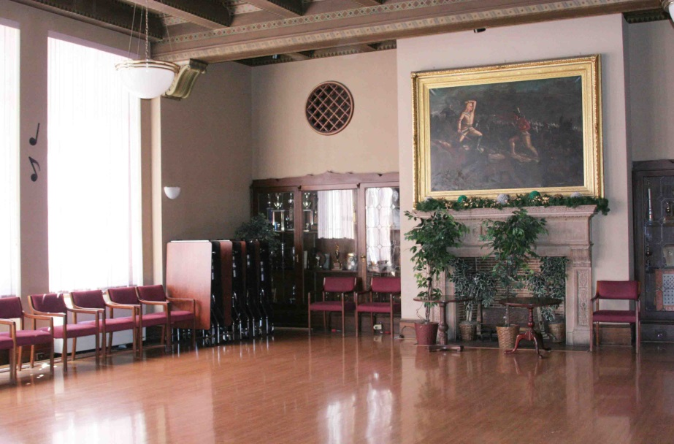
ze "Custer's Last Stand" mantle (where the cake will be, in the Den)
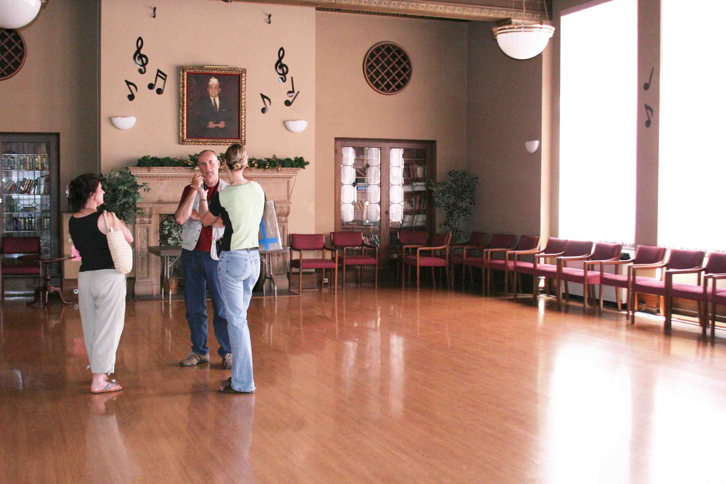
Carla (my florist) and me speaking with Dan, the facilities guy and DJ, whom we have yet to see again. (You don't REALLY want to know, right??)
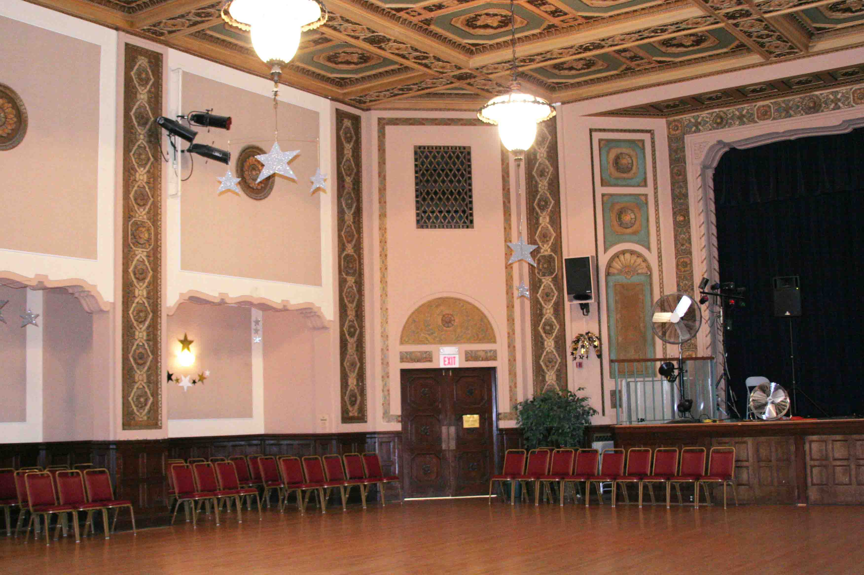
Main Ballroom, looking from the entry door, to the left of the stage.
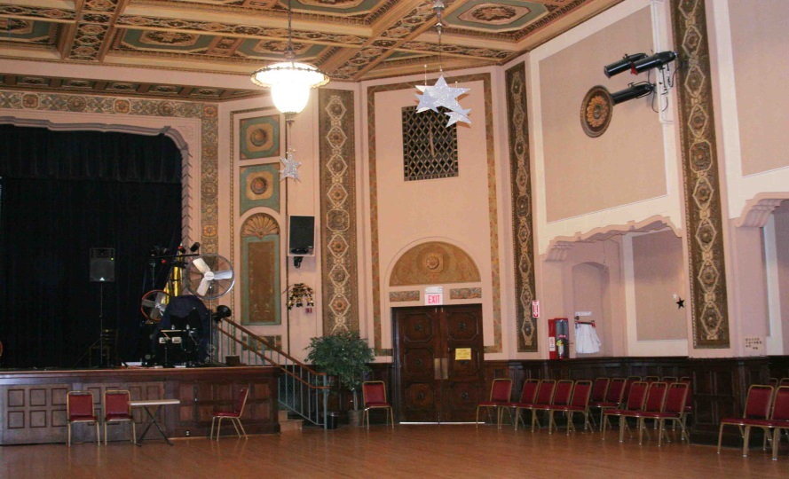
Main Ballroom, to the right of the stage. See how pretty the ceiling is?

MORE >>

Posted by Sandy Shepard at
8/22/2006 6:11 PM | View Comments (0) | Add Comment | Trackbacks (0)

S Factor

So, a while back, I was watching Oprah,
and she had a section on Sheila Kelley's S-Factor.
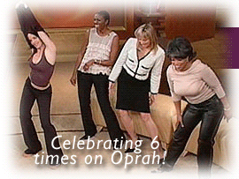 (That's Sheila, on the left, and the "girrls" doing hip circles.) If you go to www.sfactor.com you can read all about it — it's a workout based on, as you probably guessed, pole dancing. When I first started at S-Factor, I could do all the moves...but if I did, I couldn't move at all the next day! It's a serious workout. Then, of course, the pole tricks are a gas! (I have been warned that I have to "quit doing this" at least a month before the wedding — as in, now — so that the bruises have time to heal!)
I have also taken classes with Virginia at "A Pole Lotta Fun" (she will even come to your house )
My second-to-last S-Factor class was last night — I'm getting sad, since I'm not sure when I will be able to pick it back up again, and I really loved my teacher. She won't be there for our last class. Then again, instead of being sad, there is always the idea of asking for a pole as a wedding present . . . hmmmm, for those of you who keep saying "Gee, we don't want to give 'cash'," how's about chipping in on the Registry for a Home Pole Kit? Now that we would not need to return!
Don't scroll down if you don't want to scare the horses and small children...it's Flying Bridezilla!
(This is after climbing up to the ceiling at Studio B, which is a looooong way up. Maybe 2 stories?) Sorry guys — no poles at the wedding...the ceiling is just too tall to anchor the top. Drats.

MORE >>

Posted by Sandy Shepard at
8/17/2006 3:05 PM | View Comments (0) | Add Comment | Trackbacks (0)

The Incredible Nancy Mimms!!!!

This is my plug for the Incredible Nancy Mimms (415-485-1052; dancenance@earthlink.net).
(OK, yes, she is like a foot shorter than I am, but she can kick my booty all over town.) Nancy was my Pilates instructor, and I asked her to help me "get in shape" (read: Turn from a Size 12 into a Size 5) for the wedding. She took on this daunting task, and we have been working together for a few months....
...after the wedding, I will have to take over as the Governor of California, with all my muscles, isn't that the career path???
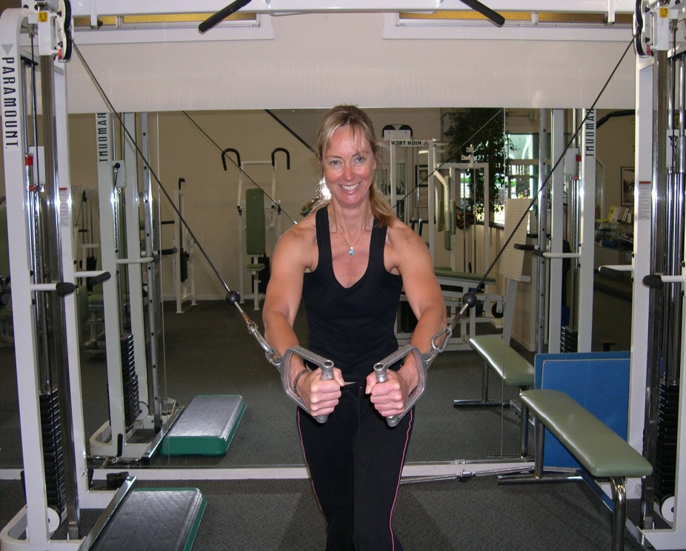
So if you're local, whether you're a guy...girl...in your house...in a gym...time to call Ms. Mimms if you want the best body of your life!

MORE >>

Posted by Sandy Shepard at
8/16/2006 9:45 AM | View Comments (0) | Add Comment | Trackbacks (0)

Photos of the Venue

We were at the venue the other day, and a couple of you have asked me "what it looks like." So I thought I would post some of the pictures, even though they're not the greatest.
The Lake Merritt Dance Center is an ex-Veterans' Memorial place, from about the 40's. The reason I love it is it has the huge ballroom floor, but also I love the ceilings in the place. The Main Ballroom is so big, though, that I'm afraid that our "little" wedding is going to look puny (I think that the Main Ballroom can hold like 500 people dancing without a problem!)
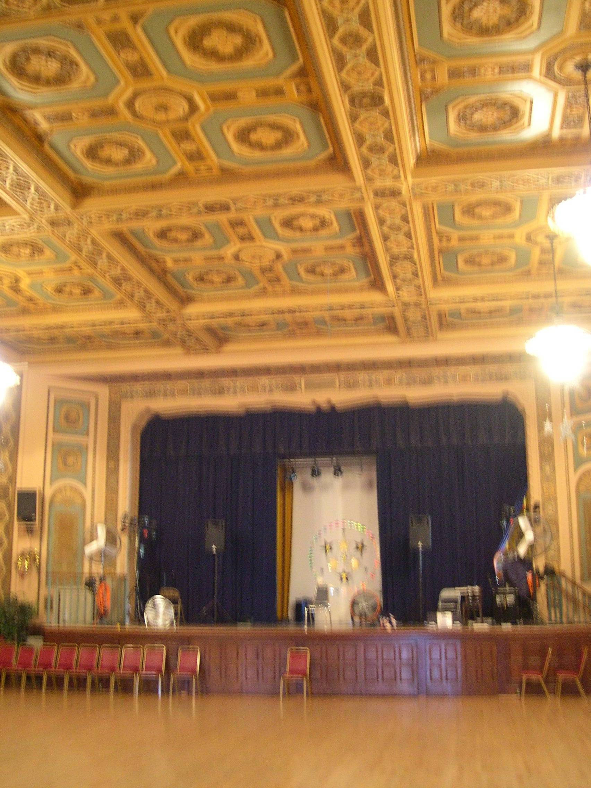 You kinda get the idea... 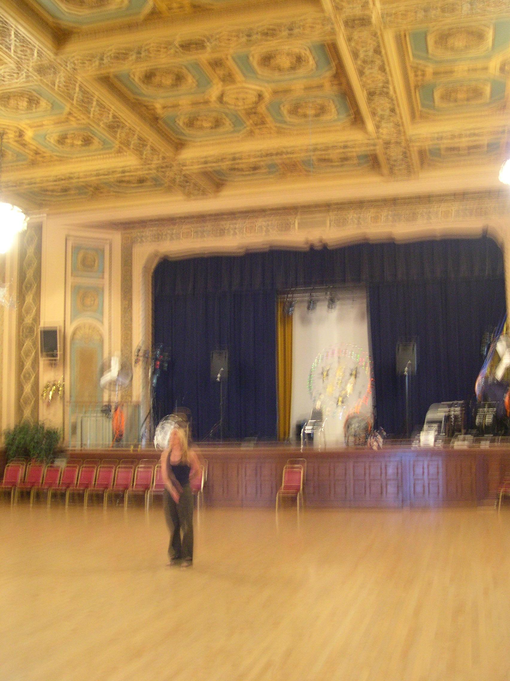
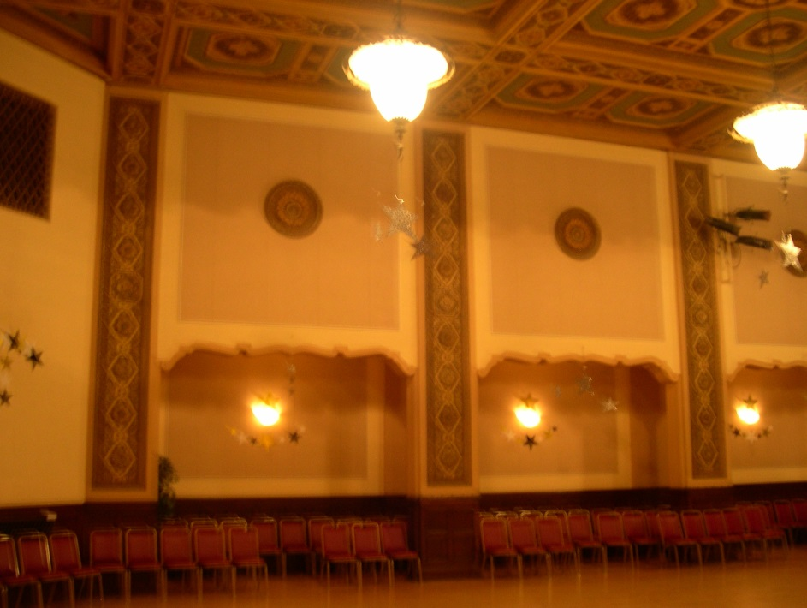 These are the side walls, and the hanging lamps. OK, yes, I obviously don't know how to take a photograph to save my life...
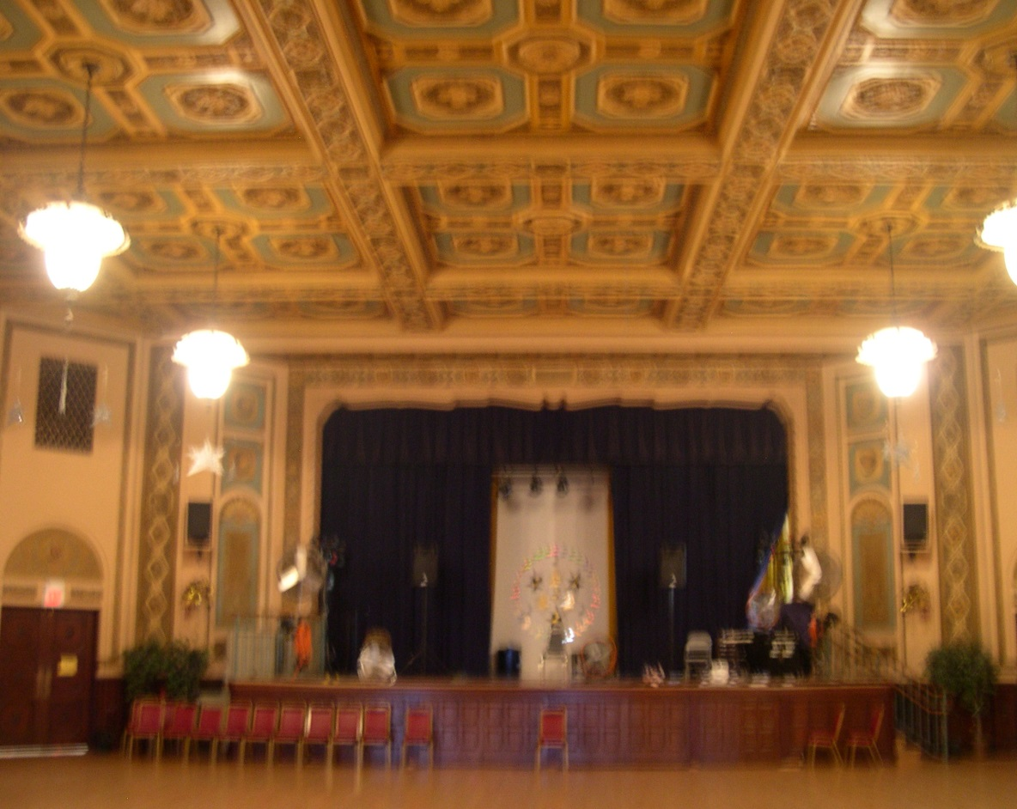 Wow, I thought these photos were better than they are...bad me, sure glad I'm the Bride not the Photographer!
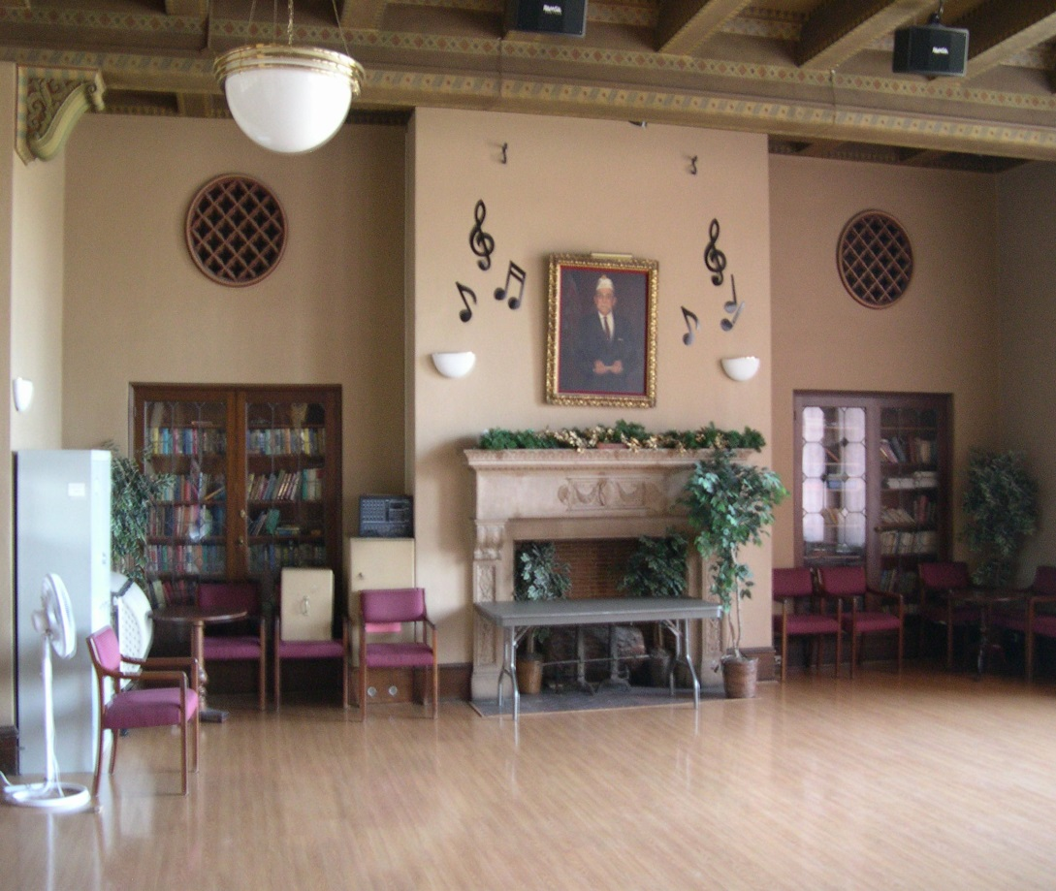 This is the room that the food/cake will be in — this is looking one direction (towards the "dead white guy" oil — there is one of Custer's Last Stand on the other wall!).
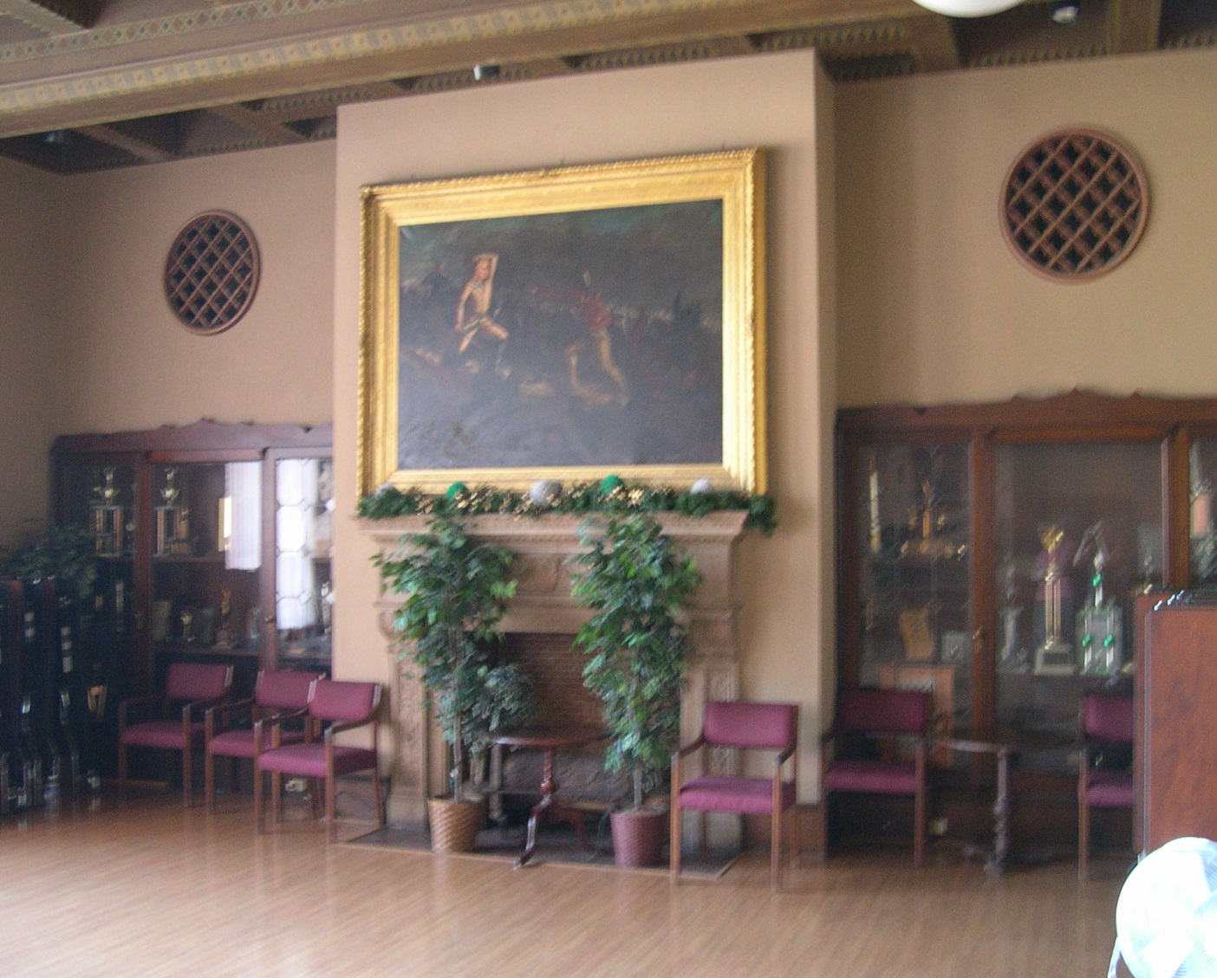
The room is as long as the Main Ballroom, just not as wide (it's 60x100, the Main Ballroom is 100x100). I did try to take another photo out the windows (which is what you see from the "front" of the building, which I posted earlier), but the sun was streaming right in over the Lake, so it didn't come out, as you can see:
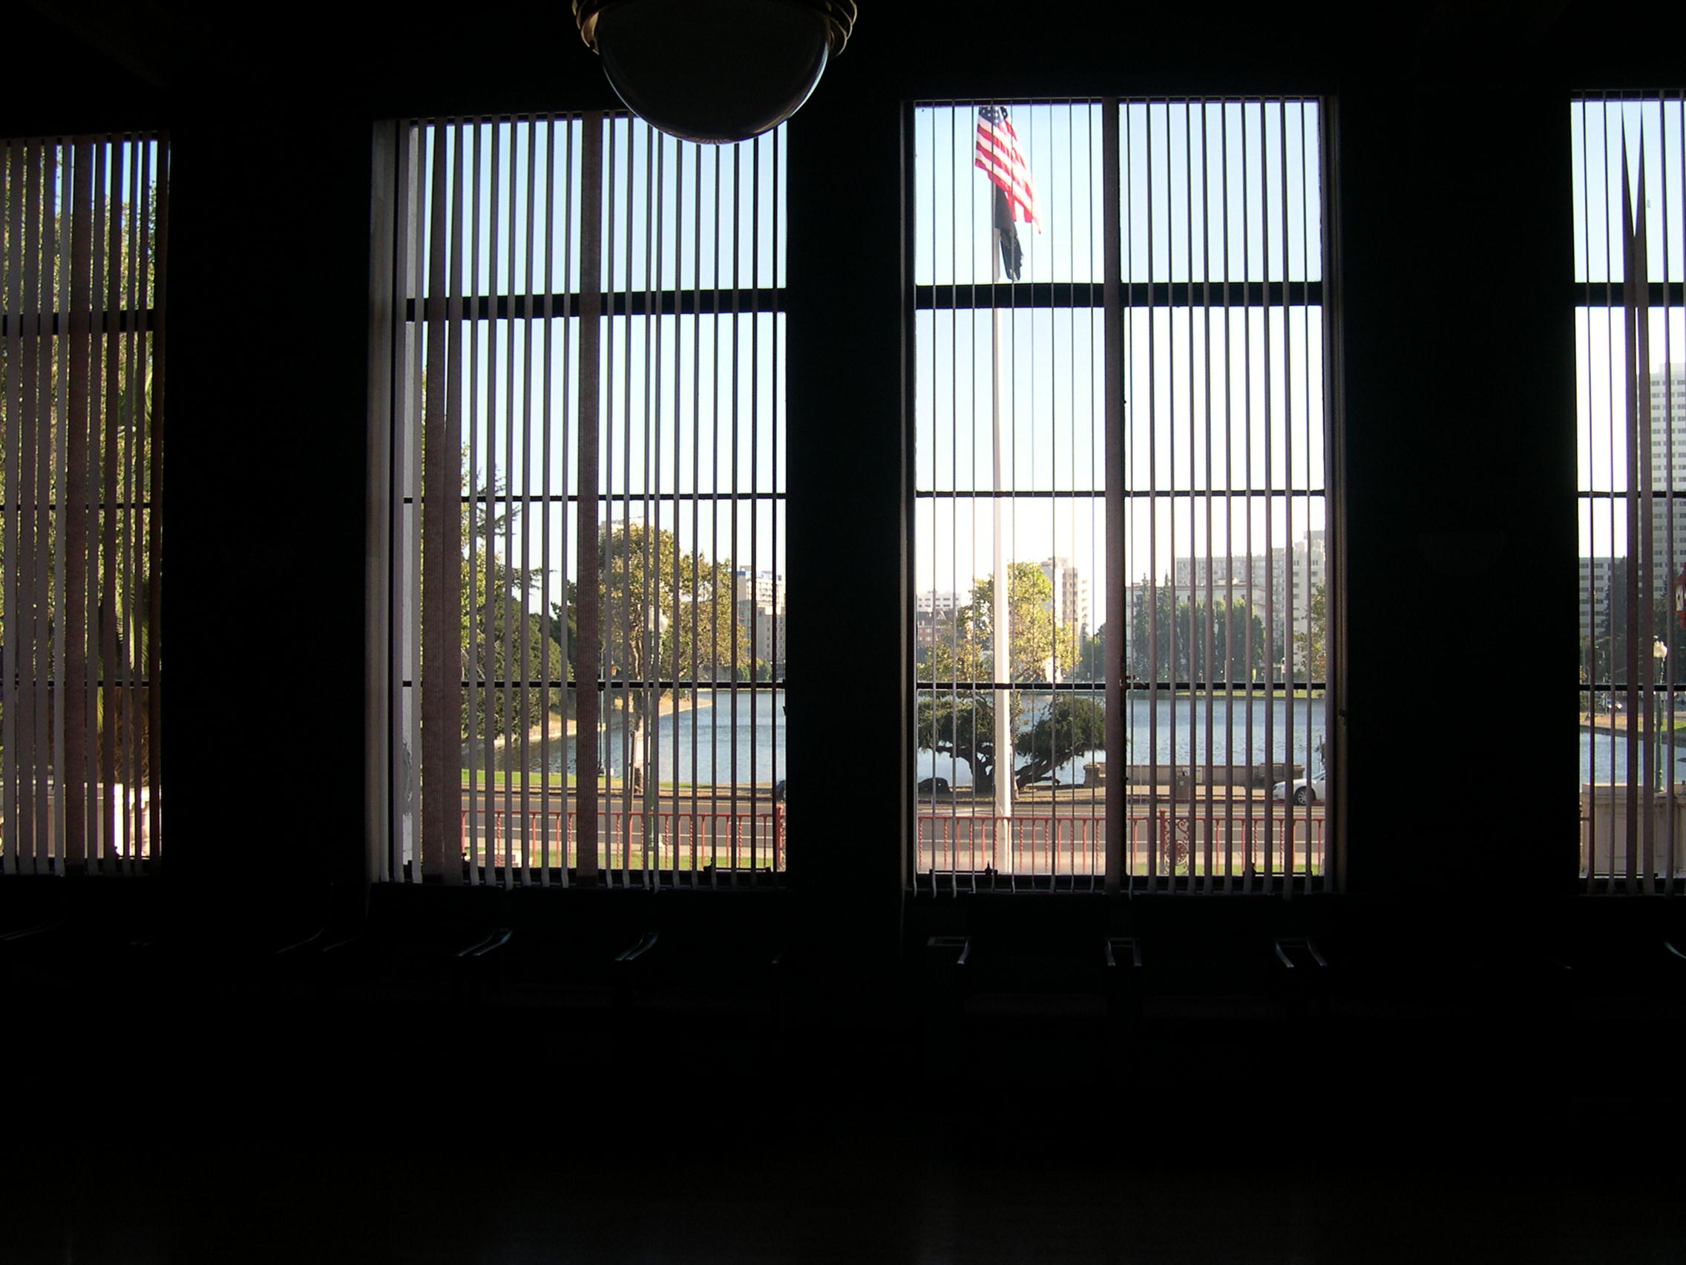
So there you have it, in some very blurry but well-intentioned photographs!

MORE >>

Posted by Sandy Shepard at
8/16/2006 9:25 AM | View Comments (0) | Add Comment | Trackbacks (0)

Cake Tasting...Dinners Out...Am I Still Going To Fit In The Dress?

So, we have decided on the Cake. Yay! On Monday, we met with Kay at Beaux Gateaux (www.beauxgateaux.com) to do the whole 'wedding cake tasting thang.' The assortment was:
1. white cake with a fresh young coconut filling and a fresh mango filling;
2. Italian wedding cake with a mocha filling and an apricot filling;
3. Italian wedding cake with a marsala/marscapone filling and a dark chocolate filling (think like Tiramasu);
4. Almond cake with a raspberry jam and raspberry whipped cream;
5. Dark chocolate, with a whipped cream and...somethin' else filling
We also brought my wedding "helmet" , because what we would like to do is have flowers on the cake (3 tiers), but to have the cake itself be "embossed" with the same sort of lace as the dress (and "helmet"), same sort of color too. Here is Dad in the "helmet"!
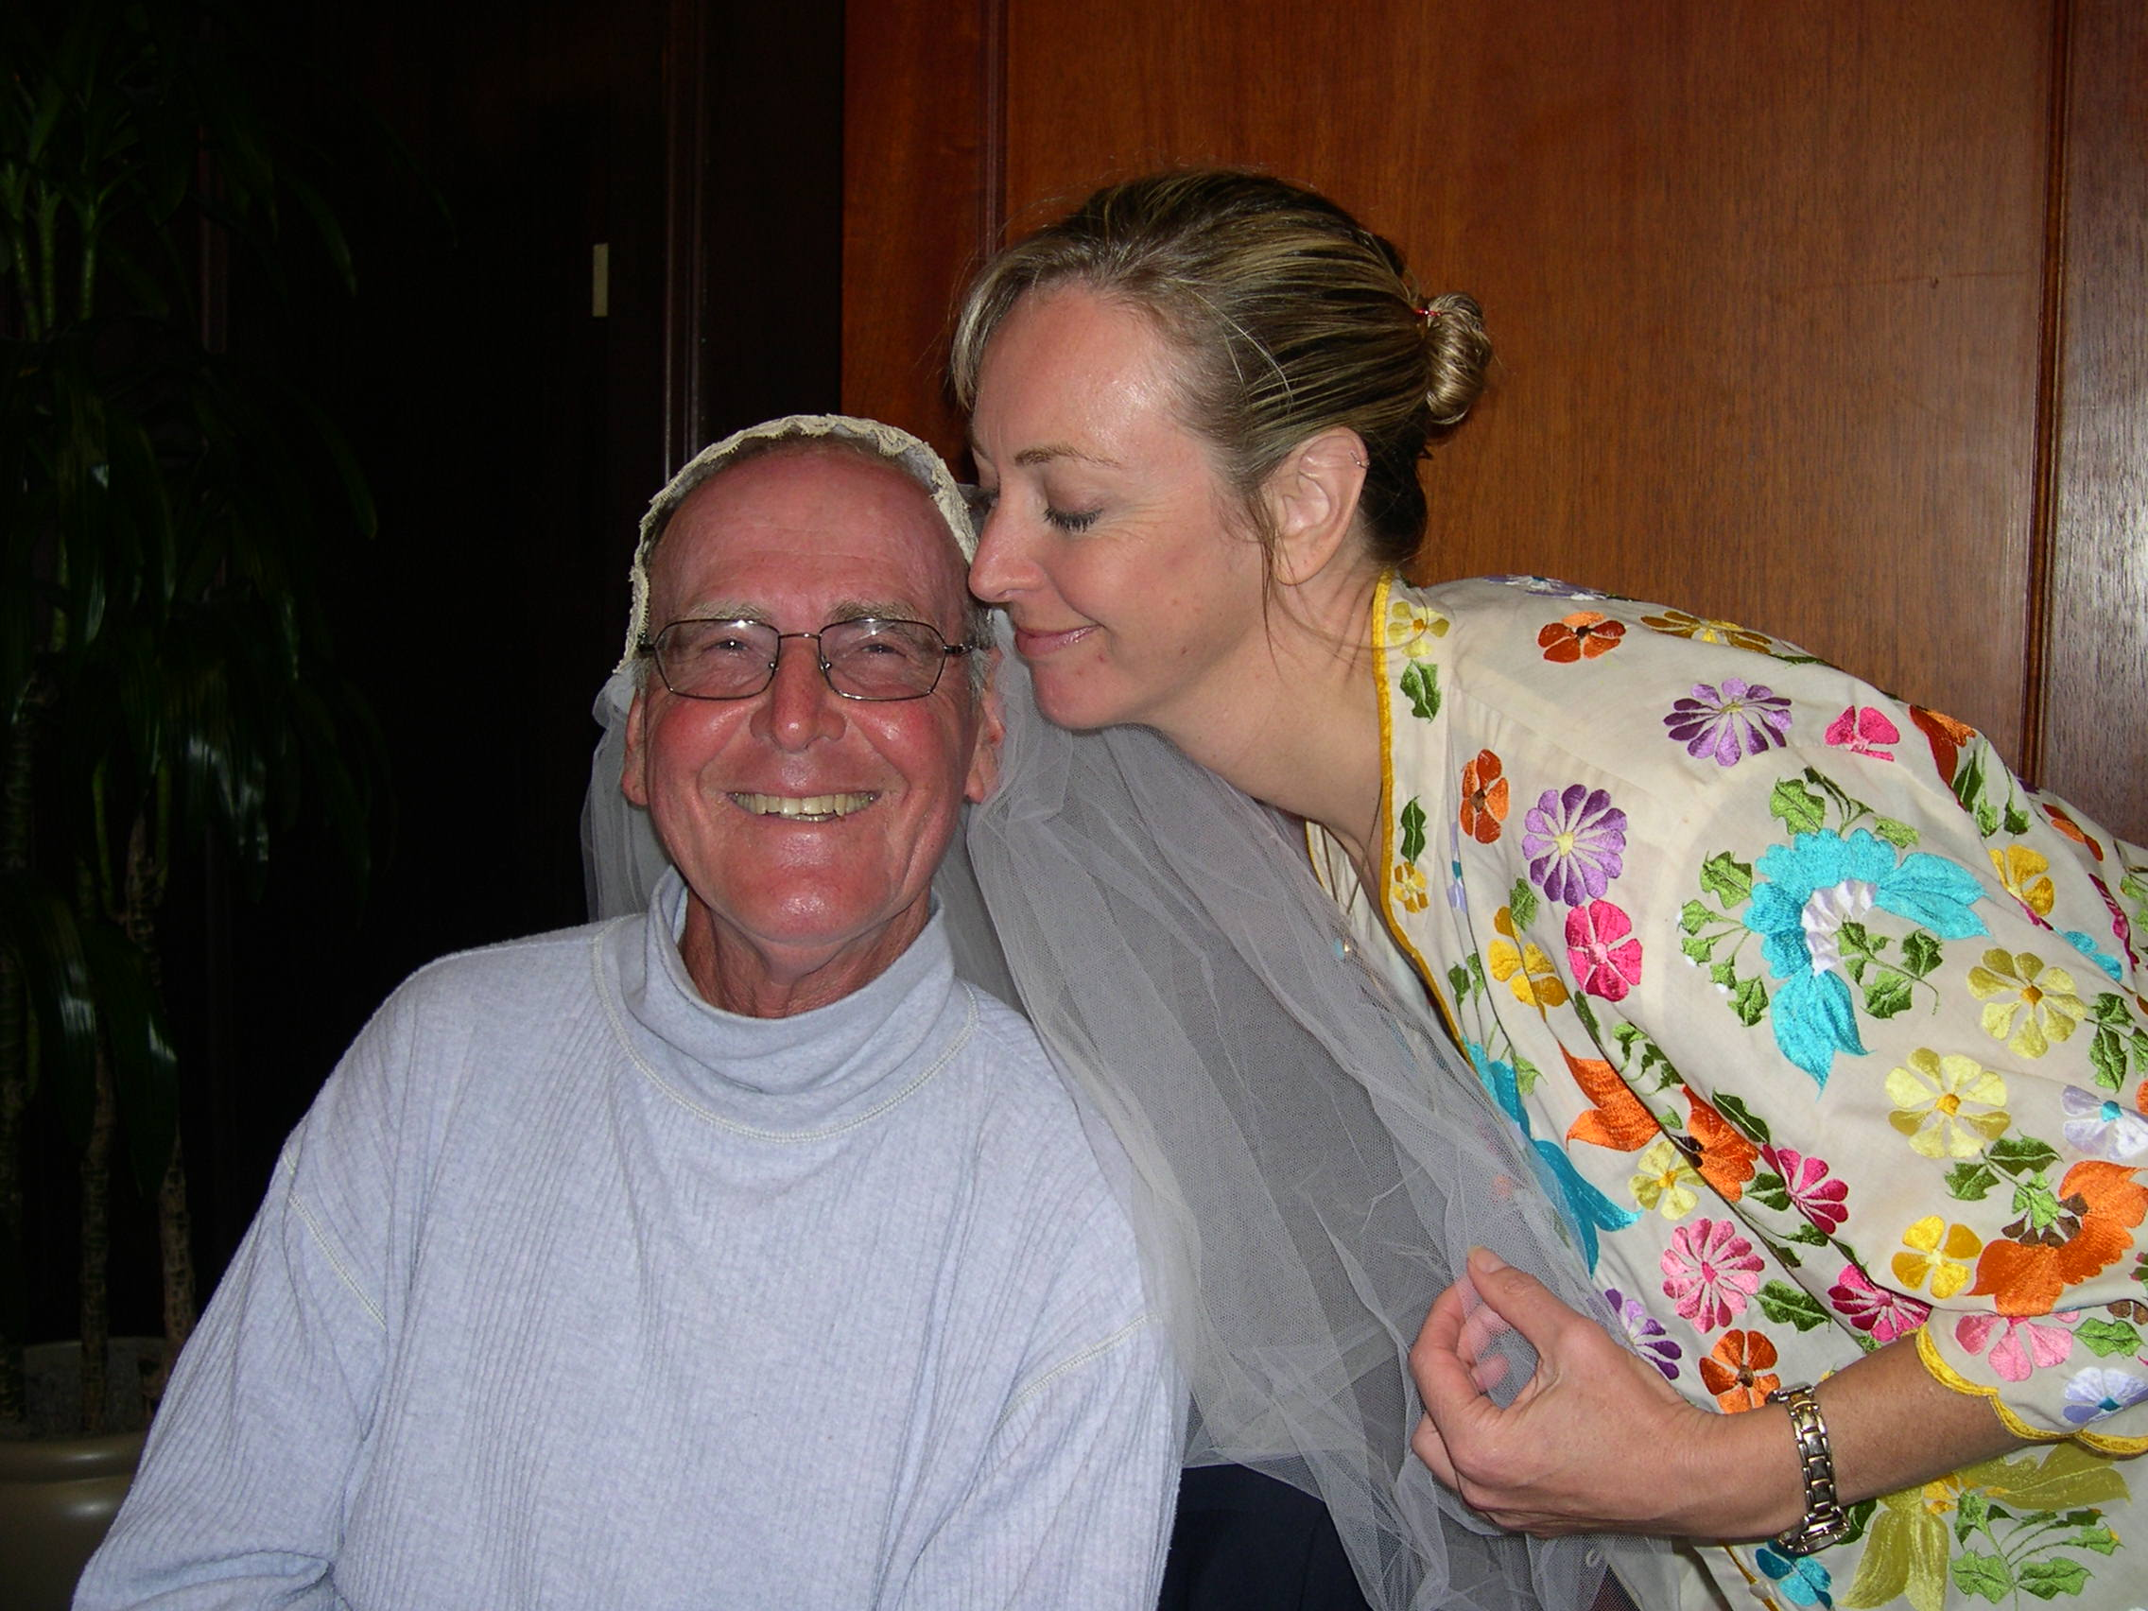
We decided (after LOTS AND LOTS of tasting of course!) on the Tirimasu-like one - but we're going to have a mocha/rum whipped filling, instead of the marsala/marscapone cream one. Yum!
*****
We also recently had Pete (Herbert's boss) and Sheila (a work compatriot) take us out to an amazing dinner at Lark Creek Inn.
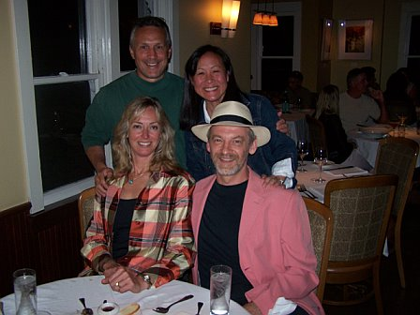
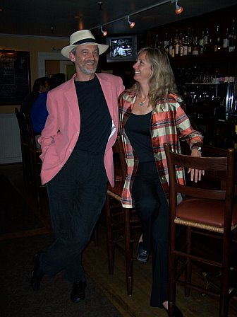 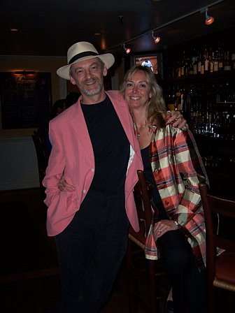
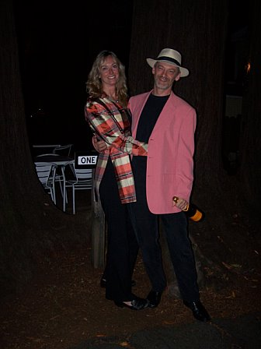
It was like 5 courses, including cheese and desserts! (FABULOUS — thank you Sheila and Pete!) So the BIG question is — am I still going to fit in The Dress on my last fitting on the 24th???

MORE >>

Posted by Sandy Shepard at
8/16/2006 9:04 AM | View Comments (0) | Add Comment | Trackbacks (0)

A Quote from the Princess Bride...

This one's from my grrlfriend Jennifer Morris. I have received a number of shorter quotes — I am adding those to the email below entitled "Quotes" (so you might scan that, if you're interested to see the new ones). Yesterday we went to the Dance Center and I have some photos to upload — just gotta find the darned cable! xx S
here ya go, the quote that seemed most appropriate to me:

"This is true love - you think this happens every day?"

...and the context. from the Princess Bride, the best book about true love ever

Westley: Hear this now: I will always come for you.
Buttercup: But how can you be sure?
Westley: This is true love - you think this happens every day?

Westley: I told you I would always come for you. Why didn't you wait for me?
Buttercup: Well... you were dead.
Westley: Death cannot stop true love. All it can do is delay it for a while.
Buttercup: I will never doubt again.
Westley: There will never be a need.

of course, there is also

Miracle Max: Sonny, true love is the greatest thing, in the world-except for a nice MLT - mutton, lettuce and tomato sandwich, where the mutton is nice and lean and the tomato is ripe

MORE >>

Posted by Sandy Shepard at
8/15/2006 1:29 PM | View Comments (0) | Add Comment | Trackbacks (0)

Why September 16th?

We have had a number of people ask us why we chose September 16th as our wedding date.
Back EIGHTEEN MONTHS AGO when we went to book the venue (wow, who knew that it would fly by so fast!), we were told that there were only 2 dates in 2006 available in the Fall — September 16th and October 7th. As my parents will be celebrating their "40-high-th" anniversary on October 4th, I thought that October 7th would be a great date. They seem to have done pretty well, and so having an anniversary close to their Date sounded good to me.
However, there was one thing that I was forgetting...this is about how the conversation went...
Sandy: "...so, either September 16th or October 7th. Because Mom and Dad's anny will be close to the 7th, what do you think? Would that work?"
Herbert: "Ah, think again, little Princess Grasshoppah. You LOVE your birthday [September 22nd]. In fact, you are a serious Birthday Princess. So, tell me this. In 2006, on your birthday, which you love, would you rather (a) be on your honeymoon lolling around drinking champagne and eating bonbons or (b) counting down 10 days to the Wedding from Hell?"
Sandy: "September 16th it is."
So there you have it — why we picked September 16th.

MORE >>

Posted by Sandy Shepard at
8/9/2006 1:21 PM | View Comments (0) | Add Comment | Trackbacks (0)

Rules for a Happy Married Life...

From our Friends Aldo and Sharon, who just got married about a month ago (you can see Aldo, Herbert and me in a photo if you scroll down a bit)
1. Never both be angry at once.
2. Never yell at each other unless the house is on fire.
3. Yield to the wishes of the other as an exercise in self-discipline if you can't think of a better reason.
4. If you have a choice between making yourself or your mate look good, choose your mate.
5. If you have any criticism, make it lovingly.
6. Never bring up a mistake of the past.
7. Neglect the whole world rather than each other.
8. Never let the day end without saying at least one kind or complimentary thing to your life's partner.
9. Never meet without an affectionate welcome.
10. Never let the sun go down on an argument unresolved.
11. When you err, make sure you talk it out and ask for forgiveness.
12. Remember, it takes two to make a quarrel. The one with the least sense is the one who will be doing the most talking.
Congratulations and enjoy the journey.....

MORE >>

Posted by Sandy Shepard at
8/9/2006 1:20 PM | View Comments (0) | Add Comment | Trackbacks (0)

Update for Today: "Signing Statement" and the Poem "Once" from my friend Marthe Reed

In finalizing the language for our ketubah (you can see it on the previous post), Herbert has decided that he wants to be like Mr. George W. Bush, and have the ability to have a "signing statement" go along with it. Um...no
My roommate from UCSD submitted the following poem for our "Hat." It's amazing — I believe she's been married happily for about 20 years now — our marriage in fact prompted me to go back in scrapbooks and look at her wedding oh-so-many years ago, on the bluffs overlooking Torrey Pines. We were just children
Marthe writes that this poem is by Eavan Boland, "looking forward from 30 years of marriage. An Irish poet, she writes from the vantage of Dundrum, a suburb of Dublin, and from the weight of Ireland's history." She ended that "...The milk bottles remind me of your year in Exeter." Marthe came to visit me when I was abroad studying at the University of Exeter - and every morning the milkman would come and delivery the milk to our doorstep. Of course, if you were the first to open the cap, you got the cream that floated to the top of the glass bottles...that is, unless the crows visited first and pecked thru the caps and drank it! (Yes, that really was true). The poem:

Once
from Marriage by Eavan Boland

The lovers in an Irish story never had good fortune.
They fled the king’s anger. They lay on the forest floor.
They kissed at the edge of death.

Did you know our suburb was a forest?
Our roof was a home for thrushes?
Our front door was a shadow of spruce?

Our faces edged in mountain freshness,
we took our milk in where the wide apart
prints of the wild and never-seen
creatures were set who have long since died out.

I do not want us to be immortal or unlucky.
To listen for our own death in the distance.
Take my hand. Stand by the window:

I want to show you what is hidden in
this ordinary, aging human love is
there still and will be until

an island coast so densely wooded
not even the ocean fog could enter it
appears in front of us and the chilled-
to-the-bone light clears and shows us

Irish wolves: a silvery man and wife.
Yellow-eye. Edged in dateless moonlight.
They are mated for life. They are legendary. They are safe.

Eavan Boland
Dundrum, Ireland

MORE >>

Posted by Sandy Shepard at
8/8/2006 10:12 AM | View Comments (0) | Add Comment | Trackbacks (0)

Honeymoon (or, as Herbert teases, "Honeydoom")

Folks keep asking us "world travellers" where we're going to be going for our honeymoon.
Halifax.
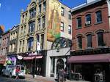 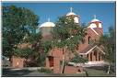
(huh??? Where????)
Well, not just Halifax, but it is so much fun to see the nonplussed look on peoples' faces when they hear that, especially when they are expecting to hear "Bali" or "Fiji" or "Burma."
We will be flying to Halifax, and then spending a few days exploring New Brunswick by car...
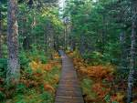 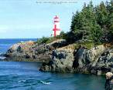
...and Nova Scotia...
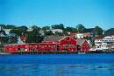 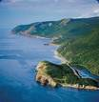
...perhaps venturing out to Prince Edward Island.
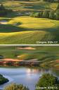
Then, we're going to come back to Halifax, and take the overnight train from Halifax to Montreal...
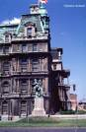 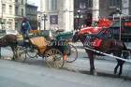 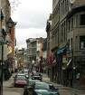
...then spend a week or so exploring Quebec. We are particularly looking forward to seeing Quebec City...
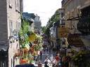 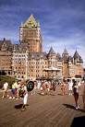
Next, we take a train to Ottawa, embarking on a 5-day cruise to Kingston (www.StLawrenceCruises.com)...
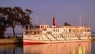
...Ultimately tooling around Kingston for a bit,
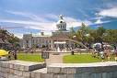 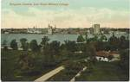 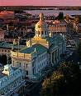
....and then flying back home!

MORE >>

Posted by Sandy Shepard at
8/6/2006 1:41 PM | View Comments (0) | Add Comment | Trackbacks (0)

A Full Day of "Chores"...! (Champagne, Rings, Angels and Things)

We have been having some "drama" around the ring "thing." Believe it or not, even though we've been searching for over a year, we hadn't really found a pair of rings that "worked" for both of us. Herbert found one that matched his watch and looked great — but it was too "blocky" for me.
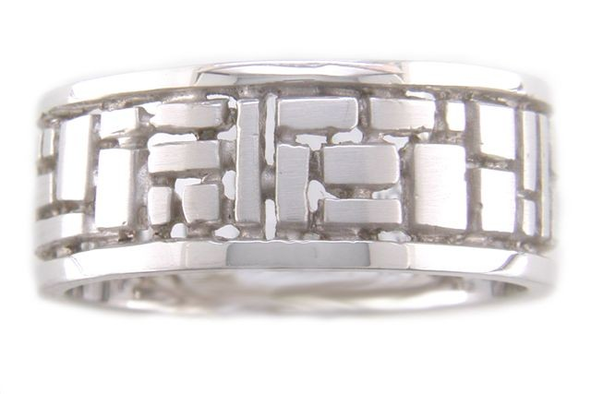
I found a set by Alex Sepkus that I LOVED because they felt "Klimt-y":
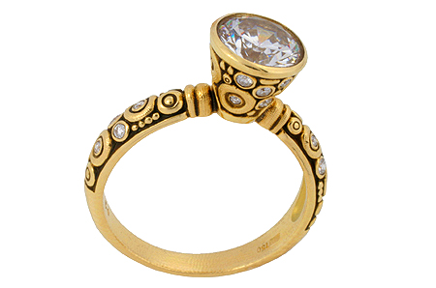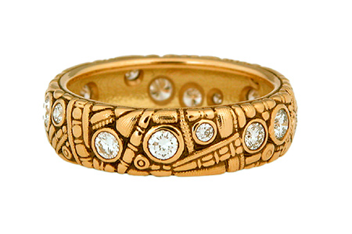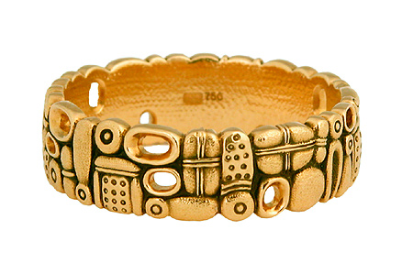
, but they just didn't work as well for Herbert (not "edge-y" enough). We found a designer we both liked (www.krespistudios.com) - but when we called to make an appointment to have her "re-make" my ring and make bands for us . . . she was in the hospital, and her assistant said "no way" could she have rings ready by September 16th.
What to do?
So this morning, Herbert woke up, and said "You know what I think would be cool? If we could find some rings from the 30s, maybe Art Deco, that we could give another wonderful life with another loving couple — us!" I thought — what a great idea! And as some of you know, I'm a big believer in the Power of Deliberate Intent (www.abraham-hicks.com), and so I added it to our "list" for today, with the complete and utter belief that we would end the day with "those" rings. (What an Optimist, huh? )
The day started with us going to Napa, to scout out more champagne houses. It was certainly a lot more pleasant than 2 weeks ago when we did the first "foray" — in 115 degree heat! Every step was like being in a sauna (and we were dehydrated enough to get a little loopy by the end of the day!) Today was very pleasant, in the 80s with a nice breeze.
We wound up at Gloria Ferrer,
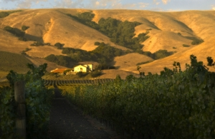
and had a super nice time with Ron in their tasting room. We think we have our eight different champagnes for the "tasting" - 4 before the wedding, 4 after - they will likely be 1-2 from Gloria Ferrer, possibly a brut from Kenwood, an "extra dry" (sweeter champagne) from either Korbel or Chandon, and then a brut from each of Roederer and Schramsberg. We liked Gloria Ferrer's rose and their blanc de noirs — both of which had a pinkish color to them, which was fun (we also like the Beringer rose). After sitting out on their porch overlooking the vineyards with a glass of champagne, we started on our Day of Driving and Errands!
Our first stop after Napa was over in Berkeley, to check out some of the antique stores on Ashby Avenue. If you know our "geography," you know that Napa, to Berkeley, to Emeryville, to San Fran, to Tiburon, to San Rafael is a LONG DAY — but we were ready to be stalwarts.
We didn't find any rings in the antique stores in Berkeley, and so we headed over to IKEA, to purchase 200 champagne flutes for the wedding.
Herbert had not only come up with the idea of having a champagne "tasting bar" at the wedding, but also having you folks (like on New Year's Eve at our place) decorate your flutes. This way, you'd have a festive keepsake, but also, if (WHEN!) you go in to dance (no food/drink on the dance floor), you can come back and pick your flute back up off a table outside the door. The problem? This means we had to purchase a whole passel of glasses!
You should see the looks you get when you are dragging around a shopping cart full of 200 tinkly champagne flutes.
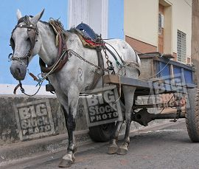
Actually - it was fun. The number of times that we heard "Hey, are we invited?" and the smiles and "second looks" were great.
SO, off from the East Bay over the Bay Bridge (is there ever a time that doggone Bridge has traffic going more than 5 MPH?? Oy!), and into San Francisco. I had to make a "product drop off" from a Passion Party I had hosted in S.F., in the upper Haight. Before leaving, I had asked my wonderful Slave Of Honor Allison if she knew of any antique ring places in S.F. and she could only think of Union Square (pricey) ... so I put "antique rings" and "Castro" and "Haight" into Google, and found a blog from a couple who had gotten married in 2003: http://www.gabeanderson.com/life/2003/06/01/antique_wedding_rings.php
They recommended Brand X Antiques — which was very close to where I was making the product drop-off. So off we went.
What a crazy place! Brand X Antiques has been around for 48 years — run by Fred and his partner Tim. It's one of those stuffed "treasure stores" where a dark corner might hold an antique 20s cigarette holder or a technicolor painting of naked men. Fred spent a long patient time with us, basically telling me over and over that at a size 8, I was "way too large" for the "standard woman's hand" from the '30s. We tried on ring after ring, and sure enough — they wouldn't even work their way over my knuckle.
We found a few diamond bands that were large enough, but they didn't really work. I already have the antique engagement ring that has been in Herbert's family for generations (2 small diamonds surrounding a ruby), and my "other" engagement ring (amazingly, diamond and ruby as well, which I had made in Thailand 20 years ago and sized up from a pinky ring). So the diamond bands were just "too much bling" on the finger. (When did you last hear a woman say THAT?) That morning, Herbert had "envisioned" two straight gold, round, 'plain and simple' bands that we could give a new life. We knew they existed - we just had to find them.
We were nearly out of the store when Herbert saw a ring that was "underneath" another in the case. (The ring case at Brand X is stuffed with rings on top of rings on top of rings, in boxes on top of boxes.) Fred pulled that one out — and it was JUST what we were looking for... a man's "salmon" gold wedding ring from the '30s, with a very small design of "bubbles" on it. (Our camera isn't working; I will try to post a picture when we figure out what's up.) It's a super friendly color of gold - just a fabulous ring. Once Herbert put it on (and it fit without issue), Fred perked up, went to a different ring case (which had silver in it) and "remembered" he had a women's ring in rose gold, from the '20s, that looked "just like it" and he had "put over here a while back." And — guess what? It was a size 8. Perfect fit.
We were giddy to find these matched rings. It was so fun - Fred might have even been more excited than we were! My ring is perfect — because it fits right up against the 2 other rings - if I were to wear all three, it just adds a nice rose-colored "divider" between the two. I can also wear it alone, or with either of the other two.
When we walked out of the store with our new purchase, we realized that, though we had started out to purchase them as a "stopgap" for the wedding, we were so happy with the rings, we didn't need anything else. We figured that "who knows, maybe in a few years" we could re-make my ex-pinky ring into a new ring/band combo and get some other wedding rings - but not now. Exciting!
How great is that? The "manifestation" of the perfect rings, about 8 hours after the words came out of Herbert's mouth.
From there, we went up to the top of Twin Peaks to see the view:
... I wish I could upload the sound of 200 champagne glasses rattling over San Francisco potholes, but you can use your imagination!
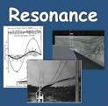
Off we went to pick up my iPod (I had left it at my pole dancing class by accident), a quick dinner (with champagne of course!) at Home restaurant...
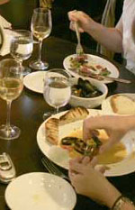
(Rush Hour three course supper $19.95 and two for one drinks, every night of the week before 6:00 - yes!! Best meatloaf either of us has ever had, even better than MINE),
Then we were off to Mom and Dad's to show off the rings (ok, that was me) and "bucket brigade" the champagne flutes out of the car (that was Herbert), to make room for more stuff we had to bring home,
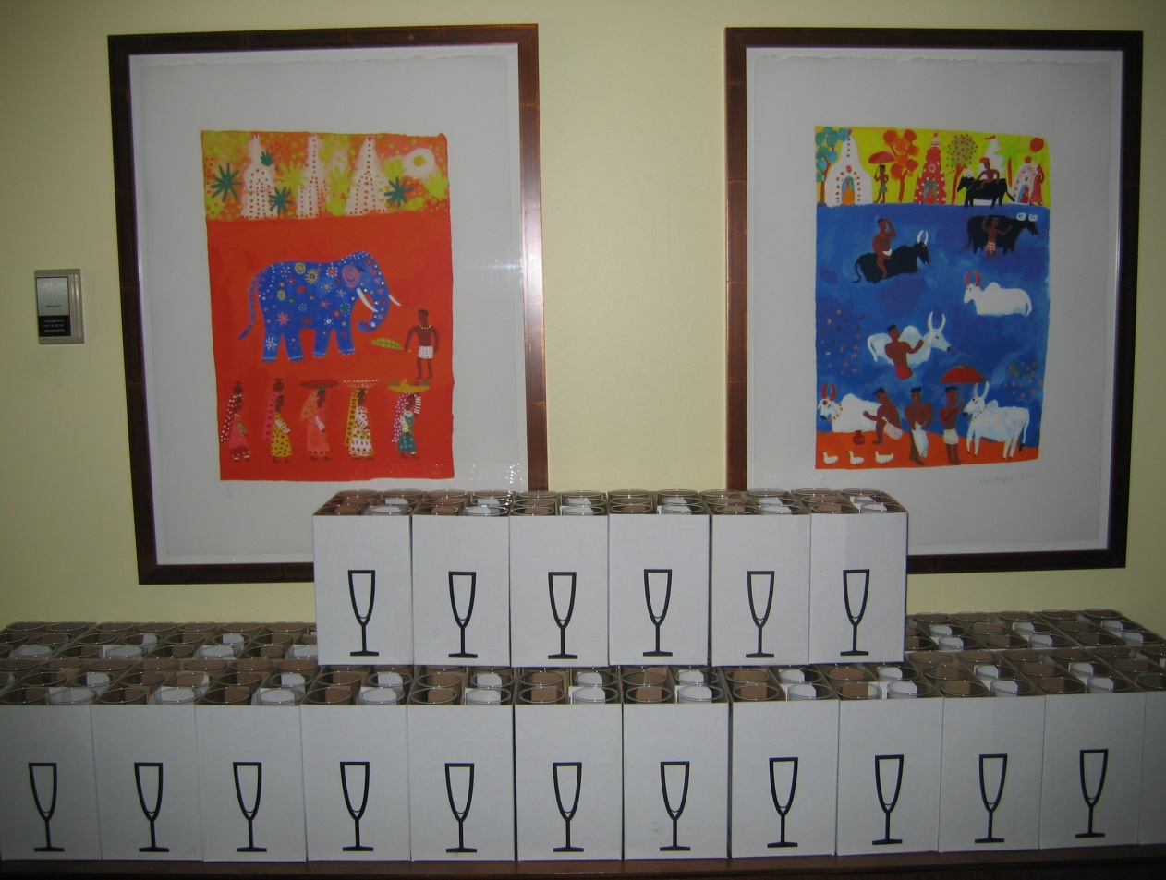
(that's the 200 champagne glasses on Mom and Dad's counter!)
...then we were off to BevMo to get two other bottles of champagne that we wanted to try out...
...and home to relax as we worked on finalizing the English on our Ketubah, which is being designed for us by Shendl Diamond at LikeMinds Press (www.likemindspress.com). 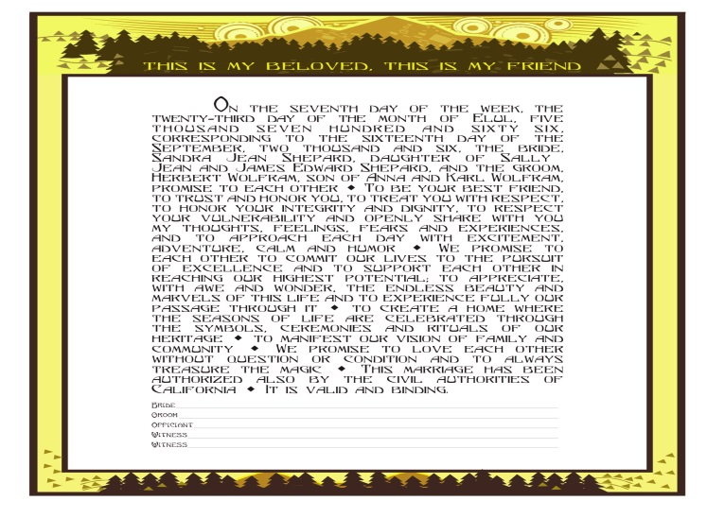
(You really must go see her site. Her cut stationery, ketubot, etc. are just beyond fabulous.) Shendl is our Ketubah Angel!
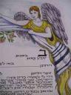
Oh..........and as a "capper" to the day and a SUPER surprise, I received an email from my Cousin Robin in London. I had been whinging about needing a "wonderful white purse" for the wedding (you know, to carry things like white out, Valium, taser gun...). She had sent me a number of them from eBay to peruse. One picture sparked the one remaining synapse in my little Bridezilla brain ... and without any effort, I found an antique white beaded purse my grandmother had given me years ago. And how did I find that one moving box, out of 50 remaining unpacked?? There Must Be some sort of 'Divine Intervention' or at least "purse angels' — I now have a posteriori evidence!!!!!
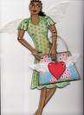
xxx Sleepy Princess Bridezilla

MORE >>

Posted by Sandy Shepard at
8/5/2006 10:55 PM | View Comments (1) | Add Comment | Trackbacks (0)

Photos From Our Evening With Sheila Dahlgren and Pete Noel at the Lark Creek Inn

Note Herbert's beautiful handmade Panama hat...and Miami Vice "salmon" jacket! Swanky!
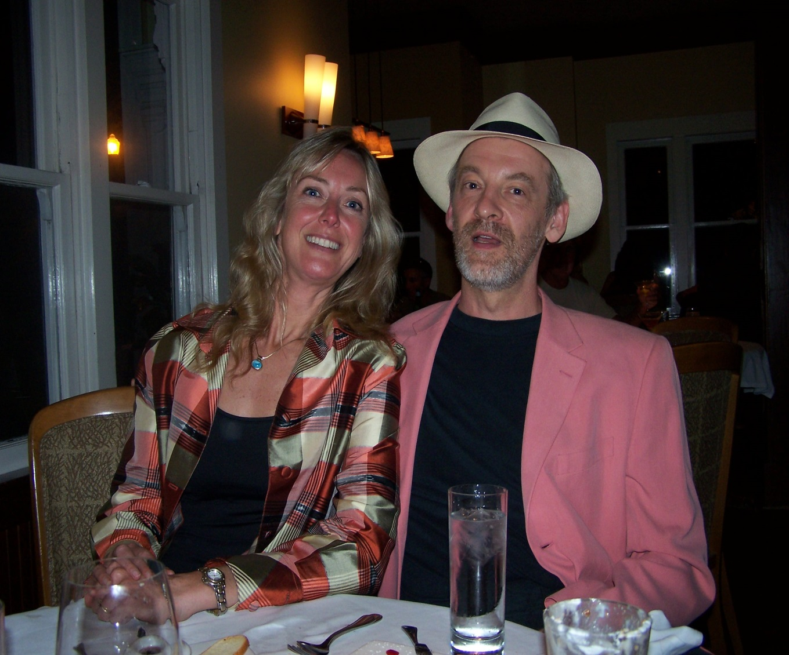 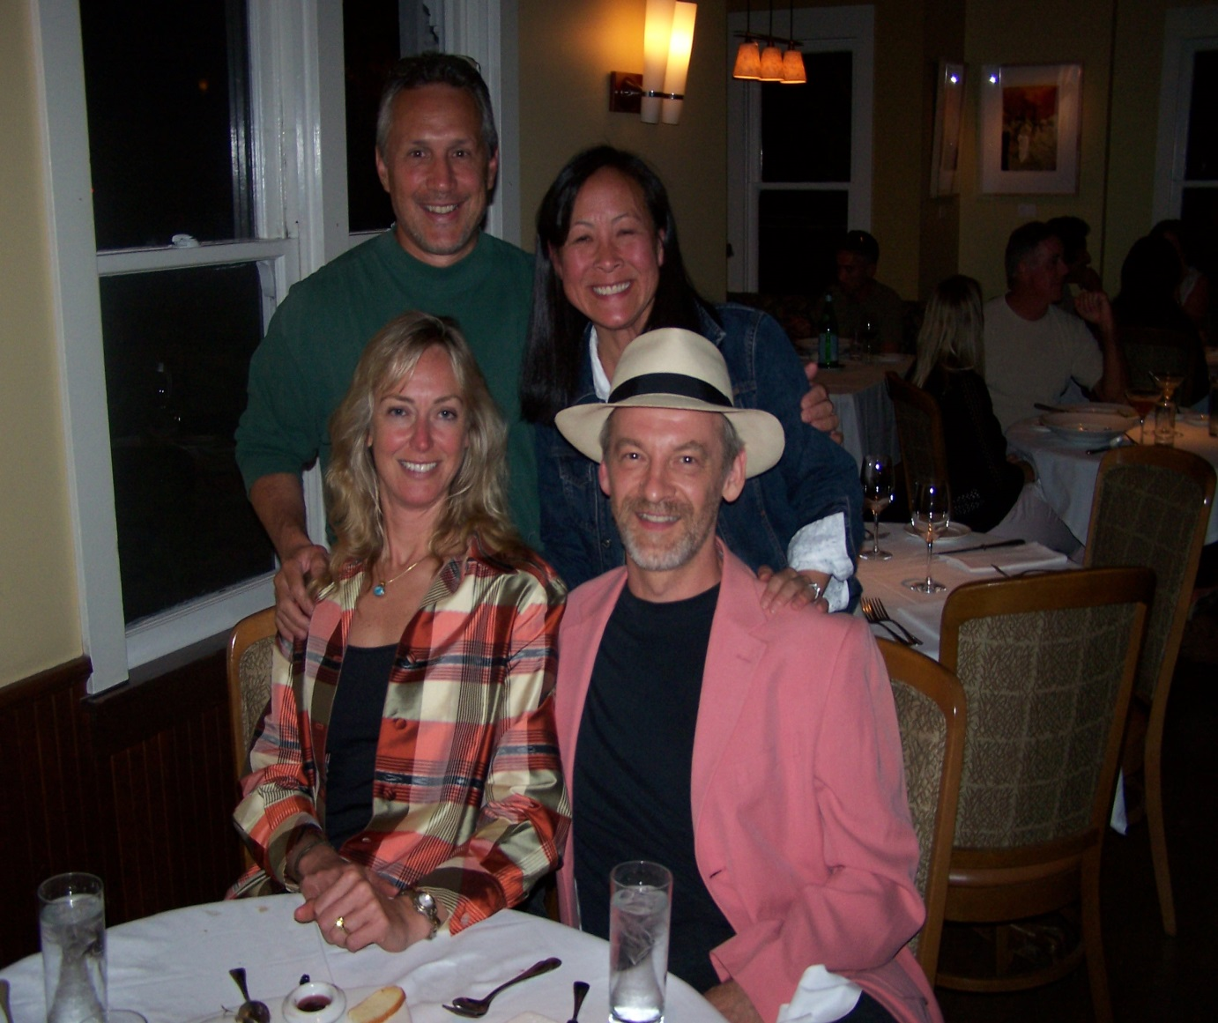
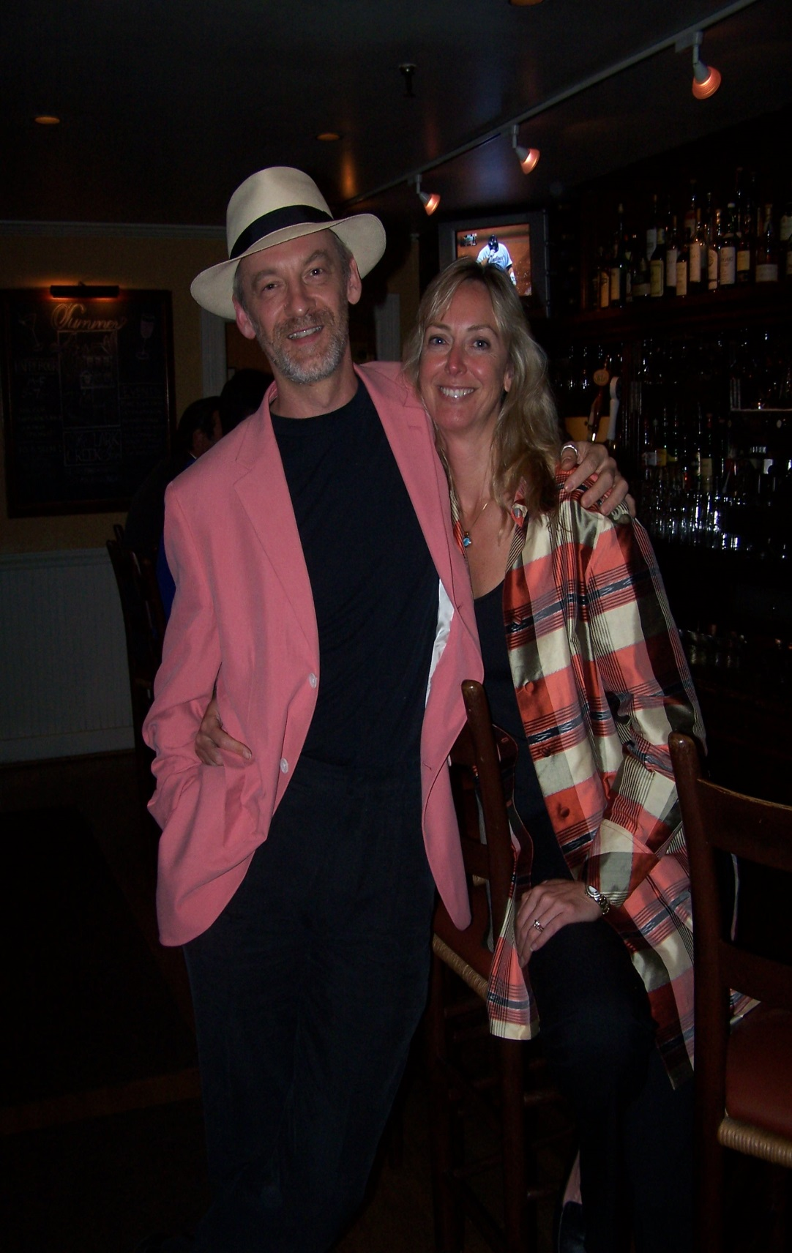

MORE >>

Posted by Sandy Shepard at
8/4/2006 12:02 PM | View Comments (0) | Add Comment | Trackbacks (0)

Ease on Down....Ease on Down...The Blog....

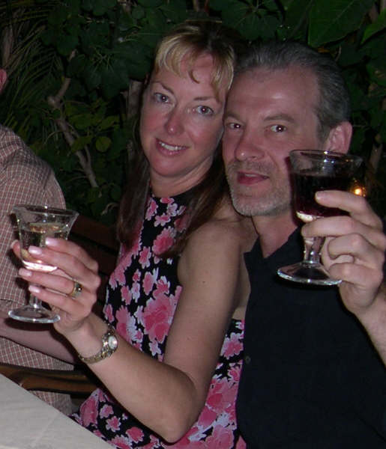
We toast you! This is another favorite picture of mine, from our trip hiking down the French Alps. Bet you can tell that we were DONE (this was taken at our celebratory dinner in Menton, on the Mediterranean).
This morning, received an email from the MOTB, stating that she was afraid that people wouldn't "wade through" all the quotes, to get to the "fun stuff" in the blog. If you want to bypass the quotes (and/or didn't realize how blogs work), just "ease on past" them — there is more "fun stuff" at the bottom. Or, look for pictures. Pictures on the post usually = me ranting on about something.
A blog is like an email "trail" or perhaps a diary (in reverse). You have the latest chronological posts at the top, and the earlier ones at the bottom.
So — if you're looking for the stories and the non-quote-y stuff — just ease on down the blog
Love,
Bridezilla

MORE >>

Posted by Sandy Shepard at
8/4/2006 7:07 AM | View Comments (0) | Add Comment | Trackbacks (0)

The Wed Site and a Wedding...

A few folks have asked us for a photo of the actual site for the wedding — a bit harder to do than I had imagined. But here we go! This is the "big white building" referred to in our WedSite page!
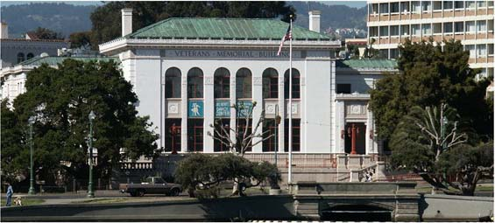
And just because I'm uploading photos, here is my favorite new photo of the two of us, from Herbert's friend Aldo's wedding the other weekend (Aldo is in the middle).
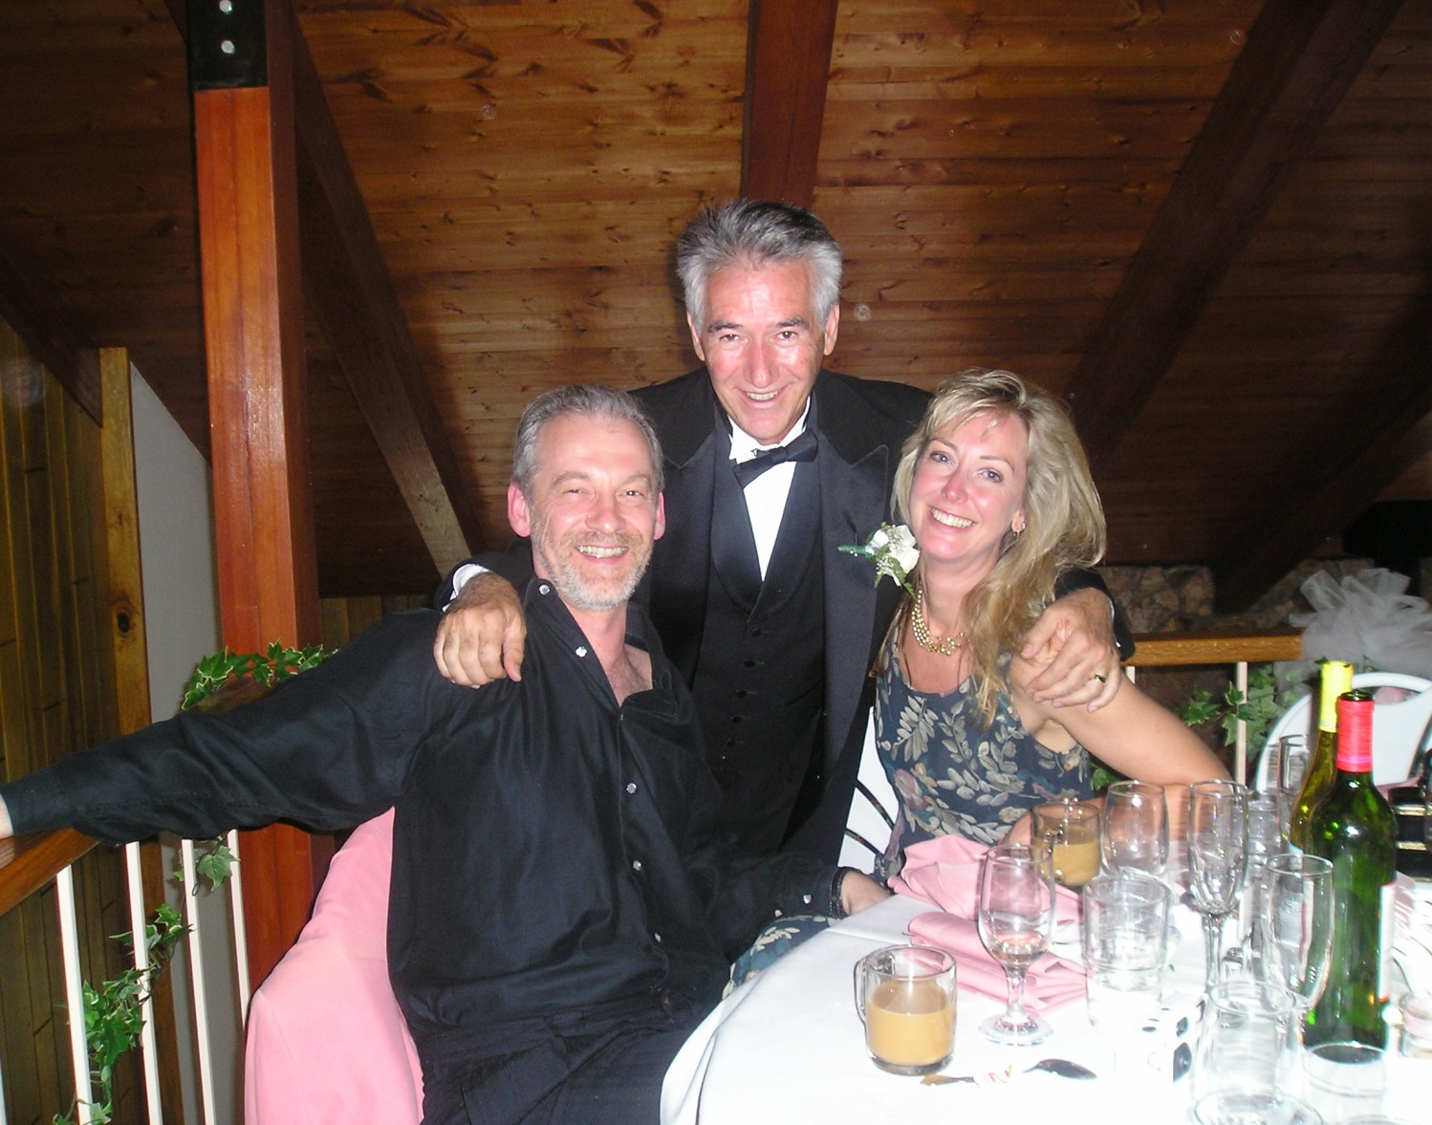

MORE >>

Posted by Sandy Shepard at
8/3/2006 1:58 PM | View Comments (0) | Add Comment | Trackbacks (0)

Quotes...

We are having fun with quotes — and we hope that if you are reading this Blog, you will donate some so our Hat (or should that be Lampshade?) will be full on Wedding Day!
I'll put the "short" ones here, and make separate entries for the "long" ones:
Marriage is not a ritual or an end. It is a long, intricate, intimate dance together and nothing matters more than your own sense of balance and your choice of partner. (Amy Bloom, submitted by Dr and Mrs Paul Ogden)

Remember to see each other as the beloved and to hold each other for what you do to make you the person that you are. Love is an amazing gift — unwrap it gently. (Madeline Wade & Mark Mooney)
A good marriage is like a casserole. Only those responsible for it really know what goes into it (Anon)
But be, as you have been, my happiness…. (poet Randall Jarrell, submitted by Mica)
A marriage where not only esteem, but passion is kept awake, is, I am convinced, the most perfect state of sublunary happiness… (playwright Frances Brooke, submitted by Mica)
The two secrets of a long-lasting and happy marriage are a good sense of humor, and a short memory (Anon)
Love is like pi — natural, irrational, and very important (Anon)
There are many roads in life; it's good to have company. Many blessings on your life together. (Allison & Jess Davis)
There are lessons to be learned by listening to others. (Warren Yamashita)
Swing and sway, Enjoy the day, "Bona fortuna" from Turin, Where we stay! (from John & Peggy Mooney, who will be biking through Italy on the wedding day)
Love gives naught but itself and takes naught but from itself. Love possesses not nor would it be possessed; For love is sufficient unto love. (The Prophet, by Kahlil Gibran, on Love, submitted by Jim Adams and Lynn Eichinger)
"Love is an exploding cigar we willingly smoke." (Lynda Barry. submitted by the Brown-Gracey family (Theresa, Chris, London & Bart))
Love is the only Game that is not called on account of darkness — may this Union be one that never goes on Strike! (Anon - baseball fan )
A successful marriage requires falling in love over and over with the same person (Anon)
The most important part of the Pursuit of Happiness is choosing the right travelling companion (Anon)
We come to love not be finding a perfect person, but by learning to see an imperfect person perfectly (Anon)
You don't marry someone you can live with; you marry the person whom you can't live without (Anon)
May the worst day of your life together be better than the best day of your lives before....May the road rise to meet you, the sun shine warm upon your faces, the rain fall softly on your fields, and may you both be held in the palm of god's hand until the end of your days. (from Eve Abbott)
A marriage without a sense of humor is like a wagon without springs — jolted by every pebble in the road (Italian proverb)
Love is patient; Love is kind; love is not envious or boastful or arrogant or rude. It does not insist on its own way; it is not irritable or resentful; it does not rejoice in wrongdoing, but rejoices in Truth. It bears all things, believes in all things, hopes all things, endures all things. Love never Ends. I Corinthians 13:4-8 (submitted by Rosemary Yates)
In our life there is a single color, as on an artist's palette, which provides the meaning of life and art. It is the color of Love. (Marc Chagall)
Cool breeze. Warm fire. Full moon. Easy chair. Empty plates. Soft words. Sweet songs. Tall tales. Short sips. Long life. (John Egerton - Southern writer)
Gravitation cannot be held responsible
for people falling in love
(Albert Einstein)
Anyone can be passionate,
But it takes real lovers to be silly
(Rose Franken, playwright)
We love because it's the only true adventure (poet Nikki Giovanni)
Love is the force that ignites the spirit, and binds teams together (Basketball coach Phil Jackson, "Sacred Hoops")
The meeting of two personalities is like
the contact of two chemical substances;
if there is any reaction
both are transformed
(Carl Jung)
You must always be a-waggle with Love (D.H. Lawrence, "Bibbles")
Age does not protect us from Love, but Love to some extent protects us from Age (French film star Jeanne Moreau)
A good marriage is based on a Talent for Friendship (Friedrich Nietzsche, "Human, All Too Human")
Love is like the Measles. The older you get it, the worse the attack (mystery writer Mary Roberts Rhinehart)
Love does not consist in gazing at each other, but in looking outward together in the same direction (Antoine de Saint-Exupery, "The Little Prince")
Love is being stupid together. (French symbolist poet Paul Valery)
Love is the same as Like, except you feel sexier. (Judith Viorst, author)
A man is not complete until he's married...and then he's finished (Anon)
There are two theories about arguing with your wife. Neither one works. (Anon)
Marriage is the only war where you sleep with the enemy (Anon)
Marriage is made in Heaven — but don't forget, so are Thunder and Lightening (Anon)
My wife and I were happy for twenty years. Then we met. (Rodney Dangerfield)
Let us set forth the Fundamental Truth about marriage. The wife is in charge. (Bill Cosby)
Never go to bed mad. Stay up and Fight. (Phyllis Diller)
Love is a perky elf dancing a merry little jig, and then suddenly he turns on you with a miniature machine gun. ("Simpsons" creator Matt Groening)
Women should be Obscene and not Heard (John Lennon)
I think men who have a pierced ear are better prepared for marriage. They've experience pain, and bought jewelry. (Rita Rudner)
If Love is the Answer....Could you re-phrase the question? (Lily Tomlin)

MORE >>

Posted by Sandy Shepard at
8/3/2006 12:58 PM | View Comments (0) | Add Comment | Trackbacks (0)

"Resignation," Nikki Giovanni

I love you
because the earth turns round the sun
because the North wind blows north
sometimes
because the Pope is Catholic
and most Rabbis Jewish
because winters flow into springs
and the air clears after a storm
because only my love for you
despite the charms of gravity
keeps me from falling off this Earth
into another dimension
I love you
because it is the natural order of things
I love you
like the habit I picked up in college
of sleeping through lectures
or saying I'm sorry
when I get stopped for speeding
because I drink a glass of water
in the morning
and chain-smoke cigarettes
all through the day
because I take my coffee Black
and my milk with chocolate
because you keep my feet warm
though my life a mess
I love you
because I don't want it
any other way.
I am helpless
in my love for you
It makes me so happy
to hear you call my name
I am amazed you can resist
locking me in an echo chamber
where your voice reverberates
through the four walls
sending me into spasmatic ecstasy
I love you
because it's been so good
for so long
that if I didn't love you
I'd have to be born again
and that is not a theological statement
I am pitiful in my love for you
The Dells* tell me Love
is so simple
the thought though of you
sends indescribably delicious multitudinous
thrills throughout and through-in my body
I love you
because no two snowflakes are alike
and it is possible
if you stand tippy-toe
to walk between the raindrops
I love you
because I am afraid of the dark
and can't sleep in the light
because I rub my eyes
when I wake up in the morning
and find you there
because you with all your magic powers were
determined that
I should love you
because there was nothing for you but that
I would love you
I love you
because you made me
want to love you
more than I love my privacy
my freedom my commitments
and responsibilities
I love you 'cause I changed my life
to love you
because you saw me one friday
afternoon and decided that I would
love you
I love you I love you I love you
*The reference to the Dells in line 47 is to "Love is so simple," a 1968 song from their album 'There is'. According to Giovanni, the
rhythm of this poem is the rhythm of the song.

MORE >>

Posted by Sandy Shepard at
8/3/2006 12:45 PM | View Comments (0) | Add Comment | Trackbacks (0)

"Oh, the Places You'll Go!" Dr. Seuss

Congratulations!
Today is your day.
You're off to Great Places!
You're off and away!

You have brains in your head.
You have feet in your shoes
You can steer yourself
any direction you choose.
You're on your own. And you know what you know.
And YOU are the [ones] who'll decide where to go.

You'll look up and down streets. Look 'em over with care.
About some you will say, "I don't choose to go there."
With your head full of brains and your shoes full of feet,
you're too smart to go down any not-so-good street.

And you may not find any
you'll want to go down.
In that case, of course,
you'll head straight out of town.

It's opener there
in the wide open air.

Out there things can happen
and frequently do
to people as brainy
and footsy as you.

And when things start to happen,
don't worry. Don't stew.
Just go right along.
You'll start happening too.

OH!
THE PLACES YOU'LL GO!

You'll be on your way up!
You'll be seeing great sights!
You'll join the high fliers
who soar to high heights.

You won't lag behind, because you'll have the speed.
You'll pass the whole gang and you'll soon take the lead.
Wherever you fly, you'll be the best of the best.
Wherever you go, you will top all the rest.

Except when you don't
Because, sometimes, you won't.

I'm sorry to say so
but, sadly, it's true
and Hang-ups
can happen to you.

You can get all hung up
in a prickle-ly perch.
And your gang will fly on.
You'll be left in a Lurch.

You'll come down from the Lurch
with an unpleasant bump.
And the chances are, then,
that you'll be in a Slump.

And when you're in a Slump,
you're not in for much fun.
Un-slumping yourself
is not easily done.

You will come to a place where the streets are not marked.
Some windows are lighted. But mostly they're darked.
A place you could sprain both you elbow and chin!
Do you dare to stay out? Do you dare to go in?
How much can you lose? How much can you win?

And IF you go in, should you turn left or right...
or right-and-three-quarters? Or, maybe, not quite?
Or go around back and sneak in from behind?
Simple it's not, I'm afraid you will find,
for a mind-maker-upper to make up his mind.

You can get so confused
that you'll start in to race
down long wiggled roads at a break-necking pace
and grind on for miles across weirdish wild space,
headed, I fear, toward a most useless place.
The Waiting Place...

...for people just waiting.
Waiting for a train to go
or a bus to come, or a plane to go
or the mail to come, or the rain to go
or the phone to ring, or the snow to snow
or waiting around for a Yes or a No
or waiting for their hair to grow.
Everyone is just waiting.

Waiting for the fish to bite
or waiting for wind to fly a kite
or waiting around for Friday night
or waiting, perhaps, for their Uncle Jake
or a pot to boil, or a Better Break
or a string of pearls, or a pair of pants
or a wig with curls, or Another Chance.
Everyone is just waiting.

NO!
That's not for you!

Somehow you'll escape
all that waiting and staying.
You'll find the bright places
where Boom Bands are playing.

With banner flip-flapping,
once more you'll ride high!
Ready for anything under the [suns].
Ready because you're that kind of [ones]!

Oh, the places you'll go! There is fun to be done!
There are points to be scored. there are games to be won.
And the magical things you can do with that ball
will make you the winning-est winner of all.
Fame! You'll be famous as famous can be,
with the whole-wide-world watching you win on TV.

...And will you succeed?
Yes! You will, indeed!
(98 and 3 / 4 percent guaranteed.)

YOU'LL MOVE MOUNTAINS!

So...
be your name Buxbaum or Bixby or Bray
or Mordecai Ali Van Allen O'Shea,
you're off to Great Places!
Today is your day!
Your mountains are waiting.
So...get on your way!

MORE >>

Posted by Sandy Shepard at
8/3/2006 12:33 PM | View Comments (0) | Add Comment | Trackbacks (0)

"West Wind #2," Mary Oliver

You are young. So you know everything. You leap into the boat and begin rowing.
But listen to me.
Without fanfare, without embarrassment, without any doubt, I talk directly to your soul.
Listen to me.
Lift the oars from the water, let your arms rest, and your heart, and heart’s little intelligence, and listen to me.
There is life without love.
It is not worth a bent penny, or a scuffed shoe.
It is not worth the body of a dead dog nine days unburied.
When you hear, a mile away and still out of sight, the churn of the water as it begins to swirl and roil,
fretting around the sharp rocks – when you hear that unmistakable pounding –
when you feel the mist on your mouth and sense ahead the embattlement,
the long falls plunging and steaming –
then row, row for your life toward it.

MORE >>

Posted by Sandy Shepard at
8/3/2006 12:32 PM | View Comments (0) | Add Comment | Trackbacks (0)

"Valentine," by Donald Hall

Chipmunks jump, and
Greensnakes slither.
Rather burst than
Not be with her.
Bluebirds fight, but
Bears are stronger.
We've got fifty
Years or longer.
Hoptoads hop, but
Hogs are fatter.
Nothing else but
Us can matter.

MORE >>

Posted by Sandy Shepard at
8/3/2006 12:29 PM | View Comments (0) | Add Comment | Trackbacks (0)

"i carry your heart with me" e.e. cummings

i carry your heart with me
(i carry it in my heart)
i am never without it
(anywhere i go you go,my dear; and whatever is done
by only me is your doing,my darling)
i fear no fate
(for you are my fate,my sweet)
i want no world
(for beautiful you are my world,my true)
and it's you are whatever a moon has always meant
and whatever a sun will always sing is you
here is the deepest secret nobody knows
(here is the root of the root and the bud of the bud
and the sky of the sky of a tree called life; which grows
higher than the soul can hope or mind can hide)
and this is the wonder that's keeping the stars apart
i carry your heart
(i carry it in my heart)

MORE >>

Posted by Sandy Shepard at
8/3/2006 12:24 PM | View Comments (0) | Add Comment | Trackbacks (0)

The Presence of Love, Samuel Taylor Coleridge (written in 1807)

And in Life`s noisiest hour,
There whispers still the ceaseless Love of Thee,
The heart's Self-solace and soliloquy.
You mould my Hopes, you fashion me within ;
And to the leading Love-throb in the Heart
Thro` all my Being, thro` my pulses beat ;
You lie in all my many Thoughts, like Light,
Like the fair light of Dawn, or summer Eve
On rippling Stream, or cloud-reflecting Lake.
And looking to the Heaven, that bends above you,
How oft ! I bless the Lot, that made me love you.

MORE >>

Posted by Sandy Shepard at
8/3/2006 12:23 PM | View Comments (0) | Add Comment | Trackbacks (0)

...And It Zips!

After much Celery Eating (not really — in fact, we went on Suzanne Somer's eating plan and I TOTALLY lost the inches and feel great!), had a fitting in the dress yesterday ... and it zips!
If you missed the first entry about the dress, it's the very first one, below. . .
Bridezilla
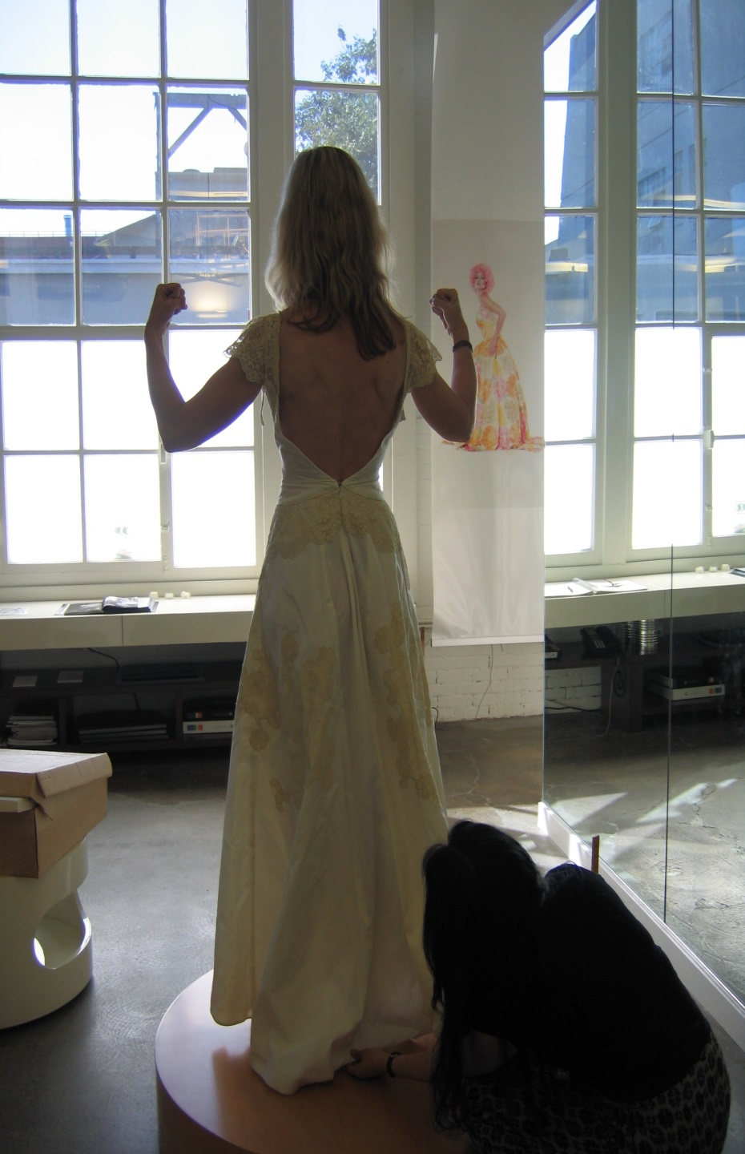
My new "back view" (courtesy of my trainer, Nancy Mimms!)
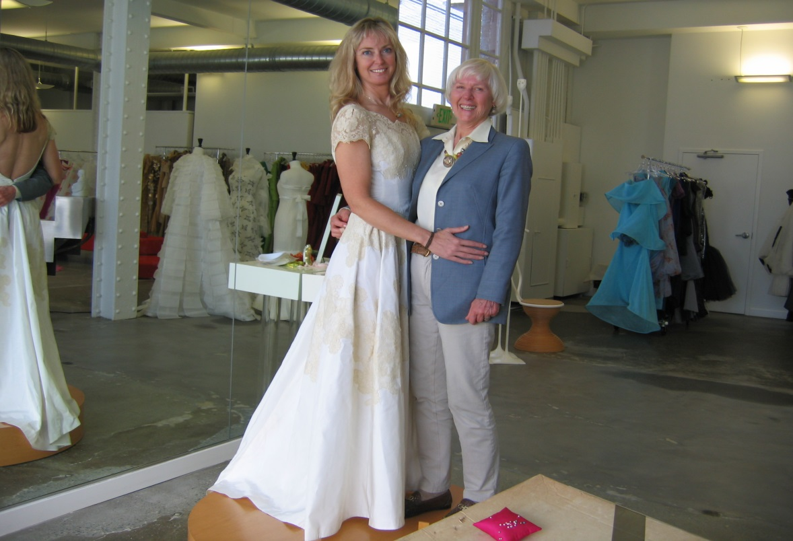
The "former Princess" (now the Queen!) and the "new Princess."
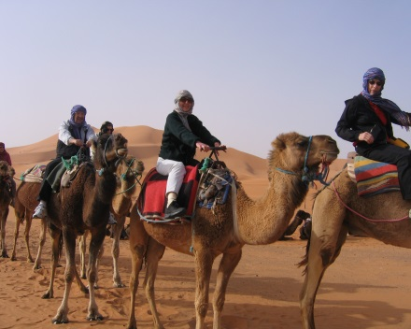
(As an aside, this is what the King and Queen get up to in their spare time — Mom and Dad riding camels in Morocco last year, and...
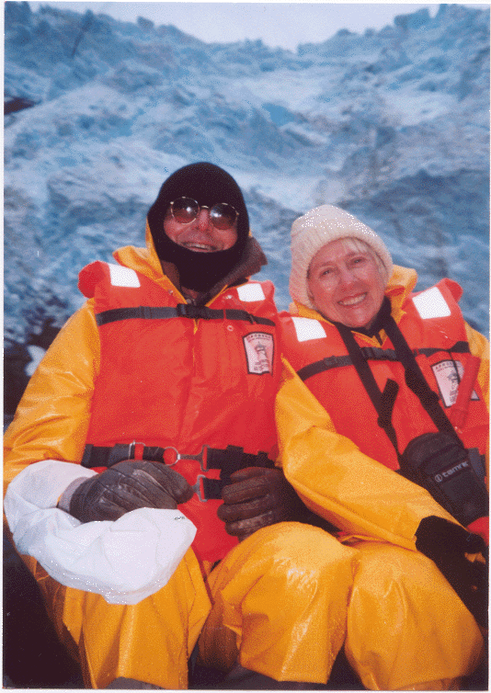
...on a glacier in Patagonia!)
And finally, a photo of She Who Made It All Possible, the inimitable couturier, Colleen Quen! (I think this is such a cute picture — cuter when you look at the reflection and see Who Is Standing Where )
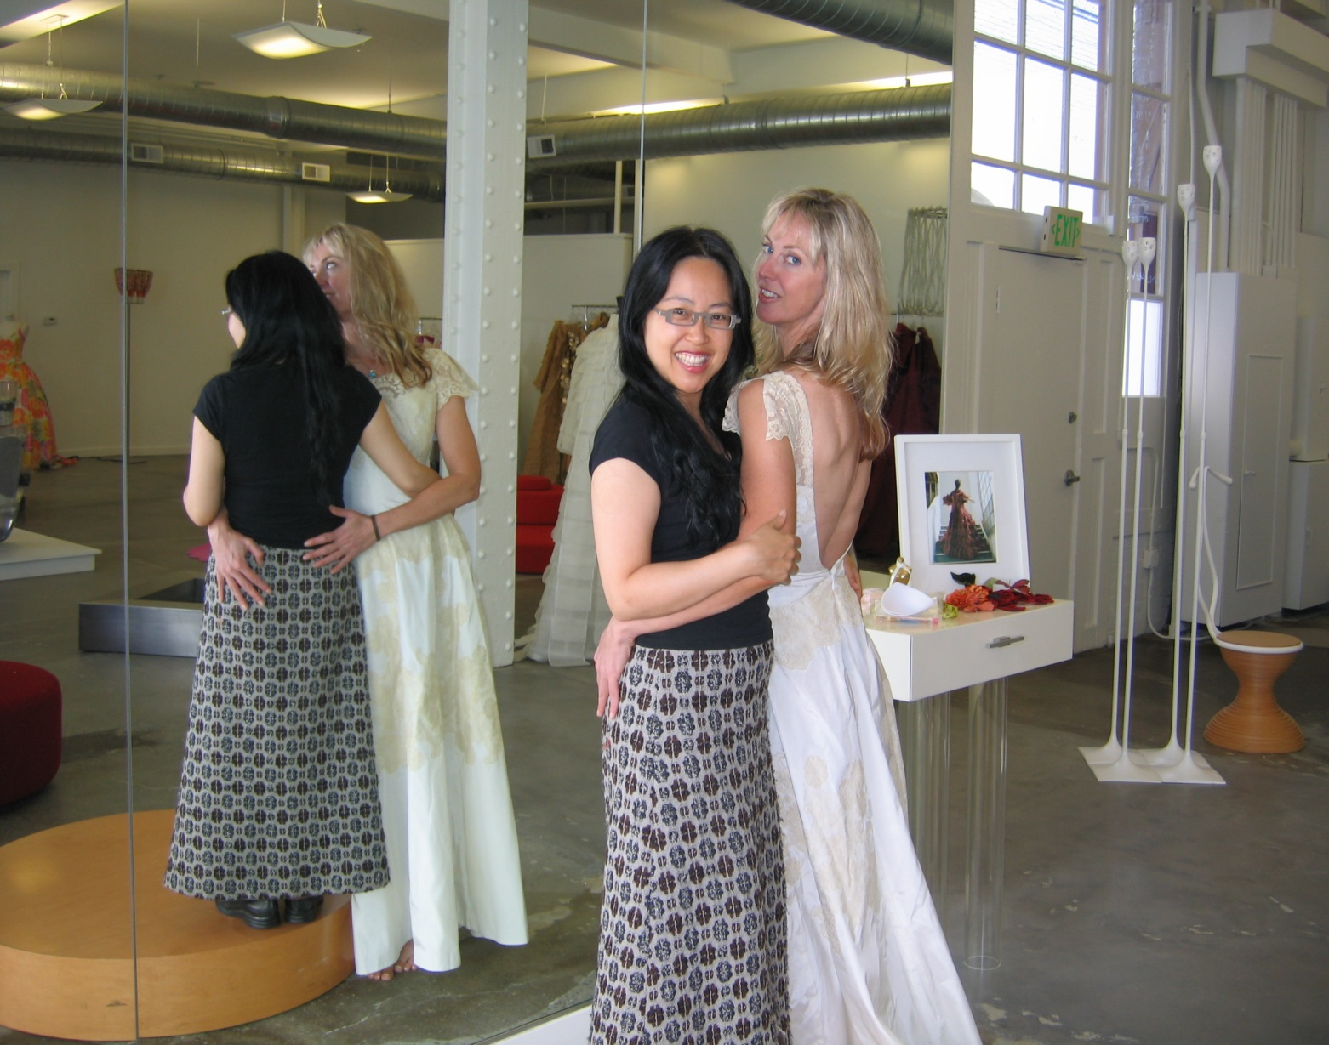

MORE >>

Posted by Sandy Shepard at
8/3/2006 11:18 AM | View Comments (0) | Add Comment | Trackbacks (0)

And the Poems Come Rolling In....

We have started to receive our first "entries" for the Gospel/Torah portion of our wedding. As noted in the WedSite, we will be reading two or three quotes or poems sent to us for the day, picked out of a hat.
We thought that we would receive some quotes from famous authors, poets, or the Bible, but our first entry was from the Very Creative Sharyn and Trip. They decided that they wanted to write their own — and here they are!
First thoughts on a sensible theme...

And so today we come to see
Two friends celebrating love, to be
Promising each other support and strength
Through ups and downs at any length
We rejoice in knowing that these two
Have each other to make it through
Any trials that life throws their way
And we're here to share their day

Second effort on a silly theme...

We thought it would never be
The lawyer, the engineer you see
Are the most unlikely couple yet
But not for their job, lest you forget
It really is because of what they are
He's a Wolf, ram going far
And her name goes against role
Sandy's a Sheep, from the herd he stole.

Last entry combining humour and poetry....

Today is for the celebrates
The union of our two mates
The tall Shepard in lawyer's clothing
And wily Wolf to whom she's betrothing.
...And I thought I was the only one who noticed the whole Wolf-Ram-Shepard thing

MORE >>

Posted by Sandy Shepard at
7/31/2006 9:59 AM | View Comments (0) | Add Comment | Trackbacks (0)

How They Met....

Once upon a time, in the Time Warp called the Nineties, there was a lovely Shepherdess Princess who worked at a software company called the Evil Empire.
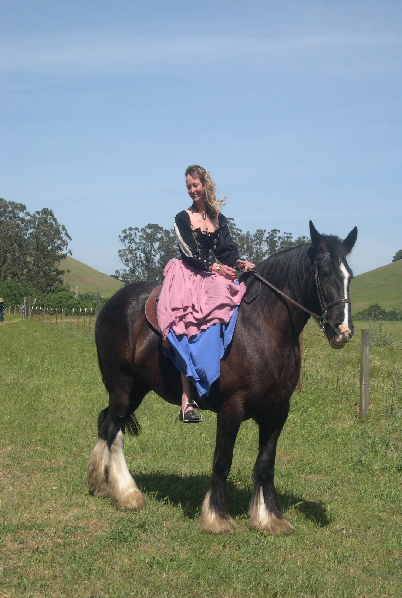
It was called the Evil Empire, as it had a habit of gobbling up other, fluffy bunny, unsuspecting, near-bankruptcy-but-loved-by-their-employees software companies. But the Princess just called it Home.
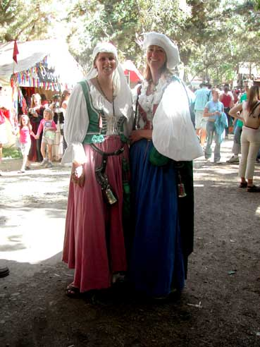
One day, after the Empire had been particularly voracious in its gobbling, it came upon the Kingdom of Broderbund, with very happy inhabitants but nothing Flowing in the River of Cash. With a belch, the Empire swallowed up the Kingdom, spitting out bits of bytes and a few bones and teeth.
The Princess, with her Evil Lawyer Hat on (though she told no one it was lined in pink fluffy bubbles), was brought in to start the dreaded task of Integration.
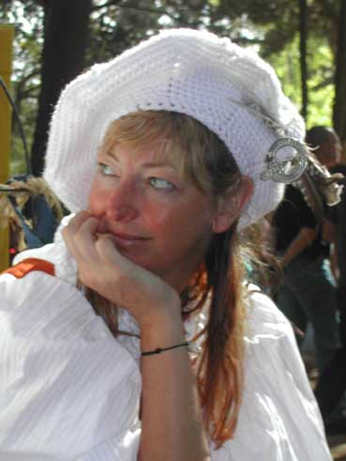
One of the inhabitants of the Kingdom was the Engineer Earl. Being a trusting and trustworthy, stand-up, man-of-his-word sort, he did all of his deals on a handshake. Unfortunately, that was against the Empire's Rules (which the Princess was tasked to enforce).
The Earl railed against the Rules. He sent out huffy emails to all the Empire. He made Princess voodoo dolls. But the Kingdom had been overthrown, and it was Empire Rules time. He huffed a lot, growling "Princess" under his breath.
However, as he was on the third floor of the Empire, and the Princess was on the second, she knew not much about the Earl (except his huffy emails).
Meanwhile, the Princess decided to decrease the stress in her life by taking a live model art class. In this class, across the easel, there was a lovely European Gentleman with an upright demeanor, black clothes, sexy clipped beard and an amazing artistic talent. (The Princess generally left the body out of stick figures, and was a little uptight about her lack of talent, so she was given a four foot long branch and a cup of ink by the teacher, to use to make her art. Yes, really.) Every time the class was tasked with walking around and commenting on one another's art, she was very solicitous to the talented and handsome European Gentleman. He was a little snarly. She wondered what his deal was. She thought a lot about the Captain in the Sound of Music.
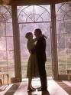 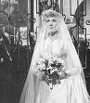
oh no, oops I mean
Soon, the Empire decided that it had grown too fat, and that it would spin off a few small Dot Com Duchies. The Shepherdess Princess was asked to lead the new Duchy's Legal subkingdom.
Her Friend who worked for the Earl, however, told her that he was Very Upset that she would be part of the Team.
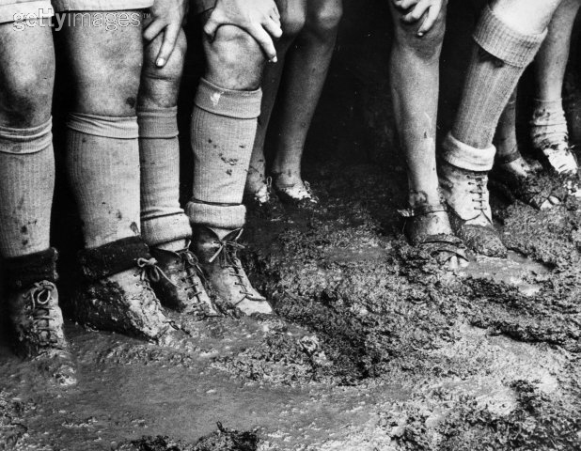
In fact, as their offices had been slated to be next to one another, he changed the plan, having her re-directed to a broom closet. She stomped her feet, demanding, at least, a window. So she was giving a broom closet with a window. Her desk wedged in sideways.
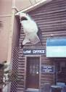 Oh no wait that was her dream...
here it is...
The Earl vowed never to cross paths with the Princess, as the Princess learned from her Friend. Because he had invented much of the software that ran the Duchy, he was a Big Kahuna. But because she ran the Legal subkingdom and had control over the contracts, she was, at least, a Medium-Sized Kahuna.
After the new Duchy had been populated, the Powers That Be had an all-Duchy meeting. The Princess attended, with her Friend. And what to her wondering eyes should appear in the doorway of the conference room, but the Distinguished Gentleman from her art class!
Oh no, wait a second...
Yeah, yeah, there we go, that's what I meant...
She gasped, turned to her Friend, and whispered, "HEY! That's that handsome GUY I told you about, from my ART class!" The Friend turned to her, an Oh No look on her face, and gasped, "HEY back atcha! That's the EARL, who Hates You!" The Earl turned and looked at the Princess from across the conference room, as her face registered what she had just been told. And he bared his teeth, um, I mean, grinned. Her heart sank.
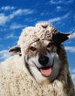
Next: The Princess Redeems Herself.

MORE >>

Posted by Sandy Shepard at
7/2/2006 4:23 PM | View Comments (0) | Add Comment | Trackbacks (0)

How They Met (Chapter Two)

When Last We Had Left the Princess, she was
As the months passed, the Earl continued to avoid the Princess, sending his minions down whenever he needed a contract interpreted and signed.
However, one evening, the Princess went over to say good evening to her Friend, who was working late. Her Friend said "Well, if you see me in these same clothes tomorrow, it's because I have been here all night."
When questioned, she continued, "Our subkingdom contractor didn't deliver, and we have Ye Olde Code Locke this evening. Therefore, the Earl and I have to get it all done ourselves."
So the Princess sat right down next to her Friend, and said "I'll help." Which she did.
The Earl came down to check on the work, and discovered the Princess there, dutifully helping.
He muttered, "What are you doing here?" to which she said, "I am here so that you can both get to bed before tomorrow morning. Now, go back in your office, and I will bring the work down to you when we are done. Go. Go."
The Friend's eyebrows shot up
, but the Princess said: "We are both Kahunas. I can talk to Him like that."
Ultimately, the project was done by about midnight, and the Earl, tired but happy, was begrudgingly grateful to the Princess for all her help.
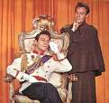
He asked her if she would like to go to a play together...
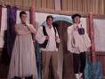 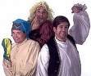
...which they did...
Then they did some dancing together...
...and some hiking together...
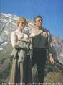
...and in the end, they decided to merge their Kingdoms, and live happily ever after!
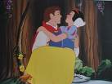

MORE >>

Posted by Sandy Shepard at
7/2/2006 2:34 PM | View Comments (0) | Add Comment | Trackbacks (0)

Wedding Dress . . .

Once upon a time, 50 years ago, a beautiful Princess wore a beautiful dress for her wedding...
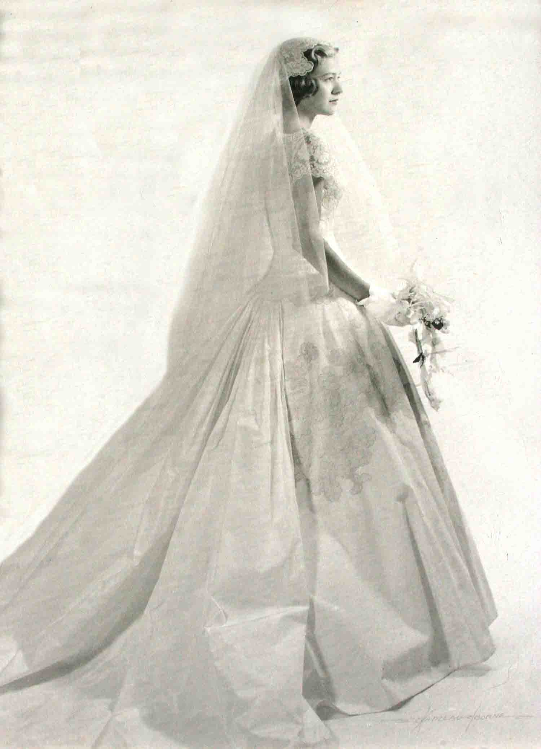
...her name was Sally-Jean Shupert, and on that day she wore the satin and antique French lace dress to marry the young doctor, James Shepard. Fifty years later, once she had become the Queen, her daughter, the new Princess, asked whether she might wear the dress for her wedding.
The Queen and the Princess went into the attic, and took a peek.
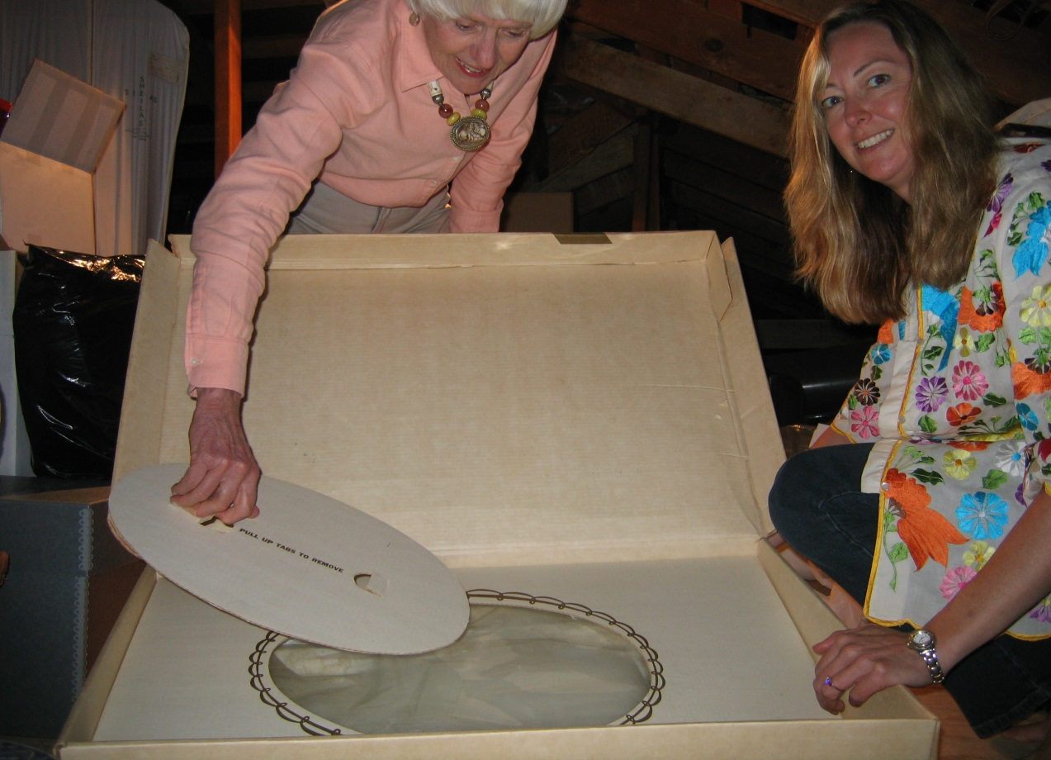
Though the Queen had been 5'7" and a Size 4 when she had been the Princess Bride, the new Princess, at 6'2" and a Size 10, decided it might just fit. When a Princess, the Queen had worn many petticoats under the dress, and the Princess therefore had hope that, without petticoats, it might actually work. So she tried it on...
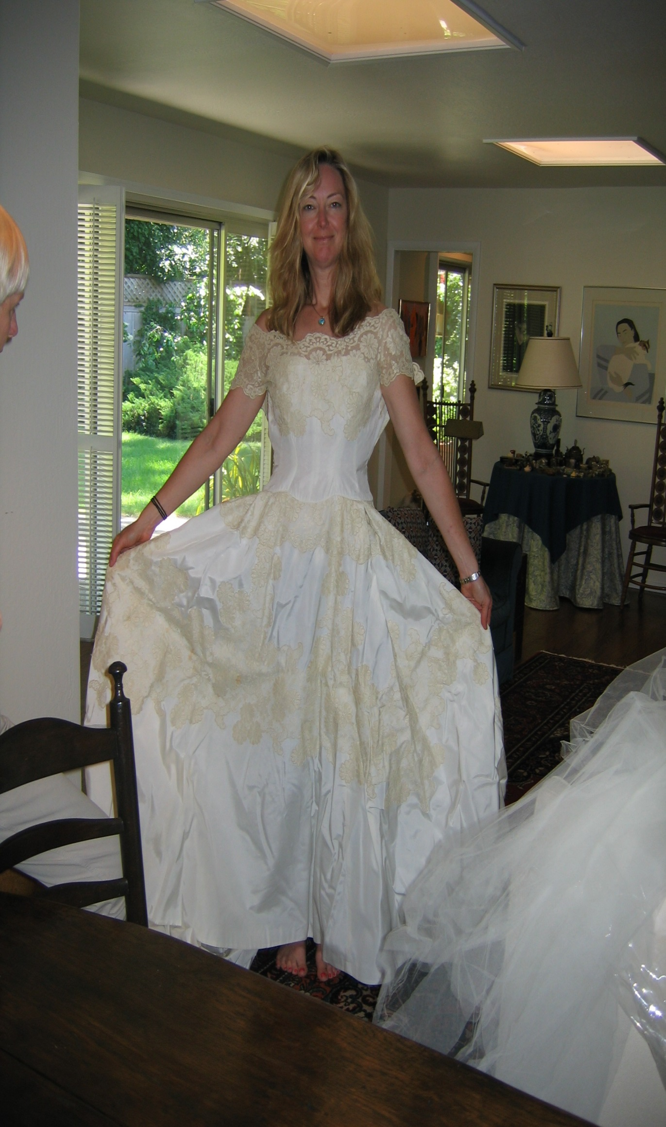
...and it even seemed to fit!! Well...
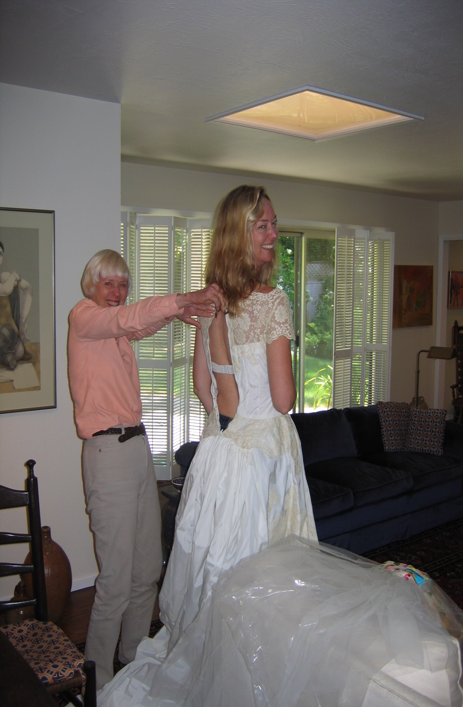
...almost! So it was off to the amazing couturier Colleen Quen (www.colleenquencouture.com), to help the Princess re-make the dress for the Day!

MORE >>

Posted by Sandy Shepard at
7/1/2006 5:52 PM | View Comments (0) | Add Comment | Trackbacks (0)

"You're My Everything," song by Tal Bachman

Every time that I look in your eyes
I know love never dies
Oh, baby...
Love is blind, and I can't see
Cupid's aimed his bow right at me
I love you and adore you, you're all that life could bring
Baby, you're my everything
Cynics sneer at fairy tales
They mock love and all its details
But we've got something magical those fools will never see
Baby, you're my everything
I can only stand for a moment or two
Being without you
Oh, I know it sounds extreme
But baby you're my dream come true
Yes, we've got something magical those fools have never seen
Baby, you're my everything.

MORE >>

Posted by Sandy Shepard at
6/25/2006 12:54 PM | View Comments (0) | Add Comment | Trackbacks (0)

"They Loved These Things Too," Lisa Jarnot

the sun the moon the stars the polar ice caps and the ice cream cones the city streets the side streets and the small tv the curve of flesh around the food the road maps and november and the tiny birds and also certain people and they loved the special chairs and also stuffed things and the carnival and big rings and the o rings and they loved the oranges in bags and florida and texas and the hotel room and they loved the chili on the highway that they loved as if they loved the onramp and the way that people called and the natural forces of destruction and the sea they loved the sea and also boats and sailing ships and whales they loved and sea birds in varieties and then they loved the choice of drinks to drink and also beer they loved the times that others liked them that they loved and also they loved things all shaped like tapirs and they loved the zoo.

MORE >>

Posted by Sandy Shepard at
6/25/2006 12:30 PM | View Comments (0) | Add Comment | Trackbacks (0)

"Love Is A Magic Ray," from The Prophet by Kahlil Gibran

Love is a magic ray
emitted from the burning core
of the soul
and illuminating
the surrounding earth.
It enables us
to perceive life
as a beautiful dream
between one awakening
and another.

MORE >>

Posted by Sandy Shepard at
6/23/2006 12:29 PM | View Comments (0) | Add Comment | Trackbacks (0)

"A Drinking Song," W.B. Yeats

Wine comes in at the mouth
And Love comes in at the eye;
That's all we shall know for Truth
Before we grow old and die.
I lift the glass to my mouth
I look at you,
and I Sigh.

MORE >>

Posted by Sandy Shepard at
6/21/2006 12:39 PM | View Comments (0) | Add Comment | Trackbacks (0)

"Wear Your Love Like Heaven" (originally recorded by Donovan, lately by Sarah McLachlan)

Color in sky prussian blue
Scarlet fleece changes hue
Crimson ball sinks from view
[CHORUS]
Wear your love like heaven
Wear your love like heaven
Wear your love like heaven
Lord kiss me once more
Fill me with song
Allah kiss me once more
That I may, that I may
Wear my love like heaven
Wear my love like heaven
Color sky havana lake
Color sky rose carmethene
Alizarian crimson
[CHORUS]
Lord kiss me once more
Fill me with song
Allah kiss me once more
That I may, that I may
Wear my love like heaven
Wear my love like heaven
Lord kiss me once more
Fill me with song
Allah kiss me once more
That I may, that I may
Wear my love like heaven
Wear my love like heaven
Cannot believe what I see
All I have wished for will be
All of our race proud and free
[CHORUS]
Lord kiss me once more
Fill me with song
Allah kiss me once more
That I may, that I may
Wear my love like heaven
Wear my love like heaven

MORE >>

Posted by Sandy Shepard at
6/20/2006 12:55 PM | View Comments (0) | Add Comment | Trackbacks (0)

Pali Karaniya Metta Sutta -- The Path of Unlimited Friendliness -- The Buddha

If you know what is truly good for you and you understand the possibility of reaching a state of perfect peace, then this is how you need to live.
Start as a capable person, who is upright - really upright - gently spoken, flexible, and not conceited. Then become contented and happy, with few worries and an uncomplicated life. Make sure your sense experience is calm and controlled, be duly respectful, and don't hanker after families and groups. And avoid doing anything unworthy, that wiser people would criticise.
Then meditate like this: May all beings be happy and secure. May all beings become happy in their heart of hearts! And think of every being without exception: the weak and the strong, from the smallest to the largest, whether you can see them or not, living nearby or far away, beings living now or yet to arise - may all beings become happy in their heart of hearts! May no one deceive or look down on anyone anywhere, for any reason. Whether through feeling angry or through reacting to someone else, may no one want another to suffer. As strongly as a mother, perhaps risking her life, cherishes her child, her only child, develop an unlimited heart for all beings. Develop an unlimited heart of friendliness for the entire universe, sending metta above, below, and all around, beyond all narrowness, beyond all rivalry, beyond all hatred. Whether you are staying in one place or travelling, sitting down or in bed, in all your waking hours rest in this mindfulness, which is known as like living in heaven right here and now!
In this way, you will come to let go of views, be spontaneously ethical, and have perfect insight. And leaving behind craving for sense pleasures, from the rounds of rebirth you will finally be completely free!
translation: Dharmachari Ratnaprabha 1990

MORE >>

Posted by Sandy Shepard at
6/20/2006 12:07 PM | View Comments (0) | Add Comment | Trackbacks (0)

Thomas A Kempis, "On the Wonderful Effect of Divine Love," Chapter 42, The Imitation of Christ

THE DISCIPLE. O Heavenly Father, ... blessed be Your Name for ever, for You have deigned to consider me, the poorest of Your servants. Father of mercies and God of all comfort,( 2 Cor. 1:3) I thank You that, unworthy as I am, You sometimes refresh me with Your consolation. Blessing and glory to You, with Your sole-begotten Son and with the Holy Spirit the Comforter, now and through endless ages. You are my glory,( Ps. 3:3) and the joy of my heart;( Ps. 119:111) for You are my hope, and my refuge in time of trouble.( Ps 59:16)
As yet my love is weak, and my virtue imperfect, and I have great need of Your strength and comfort. Therefore, visit me often, I pray, and instruct me in Your holy laws. Set me free from evil passions, and heal my heart from all disorderly affections; that, healed and cleansed in spirit, I may grow able to love, strong to endure, and steadfast to persevere.
Love is a mighty power, a great and complete good; Love alone lightens every burden, and makes the rough places smooth. It bears every hardship as though it were nothing, and renders all bitterness sweet and acceptable. The love of Jesus is noble, and inspires us to great deeds; it moves us always to desire perfection. Love aspires to high things,and is held back by nothing base. Love longs to be free, a stranger to every worldly desire, lest its inner vision become dimmed, and lest worldly self-interest hinder it or ill fortune cast it down. Nothing is sweeter than love, nothing stronger, nothing higher, nothing wider, nothing more pleasant, nothing fuller or better in heaven or earth; for love is born of God, ( I John 4:7)and can rest only in God, above all created things.
Love flies, runs, and leaps for joy; it is free and unrestrained. Love gives all for all, resting in One who is highest above all things, from whom every good flows and proceeds. Love does not regard the gifts, but turns to the Giver of all good gifts. Love knows no limits, but ardently transcends all bounds. Love feels no burden, takes no account of toil, attempts things beyond its strength; love sees nothing as impossible, for it feels able to achieve all things. Love therefore does great things; it is strange and effective; while he who lacks love faints and fails.
Love is watchful, and while resting, never sleeps; weary, it is never exhausted; imprisoned, it is never in bonds; alarmed, it is never afraid; like a living flame and a burning torch, it surges upward and surely surmounts every obstacle. Whoever loves God knows well the sound of His voice. A loud cry in the ears of God is that burning love of the soul which exclaims, `My God and my love, You are all mine, and I am Yours.'Deepen Your love in me, O Lord, that I may learn in my inmost heart how sweet it is to love, to be dissolved, and to plunge myself into Your love. Let Your love possess and raise me above myself, with a fervour and wonder beyond imagination. Let me sing the song of love. (Isa. 5:1) Let me follow You, my Beloved, into the heights. Let my soul spend itselfin Your praise, rejoicing for love. Let me love You more than myself, and myself only for Your own sake. Let me love all men who truly love You, as the law of love commands, which shines out from You.
Love is swift, pure, tender, joyful, and pleasant. Love is strong, patient, faithful, prudent, long-suffering, vigorous, and never self-seeking.(I Cor.13:4) For when a man is self-seeking he abandons love. Love is watchful, humble, and upright; Love is not fickle and sentimental, nor is it intent on vanities. It is sober, pure, steadfast, quiet, and guarded in all the senses. Love is submissive and obedient to superiors, mean and contemptible in its own sight, devoted and thankful to God, trusting and hoping in Him even when not enjoying His sweetness; for none can live in love without suffering.
Whoever is not prepared to endure everything, and to stand firmly by the will of the Beloved, is not worthy to be called a lover. A lover must willingly accept every hardship and bitterness for the sake of his Beloved, and must never desert Him because of adversity.

MORE >>

Posted by Sandy Shepard at
6/20/2006 12:06 PM | View Comments (0) | Add Comment | Trackbacks (0)

"You Are The Sunshine Of My Life," Stevie Wonder

You are the sunshine of my life
Thats why I'll always be around,
You are the apple of my eye,
Forever you'll stay in my heart
I feel like this is the beginning,
Though I've loved you for a million years,
And if I thought our love was ending,
I'd find myself drowning in my own tears.
You are the sunshine of my life,
Thats why Ill always stay around,
You are the apple of my eye,
Forever you'll stay in my heart,
You must have known that I was lonely,
Because you came to my rescue,
And I know that this must be heaven,
How could so much love be inside of you?
You are the sunshine of my life, yeah,
Thats why I'll always stay around,
You are the apple of my eye,
Forever youll stay in my heart.
(background)
Love has joined us,
Love has joined us,
Let's think sweet love.

MORE >>

Posted by Sandy Shepard at
6/15/2006 12:57 PM | View Comments (0) | Add Comment | Trackbacks (0)

from "It Was On Fire When I Laid Down On It," by Robert Fulghum (the "Everything I Need To Know I Learned in Kindergarten" guy)

I have married more than a thousand times. Officiated as the minister at a whole lot of weddings and usually managed to get so involved in each occasion that it felt like I was the one getting married. Still, I always look forward to marrying again, because most weddings are such comedies.
Not that they are intended as such. But since weddings are high state occasions involved amateurs under pressure, everything NEVER goes right. Weddings seem to be magnets for mishap and for whatever craziness lurks in family closets. In more ways than one, weddings bring out the ding-dong in everybody involved.
I will tell you the quintessential wedding tale. One of disaster. Surprisingly, it has a happy ending, though you may be in doubt, as I was, as the story unfolds.
The central figure in this drama was the mother of the bride (MOT. Not the bride and groom or the minister. Mother. Usually a polite, reasonable, intelligent, and sane human being, Mother was mentally unhinged by the announcement of her daughter's betrothal. I don't mean she was unhappy, as is often the case. To the contrary. She was overcome with joy. And just about succeeded in overcoming everybody else with her joy before the dust settled.
Nobody knew it, but this lady had been waiting with a script for a production that would have met with Cecil B. DeMille's approval. A royal wedding fit for a princess bride. And since it was her money, it was hard to say No. The father of the bride began to pray for an elopement. His prayers were not to be answered.
She had seven months to work, and no detail was left to chance or human error. Everything that could be engraved was engraved. There were teas and showers and dinners. The bride and groom I met with only three times. The MOTB called me weekly, and was in my office as often as the cleaning lady. (the caterer called me to ask if this was really a wedding, or an invasion he was involved in. "Invasion," I told him.)
An eighteen-piece brass and wind ensemble was engaged. (The church organ simply would not do - too "churchy.") The bride's desires for home furnishings were registered in stores as far east as New York and as far south as Atlanta. Not only were the bridesmaids' outfits made to order, but the tuxedos for the groom and his men were bought - not rented, mind you. Bought. If all that wasn't enough, the engagement ring was returned to the jeweler for a larger stone, quietly subsidized by the MOTB. When I say the lady came unhinged, I mean UNHINGED.
Looking back, it seems now that the rehearsal and dinner on the evening before the great event were not unlike what took place in Napoleon's camp the night before Waterloo. Nothing had been left to chance. Nothing cound prevent a victory on the coming day. Nobody would EVER forget this wedding. (Just as nobody ever forgot Waterloo. For the same reason, as it turned out.)
The juggernaut of fate rolled down the road, and the final hour came. Guests in formal attire packed the church. Enough candles were lit to bring daylight back to the evening. And the mighty MOTB coasted down the aisle with the grandeur of an opera diva at a premier performance. Never did the mother of the bride take her seat with more satisfaction. She had done it. She glowed, beamed, smiled, and sighed.
The music softened, and nine - count'em, nine - chiffon-draped bridesmaids lockstepped down the long aisle while the befrocked groom and his men marched stolidly into place.
Finally, oh so finally, the wedding march thundered from the orchestra. Here comes the bride. Preceded by four enthusiastic min-princesses chunking flower petals, and two dwarfish ringbearers - one for each ring. The congregation rose and turned in anticipation.
Ah, the bride. She had been dressed for hours if not days. No adrenaline was left in her body. Left alone with her father in the reception hall of the church while the march of the maidens went on and on, she had walked along the tables laden with gourmet goodies and absentmindedly sampled first the little pink and yellow and green mints. Then she picked through the silver bowls of mixed nuts and ate the pecans. Followed by a cheeseball or two, some black olives, and handful of glazed almonds, a little sausage with a frilly toothpick stuck in it, a couple of shrimps blanketed in bacon, and a cracker piled with liver pate. To wash this down - a glass of pink champagne. Her father gave it to her. To calm her nerves.
What you noticed as the bride stood in the doorway was not her dress, but her face. White. For what was coming down the aisle was a living grenade with the pin pulled out.
The bride threw up.
Just as she walked by her mother.
And by "threw up," I don't mean a polite little ladylike urp into her handkerchief. She puked. There's just no nice word for it. I mean, she hosed the front of the chancel - hitting two bridesmaids, the groom, a ringbearer, and me.
I am quite sure of the details. We have it all on videotape. Three cameras' worth. The MOTB had thought of everything.
Having disgorged her hors d'oeuvres, champagne, and the last of her dignity, the bride went limp in her father's arms, while her groom sat down on the floor where he had been standing, too stunned to function. And the mother of the bride fainted, slumping over in rag-doll disarray.
We had a fire drill then and there at the front of the church that only the Marx Brothers could have topped. Groomsmen rushed about heroically, mini-princess flower girls squalled, bridesmaids sobbed, and people with weak stomachs headed for the exits. All the while, unaware, the orchestra played on. The bride had not only come, she was gone - into some other state of consciousness. The smell of fresh retch drifted across the church and mixed with the smell of guttering candles. Napoleon and Waterloo came back to mind.
Only two people were seen smiling. One was the mother of the groom. And the other was the father of the bride.
What did we do? Well, we went back to real life. Guests were invited to adjourn to the reception hall, though they did not eat or drink as much as they might have in different circumstances. The bride was consoled, cleaned up, fitted out with a bridesmaid's dress, and hugged and kissed a lot by the revived groom. (She'll always love him for that. When he said "for better or for worse," he meant it.) The cast was reassembled where we left off, a single flute played a quiet air, the words were spoken and the deed was done. Everybody cried, as people are supposed to do at weddings, mostly because the groom held the bride in his arms through the entire ceremony. And no groom ever kissed a bride more tenderly than he.
If one can hope for a wedding that it be memorable, then theirs was a raging success. NOBODY who was there will EVER forget it.
They lived as happily as anyone does - happier than most, in fact. They have been married about twelve years now, and have three lively children.
But that's not the end of the story. The best part is still to come. On the tenth anniversary of this disastrous affair, a party was held. Three TV sets were mustered, a feast was laid, and best friends invited. Remember, there were three video cameras at the scene of the accident, so all three films were shown at once.) The event was hilarious, especially with the running commentary and the stop-action stuff that is a little gross when seen one frame at a time. The part that got cheers and toasts was when the camera focused on the grin on the face of the father of the bride as he contemplates his wife as she is being revived.
The reason I say this is the best part is not because of the party. But because of who organized it. Of course. The infamous MOTB. The mother of the bride is still at it, but she's a lot looser these days. She not only forgave her husband and everybody else for their part in the debacle, she foregave herself. And nobody laughed harder at the film than she.
There's a word for what she has. Grace.
And that's why that same grinning man has been married to her for forty years. And why her daughter loves her still.
(Submitted by Surrey Blackburn, Photographer for the Wedding)

MORE >>
Posted by Sandy Shepard at
6/13/2006 5:02 PM | View Comments (0) | Add Comment | Trackbacks (0)

Copyright 2006-2016. http://WEDSITEBLOG.HERBERTANDSANDY.COM. All rights reserved.

